1. Motivate

Who comes to mind when you hear the word “courage”
- Chuck Norris
- Clint Eastwood – Dirty Harry
- the 1980 US Olympic hockey team
- missionaries in the very early days of overseas outreach
- Dietrich Bonhoeffer
- Hellen Keller
- Martin Luther King
- Winston Churchill
- Moses
- Harrison Ford (in different movie roles)

2. Transition

Today we study a person had courageous faith because of her awe of Jehovah God.
- The power of God that leads us to fear Him also leads us to trust Him

3. Bible Study

3.1 Fear of God Fuels Courage

Listen for how spies were protected.

Joshua 2:1-7 (NIV) Then Joshua son of Nun secretly sent two spies from Shittim. "Go, look over the land," he said, "especially Jericho." So they went and entered the house of a prostitute named Rahab and stayed there. 2 The king of Jericho was told, "Look! Some of the Israelites have come here tonight to spy out the land."3 So the king of Jericho sent this message to Rahab: "Bring out the men who came to you and entered your house, because they have come to spy out the whole land." 4 But the woman had taken the two men and hidden them. She said, "Yes, the men came to me, but I did not know where they had come from. 5 At dusk, when it was time to close the city gate, the men left. I don't know which way they went. Go after them quickly. You may catch up with them." 6 (But she had taken them up to the roof and hidden them under the stalks of flax she had laid out on the roof.) 7 So the men set out in pursuit of the spies on the road that leads to the fords of the Jordan, and as soon as the pursuers had gone out, the gate was shut.

What action did Joshua take as further preparation for leading the Israelites across the Jordan into Canaan?
- sent two spies
- go look over the land
- especially check out Jericho

Why might the two spies have chosen to go to Rahab’s house, a known place of prostitution?
- all kinds of men would go there
- might not be suspicious of strangers going there
- probably a “no-tell” kind of place
- might not have known what it was at first
- later we learn her place was on/in the city wall, first place they came to

How do you imagine the spies felt about sneaking into Canaan, even though it was an important role?
- certain amount of apprehension
- had to know they might not fit in, might be easily seen as foreigners
- realized their speech might betray them
- clothing and appearance would be not quite right
- certainly the presence of all of the Israelites (upwards of 1 million people) camped 15 miles away was known by Jericho
- no doubt the king and his guards would be on the lookout for spies

When have you ever been scared or nervous about doing something that you knew was right?
- go on a witnessing team
- give a presentation at work
- teach a Bible study class for the first time
- sing or play your instrument as a solo
- first time in a marching band half time show
- attend college as a freshman, all alone, far from home
- meet new people you don’t know
- a first date with someone
- getting married

What actions did Rahab take to protect the Israelite spies?
- obfuscation
- hid them on her roof under piles of flax
- told the guards the men (spies) had come and gone
- sent them off searching down the road towards the river

Why was such action potentially risky for her; therefore an act of courage?
- she could be in trouble for hiding spies
- in trouble for lying to the authorities
- her actions were treasonous

3.2 Confidence in Who God Is and What He Does

Listen for a confession.

Joshua 2:8-11 (NIV) Before the spies lay down for the night, she went up on the roof 9 and said to them, "I know that the LORD has given this land to you and that a great fear of you has fallen on us, so that all who live in this country are melting in fear because of you. 10 We have heard how the LORD dried up the water of the Red Sea for you when you came out of Egypt, and what you did to Sihon and Og, the two kings of the Amorites east of the Jordan, whom you completely destroyed. 11 When we heard of it, our hearts melted and everyone's courage failed because of you, for the LORD your God is God in heaven above and on the earth below.

What words and phrases did Rahab use to describe the feelings of the people of Jericho?
- great fear fallen on us
- all who live here are melting in fear
- our hearts melted
- everyone’s courage failed

What reports of awesome events had proceeded the Israelites?
- Jehovah God had parted the Red Sea, dried up the land
- with God’s help, Israel had defeated Sihon and Og, two kings of the Amorites
- you completely destroyed them

What is the significance of her use of God’s name, LORD, or Jehovah in her descriptions?
- people of Jericho knew about the God the Israelites worshiped
- they knew of His name
- they were in awe, fear of his power and authority
- Jehovah God’s reputation had proceeded the approach of the Israelites
- she was convinced that Jehovah God would defeat her city, her land, her people

How would you explain the phrase “fear of God” to someone who isn’t a Christfollower?
- being in awe of God
- being convinced of His power and authority
- being aware of how much he loves us
- realizing God is far more than just a figment of human imagination
- He is the God who created all of the universe
- He is the God who entered into time and space and came to earth as a human
- He is in control of the flow of history, despite those who aspire to be power figures – no matter what point in history

What are some ways God has demonstrated awesome power in meeting your needs?
- provided a job
- rescued from addiction
- met a financial need just in time
- helped a child struggling with a particular class in school
- provided physical healing
- gave courage when facing death of a loved one
- brought many people to a profession of faith during an evangelistic outreach
- provided help in dealing with cleanup after a bad storm

How does our recollection of victories God has brought in the past encourage us to believe He has the power to bring about victory in the future?
- God did it before, He can do it again
- God proves His power and authority and love for us over and over
- God is faithful, we can trust Him repeatedly
- we can trust Him for even bigger things
- we discover God is able to work in our lives in more and more awesome ways

3.3 Fear of God Fuels Trust

Listen for a promise.

Joshua 2:12-14 (NIV) Now then, please swear to me by the LORD that you will show kindness to my family, because I have shown kindness to you. Give me a sure sign 13 that you will spare the lives of my father and mother, my brothers and sisters, and all who belong to them, and that you will save us from death." 14 "Our lives for your lives!" the men assured her. "If you don't tell what we are doing, we will treat you kindly and faithfully when the LORD gives us the land."

What promise did Rahab ask the men of Israel to make to her?
- please promise to show kindness to my family
- remember that I have shown kindness to you
- give me a sure sign you will spare the lives of my family
- save us from death

What was the basis of the request?
- I’ve protected you
- only fair that you protect me

How did they respond?
- our lives for your lives
- they assured her
- if you don’t report what we’re doing, we’ll treat you kindly and faithfully when Jehovah gives us the land

How might their response reflect the character of the God they served?
- God is loving and kind
- God wants good things for us
- when we are in awe of Him, when we trust Him, He honors our faith

Consider the statement, Fear of God fuels faith into action. What do you think that means?
- if you are in awe of God’s power and authority and love
- then you can trust him to be with you when you step out in faith
- when you obey Him and do His will you can be convinced of His presence and
- you are assured in your heart and mind that He will enable you

When have you experienced the fear of God leading you to trust God more?
- read a verse that gave assurance
- heard a sermon and the Holy Spirit convinced you to trust Him and obey Him
- heard someone’s testimony how God had met their need and it encouraged you to trust Him in your own situation
- read amazing reports of how God is using something simple like Operation Christmas Child and you were encouraged to become involved and fill a shoebox also
Use the last page as a handout so your learners can take home the application points of this week’s lesson. A video is available for the application points.
View at https://watch.liberty.edu/media/t/1_1vk3j0yz
Download at https://tinyurl.com/y33dnu4t

Application
Express thanks.
- Pray and thank God for His faithfulness and His promises.
- Remember that your past does not determine your future.

Tackle the wall.
- Is there a “wall” in your life that you need God to tear down?
- Trust Him to do so.
- Journal your fears and write out Scriptures that remind you of God’s faithfulness.
- Remember Psalm 145:6: “They tell of the power of your awesome works—and I will proclaim your great deeds.”

Leave a legacy.
- Ask God to guide you in leaving the right kind of spiritual legacy to those who follow you.
- It begins with sharing your faith in Christ.
- Seek opportunities to talk and pray with someone who needs to turn from sin and trust in Christ.

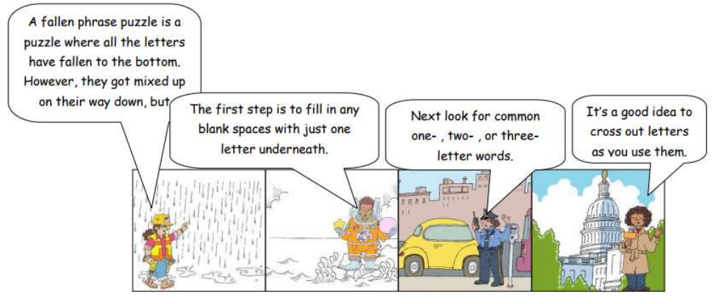
Fallen Phrases Puzzle
If you get stuck, you can go to
https://tinyurl.com/y33dnu4t
There’s other cool activities there also.
A. W. Tozer

