1. Motivate

To what charities or special causes do you like giving, even giving sacrificially?
- Lottie Moon Missions offering
- church building program
A short video for the introduction is available.
View at https://watch.liberty.edu/media/t/1_t9310of9
Download from https://tinyurl.com/yycsc7dw
- March of Dimes
- United Way
- Red Cross
- rescue mission
- charities which work towards healing of diseases … cancer, liver problems, diabetes,
- youth and college ministries

2. Transition

Today we consider contrasting attitudes towards generosity and giving.
- We will find that giving reflects your faith and trust in Christ

3. Bible Study

3.1 Abundance vs. Abundant Life

Listen for Jesus’ warning.

Luke 12:13-15 (NIV) Someone in the crowd said to him, "Teacher, tell my brother to divide the inheritance with me." 14 Jesus replied, "Man, who appointed me a judge or an arbiter between you?" 15 Then he said to them, "Watch out! Be on your guard against all kinds of greed; a man's life does not consist in the abundance of his possessions."

Who interrupted Jesus’ teaching and what was his issue?
- a man in the crowd
- wanted Jesus to intervene in a family/legal matter
- issue had to do with the division of inheritance with his brother
- probably the older brother had taken more than what this fellow said was true

What insight does Jesus give to His purpose for coming to the world?
- Jesus says He is not meant to be a judge
- He is not a an officer of arbitration
- Jesus is saying this is not His ministry
- He has come to proclaim the Kingdom/Rule of God in people’s lives

Against what did Jesus caution the man?
- Watch out!
- be on guard against all kinds of greed
- life is not made up of how much stuff you can acquire

What are some things other than money and possessions for which people can be greedy?

- power
- influence
- fame
- position
- honor
- control

Jesus is saying that wanting all of these things is a great mistake … why so?
- life is really much more than gaining these things, these qualities
- our focus is too often on the material, rather than the spiritual
- that is how the world lives, not how believers are to live

How might greed affect our decisions regarding the distribution of our assets after death?
- you might try to take it with you!?
- you base your gifts on who has been nice to you
- you often change your will based on your anger at various people
- you use the will as a way to get back at relatives (Consider The Testament by John Grisham)

Is saving money the same as being greedy?
- according to a Larry Burkett study, “no”
- hoarding is different from saving
- saving is setting aside money that you know you will need for a future eventuality (car repairs, insurance bills, yearly expenses)
- greed would be partly an attitude issue – that ongoing desire to get more, feeling you never have enough

What does it mean to “watch out” for greed? What steps can believers take to “be on guard” against greed?
- be sure to practice tithing (and beyond)
- claim the Fruit of the Spirit – love, joy, peace, patience, kindness, goodness, self-control, gentleness, faithfulness
- ask God to show you ways in which you can share from your abundance

3.2 Have An Eternal Perspective

Listen for a tragic end to the story.

Luke 12:16-21 (NIV) And he told them this parable: "The ground of a certain rich man produced a good crop. 17 He thought to himself, 'What shall I do? I have no place to store my crops.' 18 "Then he said, 'This is what I'll do. I will tear down my barns and build bigger ones, and there I will store all my grain and my goods. 19 And I'll say to myself, "You have plenty of good things laid up for many years. Take life easy; eat, drink and be merry."' 20 "But God said to him, 'You fool! This very night your life will be demanded from you. Then who will get what you have prepared for yourself?' 21 "This is how it will be with anyone who stores up things for himself but is not rich toward God."

What good situation did the rich man in the parable Jesus told find himself in?
- for a particular year, he had a “bumper crop”
- a fantastic harvest, more than he had room to store
- needed more storage

What was his solution?
- tear down the older smaller barns
- build new and larger barns
- probably needed to do it quickly
- decided he was now on “easy street”
- this harvest had set him up for good
- he figured he had plenty of what he needed for years to come
- now it was time to take it easy and enjoy the good life

How did the rich man’s thinking prove to be flawed?
- physical life is not forever
- you don’t know how many years/days you have left
- no matter how rich you are, you might not live long enough to enjoy it
- in fact, in the story, Jesus said he would die that night and never get to enjoy all that he had acquired

What parts of the parable make you uncomfortable?
- this was a good business man
- seemed honest, resourceful, hardworking, a planner – all good traits
- not unlike our culture, even as Christian believers
- realize it is easy to fall into the trap of materialism

In what ways do we act as if we will live for many, many years?
- take on debt
- gather lots of “stuff”
- make extensive plans
- acquire bigger houses

How can we be guilty of “building bigger barns”?
- frequent purchase of new vehicles
- looking to move to a bigger house in a newer neighborhood
- expand the business
- move up the corporate ladder, get that promotion
- push the kids to get a prestigious education

What do you think God meant by the term “rich toward God”?
- not preoccupied with laying up treasure in earth
- rather, laying up treasure in heaven
- making “eternal investments”
- having a right relationship with God
- having a right relationship with others

How do we make eternal investments?
- giving of our resources to spiritual ministries
- sharing God's plenty in ways that will minister to needs of those whose lives will go on to count for eternity
3.3 Sacrifice and Trusting God

Listen for a contrast to the rich fool.

Luke 21:1-4 (NIV) As he looked up, Jesus saw the rich putting their gifts into the temple treasury. 2 He also saw a poor widow put in two very small copper coins. 3 "I tell you the truth," he said, "this poor widow has put in more than all the others. 4 All these people gave their gifts out of their wealth; but she out of her poverty put in all she had to live on."

What words and phrases does Jesus use to contrast the rich and poor people giving their offerings?
Rich | Poor
- “the rich” vs. 1  - gifts placed n temple treasure (boxes with funnel shaped receptacles)  - those who gave out of their wealth | - “poor widow” vs. 2  - two very small copper coins  - poor widow gave more than the others  - she gave out of her poverty  - put in all she had to live on

Why is giving out of our wealth a relatively easy thing to do?
- you don’t miss it that much
- 10% of a million dollars still leaves $900,000 – easy to live on that
- 10% of a hundred dollars leaves only $90 – which doesn’t go far in paying normal bills.

Why do you think the widow gave all the money that she had to live on?
- gratitude
- she loved the Lord that much
- she depended on the Lord to supply her needs
- He did it before, He could do it again

How might she be criticized by the world for what she did?
- how is she going to live?
- certainly God does not expect someone like this to be required to give!
- not even the IRS makes people at that kind of poverty level pay taxes
- she’ll just be dependent on society now
- another person on welfare!
- why doesn’t she get a job?

What would it look like to follow this woman’s example in today’s world?
- give sacrificially
- give motivated by love for God and for spiritual ministries
- set aside your current desires for more stuff and give the money to the Lord’s work
- give more than the 10% specified tithe
- learn to live on less so you can give more to reaching people for God
Use the last page as a handout so your learners can take home the application points of this week’s lesson.
Application
Give.
- Ask the Lord to give you an opportunity to financially bless someone in need this week.
- Keep extra cash in your wallet so you are prepared when the need arises. Give without an expectation of being repaid.
- See if you can remain anonymous in your giving.

Memorize.
- Memorize Matthew 6:2- 4: “So when you give to the needy, do not announce it with trumpets, as the hypocrites do in the synagogues and on the streets, to be honored by others. Truly I tell you, they have received their reward in full. But when you give to the needy, do not let your left hand know what your right hand is doing, so that your giving may be in secret. Then your Father, who sees what is done in secret, will reward you”

Increase.
- Evaluate your current charitable giving and how you are supporting your local church.
- Is your giving consistent? Is it sacrificial?
- Challenge yourself to give more for the sake of kingdom work.
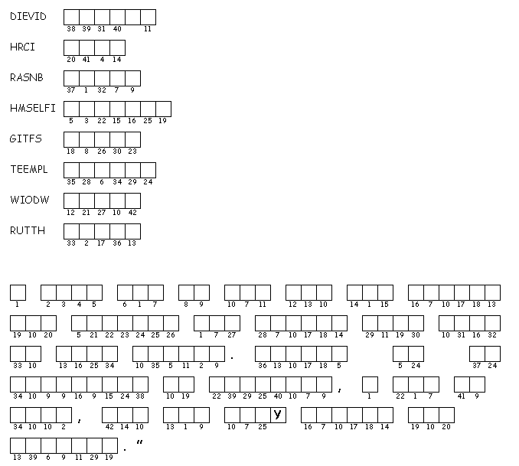

This just in … literary hooligans have scrambled the words on the left, thus rendering the message below unknown. Unscramble each of the clue words. Copy the letters in the numbered cells to other cells with the same number. The scrambled words taken from Luke 12:13-21; 21:1-4 (NIV). If you get stuck go to https://tinyurl.com/yycsc7dw There’s other great Family Activities there also.

