1. Motivate

When have you felt like “the new kid”?
- moving to a new school district
- moving to a new neighborhood
- put on the varsity team, even though you were only a freshman
- going from a smaller junior high to the big high school
- if you ever attended a boarding school – first time there
- took your first job out of college
- entered a Sunday School class first time at a new church
- orientation move in day at college

2. Transition

For new visitors in our church, those are the same feelings, no matter what their age.
- We want them to feel welcome, despite those feelings.
- We need to realize that a true welcome goes beyond a friendly handshake

3. Bible Study

3.1 Treat Everyone the Same

Listen for how prejudice was shown.

James 2:1-4 (NIV) My brothers, as believers in our glorious Lord Jesus Christ, don't show favoritism. 2 Suppose a man comes into your meeting wearing a gold ring and fine clothes, and a poor man in shabby clothes also comes in. 3 If you show special attention to the man wearing fine clothes and say, "Here's a good seat for you," but say to the poor man, "You stand there" or "Sit on the floor by my feet," 4 have you not discriminated among yourselves and become judges with evil thoughts?

What examples of prejudice and partiality does James describe?
- people with fancy jewelry
- people with fine clothes
- contrast with an impoverished person
- person with shabby clothes
- you can almost infer that they might be a bit stinky also

What rationale might an usher or deacon give for such treatment to someone today?
- fancy family might join the church … prestige involved,
- they are also potential generous givers
- the scruffy person is just looking for a handout, here today, gone tomorrow
- nice folks will be scared away if we have a bunch of smelly homeless people crowding in here

What other ways might such treatment happen in today’s churches?
- homeless person shuffled off to the kitchen, given food, told not to come back
- maybe sent to Salvation Army or rescue mission
- rich person welcomed from the platform, greeted as a guest

What criteria might cause special treatment (either positive or negative)?
- race or color of skin
- good looks (or ugly)
- denomination
- what part of town they come from
- are they famous in sports, music, business, politics, etc.
- might the person be infamous – a politician we disagree with, a criminal, etc.

Why do we often treat rich people as more important than poor people?
- we want to gain their favor
- to impress them that we know they deserve special treatment
- maybe they will tip us for our “kindness” with one of their many $100 bills!
- if it were here at church, maybe they will be inclined to be generous with their wealth to the church
- we seem to know that they expect special treatment

How does James characterize those who engage in these attitudes or actions?
- you are acting as judges
- you act with evil thoughts

How is showing favoritism or preference to one person or group an act of “prejudging?”
- we establish our opinion about them based on the group we put them in
- we make the assumption that all people in that group act in a certain way, this is a person of that group, they will be that way
- we stereotype

What are some examples of wrong pre-judgments you have made with people you know?
- “funny looking” person really a nice guy, now your best friend
- one of most well off and generous people you know drives an old pickup and wears jeans
- little old lady who looks mean is really a sweetie
- geeky kid you knew in high school you ended up marrying (still geeky, but quite lovable)!
- guy with all the influence and bravado when you were young now just getting by
- was a football star/head cheerleader back in the day, now quite down to earth, unassuming
- we might have initially rejected a person of another race/religion/culture, but once you get to know them, they are interesting and a good friend

⇒ You only discover that when you get to know the person … God wants you NOT to show favoritism, NOT to have an attitude of prejudice

3.2 No Partiality with God

Listen for how God sees people is different from our view.
James 2:5-7 (NIV) Listen, my dear brothers: Has not God chosen those who are poor in the eyes of the world to be rich in faith and to inherit the kingdom he promised those who love him? 6 But you have insulted the poor. Is it not the rich who are exploiting you? Are they not the ones who are dragging you into court? 7 Are they not the ones who are slandering the noble name of him to whom you belong?

So, let’s make the contrast … how does God, how do we see people?
How God sees people | How we see people
- people who might be financially poor are rich in faith  - rich people seem not to need faith, they’ve got it made  - God knows do they love Him or not | - financially poor people are losers  - rich people must have it together, able to handle life just fine  - we cannot see initially whether they love God or not

Why do you think God has a special concern for poor people?
- they will be more prone to trust God
- rich people trust in their own skills, their own influence
- poor people know that only God looks after them

What do rich people have a history of doing to people in the church?
- exploit others, including believers
- drag people into court – sue believers if they disagree with you or if they can find a way to exploit you
- they actually slander or blaspheme the very Name of Jesus

What are some dangers of showing favoritism?
- the people to whom you show favor are not all that nice
- they can turn on you
- rich people often want to be influential … but they might influence things in the wrong direction
- the people you shun because of their appearance might be really nice, friendly, even generous
- the people you shun could be driven away from knowing Jesus by your unfriendliness

Why does favoritism within a group (family, church, etc.) lead to disasters in relationships?
- the slighted person feels less worthy
- over time this becomes a deep seated hurt, cause deep emotional scars
- the favored person comes to believe that he/she can act as they please and get away with it
- they develop a warped sense of right and wrong

What steps can we take to overcome favoritism?
- confess, repent
- pray and ask God to change your heart, your attitudes
- take steps to become involved in the lives of people that cannot reward you in turn for being nice to them
- pray for your enemies …
3.3 God Is Love

Listen for what is the “royal law.”

James 2:8-10 (NIV) If you really keep the royal law found in Scripture, "Love your neighbor as yourself," you are doing right. 9 But if you show favoritism, you sin and are convicted by the law as lawbreakers. 10 For whoever keeps the whole law and yet stumbles at just one point is guilty of breaking all of it.

What was the “royal law?” ⇒ Love your neighbor as yourself

Why is it “royal?” ⇒ Jesus called it the 2nd greatest commandment
⇒ Primary starting point for all commandments dealing
with interpersonal relationships

What does the Royal Law have to do with prejudice and favoritism?
- no one likes to be treated poorly or as a 2nd class citizen
- we won’t favor one person over another if we treat them as we would want to be treated

Finish the sentence, “Showing favoritism isn’t as bad as __________.”
- murder
- rape
- adultery
- bank robbery
- wife/husband beating

⇒ We don’t tend to include favoritism into the same category as these …

But what does James say about favoritism or prejudice being a sin.
- sin is sin
- God says love your neighbor as yourself, not to do so is sin … you are a lawbreaker
- break one of the commands and in effect you’ve broken them all

Why might we have more responsibility towards those whom we find it difficult to love?
- James is saying that we are to love all people
- Jesus said love your neighbor as yourself (not just the agreeable ones)
- those kinds of people are probably the ones who really need love

How does showing love (instead of favoritism) cause us to obey other laws?
- when you put someone else first you are not going to steal from them or murder them
- when you put others needs ahead of your own, you are not going to sin against them
- this is why Jesus said that loving your neighbor was the second greatest commandment … all the other commandments are just extensions to (corollaries of) the two that He stated
Use the last page as a handout so your learners can take home the application points of this week’s lesson.

Application
Remind yourself.
- Identify a practical way you can remind yourself of the gospel this week.

List.
- Create a list of things that, in your opinion, would be the ideal way to “do” church.
- Identify which of those items are integral to the mission and ministry of the church and which ones are based on your personal preferences.

Befriend.
- Make an intentional effort to befriend someone who is different than you.
- Consider what you can do to make that person feel welcome in your church.
atttention (??)
believers
blaspheming
breaking
brothers
chosen
clothes
court
discriminate
dishonored
evil
exploiting
favoritism
filthy
fine
floor
gold
guilty
inherit
judges
kingdom
love
meeting
name
neighbor
noble
point
poor
promised
ring
scripture
seat
sisters
special
stumbles
suppose
thoughts
whoever
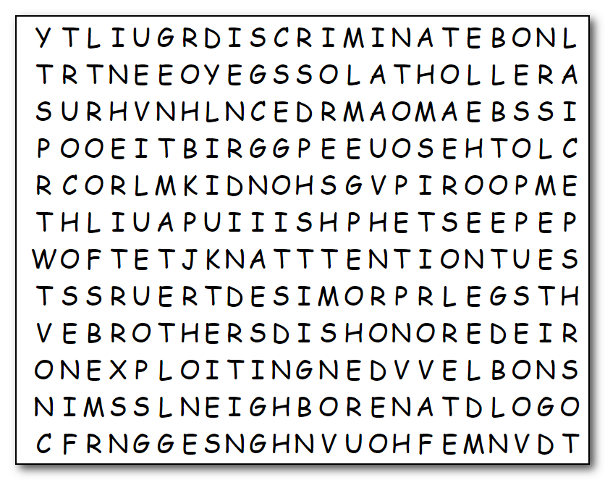
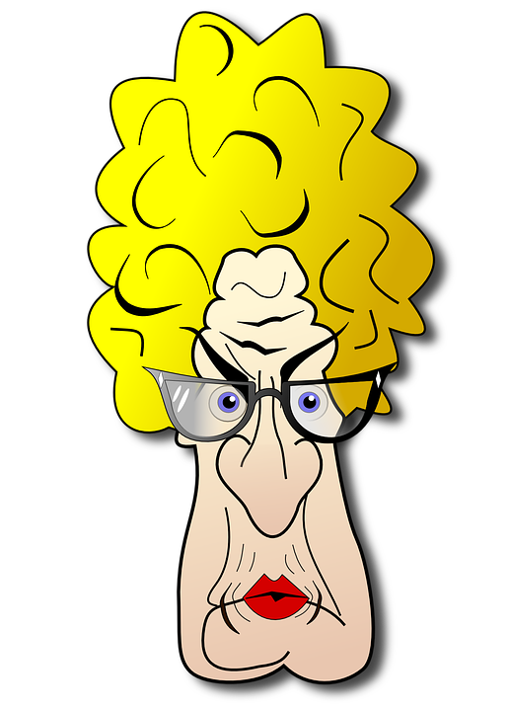
Humph! Obviously someone cannot spell. And the same person has carelessly placed those words in the grid in a big jumble. Please find them for me … they’ve been left forwards, backwards, up, down, and diagonal. What a mess! I just cannot understand some people! You can get help at
https://tinyurl.com/ybpwklak
I hope the other Family Activities show better grammar!

