1. Motivate

What is good advice that people that people often ignore?
- brush after every meal
- eat more fiber
A video introduction to the lesson is available. View it at https://watch.liberty.edu/media/t/1_wkcaw1k2 If you have no wi-fi where you teach, best to download to your computer from https://tinyurl.com/2sv2x4jp
- don’t exceed the speed limit
- read your Bible every day
- get 8 hours of sleep
- exercise every day
- avoid greasy food
- go easy on the salt
- tithe
- put 10% of your income in savings
- contribute to your retirement

2. Transition

God’s Word gives us direction and specific advice.
- We are wise not to ignore it
- We display the truth and value of God’s Word as we live it out.

3. Bible Study

3.1 Respond to God’s Word with Humility

Listen for advice for righteous living.

James 1:19-21 (NIV) My dear brothers, take note of this: Everyone should be quick to listen, slow to speak and slow to become angry, 20 for man's anger does not bring about the righteous life that God desires. 21 Therefore, get rid of all moral filth and the evil that is so prevalent and humbly accept the word planted in you, which can save you.

James is speaking to the issue of righteous living. What actions are believers to take to prepare themselves to receive God’s Word?
- quick to listen
- slow to speak
- slow to become angry
- get rid of moral filth and evil
- accept the word planted in you

James mentions “moral filth” and “evil”. What kinds of these elements do we struggle with in our society?
- pornography
- materialism
- faithfulness in marriage
- abortion
- wokeness, gender confusion, anti-Christian attitudes and policies in media and government
- substance abuse
- hate, deceit, anger, lust, greed, foul language

What makes it hard for us to be good listeners when we are in a conversation?
- we are busy thinking of what we will say
- we want to impress the other person(s) with our clever wit, wide knowledge, or ability to refute their opinions
- we don’t really care about the other person’s thoughts
- we feel they don’t have anything that important to say
- Consider the Rotary Club Four Way test for what you would say
  - Is it the TRUTH?
  - Is it FAIR to all concerned?
  - Will it build GOODWILL and BETTER FRIENDSHIPS?
  - Will it be BENEFICAL to all concerned?

How can being quick to speak and quick to anger get you into trouble?
- you speak without thinking of the wider implications of what we are about to say
- we can easily offend or hurt someone’s feelings
- will we say something that will harm our witness?

What do you think he means by “the word planted in you”?
- obviously speaking of God’s Word
- Jesus spoke of God’s word as seed that is planted
- can fall on good “ground” or bad
- when it is good ground and takes root and grows it will reproduce itself many times over

What powerful effect does the reception of the Word of God have on these issues in the lives of individuals?
- salvation
- forgiveness of sins
- freed from penalty of sin
- freed from power of sin over us
- God’s spirit within the believer empowers the person to change their lives

3.2 Obey Scripture without Delay

Listen for why to put Scripture into practice.

James 1:22-25 (NIV) Do not merely listen to the word, and so deceive yourselves. Do what it says. 23 Anyone who listens to the word but does not do what it says is like a man who looks at his face in a mirror 24 and, after looking at himself, goes away and immediately forgets what he looks like. 25 But the man who looks intently into the perfect law that gives freedom, and continues to do this, not forgetting what he has heard, but doing it--he will be blessed in what he does.

What do you think James meant when he advised readers to “not merely listen”?
- don’t just hear God’s Word or read it and forget it
- don’t merely acknowledge “yep that’s good stuff”
- heed it, apply it to your lives
- do what it says

What has happened to you when you either forgot to look in the mirror before leaving home or when you did look, you didn’t really pay attention?
- hair out of place (or totally uncombed)
- only one earring (or two different ones), different shoes or socks
- didn’t zip up
- smudge on your face
- forgot to shave, forgot your makeup

So how does that illustrate the need to look “intently into the law that gives freedom”?
- you don’t realize what God wants to do in your life
- what He can do in your life to give you freedom (from the penalty, power of sin)
- you end up looking/feeling foolish
- you fail in your Christian walk because God’s Truth was ignored

What helps us move beyond just being hearers of God’s Word as we approach a Bible study session or a preaching service?
- ask God to help you pay attention
- pray that your mind will not wander
- ask God to give you something specific you can apply to your life
- it’s a good idea to take notes as you hear a sermon or sit in a Bible study that is mainly lecture
- if you have study guides for Bible study, read up on the lesson in preparation
- pray for the person who preaches or leads your Bible study, that God will guide their thoughts
- as the preaching service or Bible study finishes, ask God to help you apply what you have heard

3.3 Don’t Have “Worthless” Faith

Listen for examples of being doers of the Word.

James 1:26-27 (NIV) If anyone considers himself religious and yet does not keep a tight rein on his tongue, he deceives himself and his religion is worthless. 27 Religion that God our Father accepts as pure and faultless is this: to look after orphans and widows in their distress and to keep oneself from being polluted by the world.

How did James characterize religion that was void of actual practice?
- someone who speaks without thought of the effect of what he says
- people with an ungodly vocabulary
- people who have no care for those around them who are in need, such as orphans or widows
- those who allow the secular world to affect them more than the Truths of God’s Word

What are some consequences when our words and actions don’t align?
- people see us as fake Christians
- we will be classified as hypocrites
- what we say will not be trusted
- we malign the name of Christ, whom we claim to be our Savior and Lord
- we end up giving the wrong impression of all believers
- people equate one person’s being a hypocrite to all others who call themselves Christians

How is a person’s speech related to the credibility of his or her faith? (1:26)
- Christians claim to have been “born again” or have “new life”
- if they still use the same crude vocabulary, people will wonder
- can people trust that you will do what you say?
- will people believe what you say?
- If you cannot be trusted in your statements or promises, your claims of being a believer are in doubt by those around you

How can pride (a lack of humility) keep you from hearing and obeying what God’s Word says to you personally?
- you think you know it all (raised in a Christian home, been to church all your life)
- maybe you think you don’t need to read all those Bible stories again and again
- I’m a good person, I don’t need to make any new spiritual decisions
- I’ve heard all those sermons before, nothing new for me to hear
- I’ve held church offices for many years, what will people think if I go forward to pray
- I went to the altar when I was saved, I’m still saved … that’s good enough

Use the last page as a handout so your learners can take home the application points of this week’s lesson.
Application
Confess.
- Is there a sin in your life that God’s Word is revealing to you?
- Allow God to wipe it off.
- Confess that sin to Him.
- Receive His forgiveness and choose to walk in obedience.

Commit.
- Is there a specific command or task God’s Word is calling you to do, but you have been procrastinating?
- Commit to follow through and carry out that task. Pursue obedience.

Counsel.
- You may know someone who is ignoring or struggling with obedience to God’s Word.
- Encourage that person, pray for and help him or her pursue a life of obedience.
LIFE
LISTEN
MIRROR
MORAL
NOTE
ORPHANS
PERFECT
PLANTED
POLLUTED
PREVALENT
PURE
QUICK
REIN
RELIGEOUS
RIGHTEOUS
SAVE
SLOW
SPEAK
TIGHT
TONGUE
WIDOWS
WORD
WORTHLESS
ACCEPT
ANGRY
BLESSED
BROTHERS
CONSIDERS
CONTINUES
DEAR
DECEIVE
DECEIVES
DESIRES
DISTRESS
DOING
EVIL
FACE
FAULTLESS
FILTH
FORGETS
FORGETTING
FREEDOM
HEARD
HIMSELF
HUMBLY
INTENTLY
LAW
Word Search
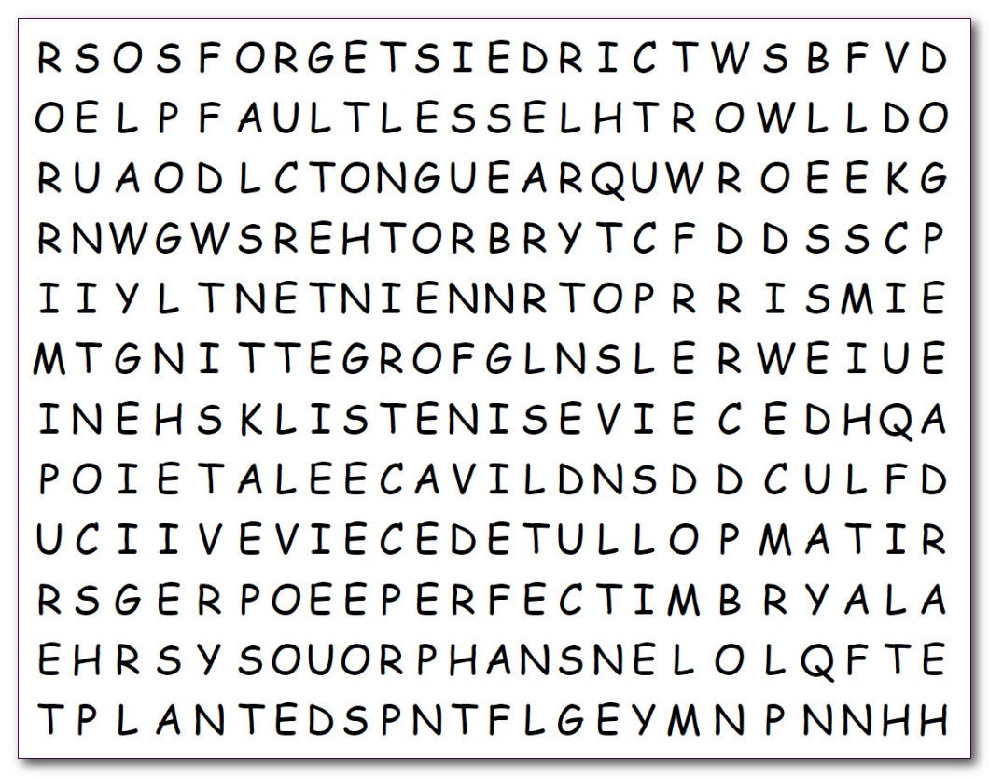
Well, you’re back. Humph! It’s about time. You haven’t done one these assignments for some weeks now. You need to obey these instructions and find the words. My suggestion is just to look at the grid and see what words jump out at you. Then start looking for the ones on the list you haven’t found yet. Remember they go in all directions. If you wimp out, there’s help at https://tinyurl.com/2sv2x4jp And for you people in the front corner, there’s the crossword.

