1. Motivate

What’s a memorable celebration you’ve been a part of?
- Olympics,
- Independence Day,
- birthday,
- wedding,
- dedication of a building,
- a festival or fair,
- religious celebration
- retirement party
- graduation

2. Transition

Today we study Nehemiah and the people praising God.
- With God’s help they had completed the wall
- Serving God includes celebrating His great work.

3. Bible Study

3.1 Repentance and Celebration

Listen for a shift in emotions.

Nehemiah 8:9-12 (NIV) Then Nehemiah the governor, Ezra the priest and scribe, and the Levites who were instructing the people said to them all, "This day is sacred to the LORD your God. Do not mourn or weep." For all the people had been weeping as they listened to the words of the Law. 10 Nehemiah said, "Go and enjoy choice food and sweet drinks, and send some to those who have nothing prepared. This day is sacred to our Lord. Do not grieve, for the joy of the LORD is your strength." 11 The Levites calmed all the people, saying, "Be still, for this is a sacred day. Do not grieve." 12 Then all the people went away to eat and drink, to send portions of food and to celebrate with great joy, because they now understood the words that had been made known to them.

How had the people responded to the reading of the Word of God by Ezra and the Levites?
- initially they were grieving, mourning
- they were struck by the reality of the Truth from God’s Word
- in the history of the nation, there was sin
- that sin had been ultimately punished by the defeat of the nation, the exile
- they realized how much had been lost by disobedience of God

When has a truth from Scripture really resonated with you?
- a specific sermon
- a special service at church camp
- when reading a passage, the verse seems to jump up and slap you in the face
- God speaks through the passage to convict or encourage or challenge

What did Nehemiah, Ezra, and the Levites tell the people they should do instead? Why?
- this is a sacred, a special day
- go enjoy a banquet
- share your food
- celebrate the joy of the Lord … it is your strength
- realize God’s blessings and celebrate them

In what way can the grief of repentance lead you to the joy of celebration?
- burden of guilt is lifted
- realization of God’s forgiveness
- knowledge of God’s power now at work in your life
- set free from sin’s penalty and sin’s power

How can the joy of the Lord be our strength?
- the joy of God’s forgiveness, God’s power at work … this is the strength with which you can live victoriously
- joy of new found power in your life
- you are saved not only from the penalty of sin, but rescued and set free from the power of sin over you
- the joy you have when you realize you can live a life that glorifies God
- realization of newfound strength to serve and minister

When has knowing this kind of joy from the Lord provided you strength and refuge during a difficult time?
- peace and assurance that God is at work, no matter what is happening
- realization that God is in charge, He will accomplish His good purposes for us
- remembering God’s power, authority, and His love for you
- verses like, “If God be for us, who can be against us?” … no one!
- it’s like you hang on to such a verse like a drowning person with a life preserver

3.2 Celebrate for What God Has Done

Listen for who was hired.

Nehemiah 12:27-29 (NIV) At the dedication of the wall of Jerusalem, the Levites were sought out from where they lived and were brought to Jerusalem to celebrate joyfully the dedication with songs of thanksgiving and with the music of cymbals, harps and lyres. 28 The singers also were brought together from the region around Jerusalem--from the villages of the Netophathites, 29 from Beth Gilgal, and from the area of Geba and Azmaveth, for the singers had built villages for themselves around Jerusalem.

Why were the Levites sought out and brought to Jerusalem?
- for the dedication of the completed city wall
- help celebrate joyfully
- participate in the musical portions of the celebration

What has the Lord done in your life recently that motivates you to praise Him?
- physical recovery, healing
- a young child who made their first profession of faith
- a teen who got right with God and straightened out his/her life
- new believers who joined the church
- provided a job
- a financial need was provided for
- as a church, celebrate a new facility
- celebration of Christmas, Easter
- one of your children finished well in a very hard school class

What were the specific ways praise and thanksgiving were expressed to the Lord?
- singing
- instrumental music
- songs of thanks giving
- the gathering of skilled singers – no monotone or off key singers for praising God

Verse 27 says they celebrated with gladness, thanksgiving, and singing. In your own words, describe what the people of Jerusalem had to be thankful for and glad about at that time.
- they had been set free from exiled captivity
- they got to return to the land of their ancestors (this was 70 years after the initial exile … essentially 2 generations)
- they got a fresh start
- they had finished the wall in 52 days
- they had done this in the face of local opposition and physical threats
- they had dealt with their own sin, they had confessed and repented
- God had protected and provided

Why was celebrating God’s faithfulness important for the people?
- they realized they could not have done these things without God’s help
- they had to admit that despite their own sin of unfaithfulness, God was still faithful
- God has done amazing things – we need to praise, worship, and thank Him

Why is it important for us, today?
- all exactly the same reasons
- despite our sinful actions and attitudes, God forgives and restores
- He deserves our praise and worship
- we can/should celebrate His power, His authority, His love at work in our lives

3.3 Purified Worship

Listen for preparations made.

Nehemiah 12:30-31a. 38, 40, 43 (NIV) When the priests and Levites had purified themselves ceremonially, they purified the people, the gates and the wall. 31 I had the leaders of Judah go up on top of the wall. I also assigned two large choirs to give thanks. One was to proceed on top of the wall to the right … 38. The second choir proceeded in the opposite direction. I followed them on top of the wall together with half the people. … 40 The two choirs that gave thanks then took their places in the house of God; so did I. … 43 And on that day they offered great sacrifices, rejoicing because God had given them great joy. The women and children also rejoiced. The sound of rejoicing in Jerusalem could be heard far away.

So, what were the preparations made for the dedication?
- purified themselves ceremonially
- purified the people
- purified the gates and the wall

At first thought, it would seem that sacrifice and purification don’t go with celebrating and giving thanks. They seem out of place. Why not?
- God desires joyful hearts and grateful spirits,
- He also desires holiness – uniqueness, distinctiveness, separation from sin
- The people of Jerusalem were doing just that. They were cleansing themselves.
- They desired to worship and celebrate the Lord with clean hands and pure hearts.
- They sought to remove idols and pride and ungratefulness and doubt.
- Before they celebrate rightly, the people must realign and refocus their hearts because God desires pure and genuine worship.

What are some typical (not so great) ways that we approach a Sunday worship service?
- mad dash in the car, barely make it on time
- yelling at kids for their foolishness and slowness
These two points might be given as lecture
- joking and talking about weekend football games
- corralling the kids and getting them in place in your usual pew

In the context of what we see the people of Jerusalem purifying themselves for worship, what are some better ways we might approach a Sunday worship service?
- prepare the night before to be on time and in a frame of mind to focus on God
- pray for those who minister … in music, in teaching, in preaching
- be praying for those present who need a touch from God … for salvation, for deliverance, for encouragement

What elements of the celebration and dedication here by Nehemiah should mark the worship of New Testament believers?
- singing, instrumental music, parades
- hearing God’s Word, God’s Truth being proclaimed
- group picnics, feasts
Use the last page as a handout so your learners can take home the application points of this week’s lesson.
- times of prayer and dedication
- honoring those who have served the Lord
- honoring those who have served our country
Application
Confess.
- Write down any unconfessed sin. Reflect on how this sin offended God.
- Repent and thank God for His forgiveness in Christ.
- Shred or burn the paper as an act of joy.

Talk.
- Talk with a friend, family member, or acquaintance who recently had reason to celebrate.
- Talk about the work and presence of God in what he or she experienced.
- Share a moment of joyful thanksgiving with him or her.

Invite.
- Invite a neighbor or coworker to your home for dinner, someone who has never been to your home.
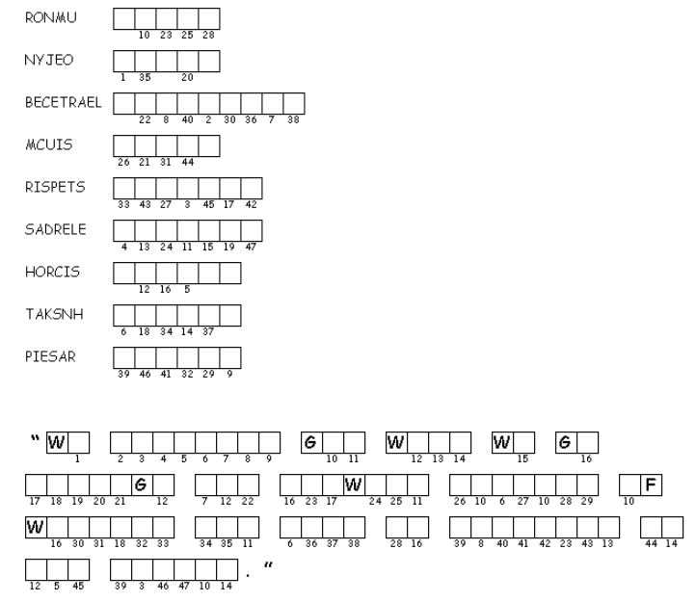

- Make a lavish dinner and demonstrate God’s joy in your extravagance.
This is an important statement about praise and worship by the well-known pastor, John Piper. Unscramble each of the clue words. Copy the letters in the numbered cells to other cells with the same number. Hint, the words come from our passage, Nehemiah 8:9-12; 12:27-31a (NIV) If you get stuck, the solution is at https://tinyurl.com/y9cgzuac
If you’d rather do the crossword, you can find it there too with other Family Activities

