1. Motivate
A video introduction to the lesson is available. View at https://watch.liberty.edu/media/t/0_ylgfykb7
How do the people you love (whether close friends, spouse, or family members) know that you love them?

2. Transition

Jesus spoke to the issue of how to love.
- He said we should base every relationship on the unconditional love He has for us
- Jesus challenges us to let love permeate every relationship.

3. Bible Study

3.1 Grounded in God’s Love

What kind of skill have you learned by watching someone else repeatedly perform the skill?

How was this method of learning more effective than just reading a book about the skill?

Listen for How Christ teaches us by His example.

John 15:9-10 (NIV) "As the Father has loved me, so have I loved you. Now remain in my love. 10 If you obey my commands, you will remain in my love, just as I have obeyed my Father's commands and remain in his love.

How does Christ teach us by example?

What appeal to the disciples (and to us) did Jesus make in these verses?

What evidence does Jesus mention about abiding in Christ’s love?

How would you describe the connection between “remaining in love” and “obeying commandments”?

How do we sometimes miss the connection between love and obedience?
What does this passage tell us about God’s design for our class, our church?

3.2 Imitate Jesus’ Love For Us

Listen for how to love others.

John 15:11-12 (NIV) I have told you this so that my joy may be in you and that your joy may be complete. 12 My command is this: Love each other as I have loved you.

What is the antecedent to the pronoun “this” (NIV) or the words “these things” (KJV) in verse 11?

What was the standard Jesus gave for His disciples to use in measuring their love?

So, what does it look like to love others in the same way Jesus has loved us?

How have you experienced the joy of someone showing love to you during the recent pandemic?

When do you struggle with loving others the way Jesus has loved you?

According to verse 11, if we truly love and obey then God’s joy is within us, it is a completed joy. In what ways does this happen? How is God’s joy manifested in you? How is it made complete?

3.3 Love for Others Means Sacrifice

Listen for sacrifice.

John 15:13-14 (NIV) Greater love has no one than this, that he lay down his life for his friends. 14 You are my friends if you do what I command.

According to Jesus, what was the greatest act of love?

What does it mean for a person to lay down his life?

What does it mean to be friends with Jesus? How do we show we are His friends?

When have you experienced the power of sacrificial love?

What opportunities do you have to “lay down your life” for others? What does it look like to love others the way Jesus loves us?

Application
Give a small gift.
- Give an unexpected gift to someone who needs it.
- Attach this simple note: Thank you for playing an important role in my life.”

Reach out.
- Think of a relationship that has become stale, or even hostile.
- Make a phone call to see if you can revive or refresh that connection.

Make a major sacrifice.
- Think of something that hinders your closest relationships—golf clubs, salon appointments, cable TV, a car payment, and so on.
- Then get rid of it!
Crossword Puzzle
Clues and words taken from John 15:9 – 14 (NIV)


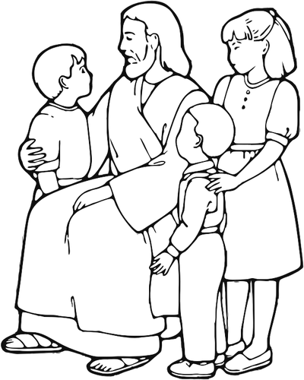

Across
2. if you _?_ my commands
5. so my _?_ may be in you
6. As the _?_ has loved me
8. my friends if you do what I _?_
9. lay _?_ his life
12. _?_ love has no one than this
14. my command is _?_, love each other

Down
1. your joy may be _?_
3. as I have loved _?_
4. so I have _?_ you
7. _?_ in my love
10. love each _?_
11. lay down his life for his _?_
13. I have _?_ you this

