1. Motivate

When have you been surprised to run into someone unexpectedly?
- met a classmate on vacation you hadn’t seen since graduation
- crossed paths with a relative in an airport
- end up in the same business meeting with a former work mate
- went to a concert and ended up sitting with an old friend
- got to meet a popular celebrity in a restaurant
- ran into an old girlfriend/boyfriend and your spouse wondered why you’d ever be attracted to that person

2. Transition

Today we look at how Jesus’ followers were surprised on Easter morning.
- They were surprised by the empty tomb, and then by the appearance of Jesus
- Because of who they saw and heard and spoke to in person, we can be confident of the reality of the resurrection.
A video introduction is available to view at https://watch.liberty.edu/media/t/1_ue27kebc If you have no wi-fi where you teach, best to download to your compute from https://tinyurl.com/2s4b3xzu
3. Bible Study

3.1 The Event

Listen for phenomenal events.

Matthew 28:1-5 (NIV) After the Sabbath, at dawn on the first day of the week, Mary Magdalene and the other Mary went to look at the tomb. 2 There was a violent earthquake, for an angel of the Lord came down from heaven and, going to the tomb, rolled back the stone and sat on it. 3 His appearance was like lightning, and his clothes were white as snow. 4 The guards were so afraid of him that they shook and became like dead men. 5 The angel said to the women, "Do not be afraid, for I know that you are looking for Jesus, who was crucified.

If you can mentally place yourself at the tomb of Christ on that first “Easter morning,” what emotions would you be feeling as you approached?
- fear, spooky
- confused, discouraged
- unsure of what is happening

When does it appear the women returned to the tomb?
- first day of the week
- what we know as Sunday

What does the passage say was the reason they returned to the tomb?
- they went “to look at the tomb”

Note: Jesus’ body had been removed from the cross and placed in the tomb late on Friday.
- This was the beginning of the Sabbath
- The tasks to properly deal with the typical burial tasks could not be completed because of the religious rules regarding the Sabbath
- So the women probably were bringing burial spices put around the corpse

What phenomenal events does Matthew describe in this account?
- earthquake
- appearance of the angel
- rolling back the stone
- angel sitting on the stone
- angel’s appearance was bright like lightning

God is at work here in a powerful way. When have you seen the power of God demonstrated?
- weather events … hurricane, blizzard
- God’s protection in dangerous situations (such as in a hurricane or blizzard or other tragedy)
- each spring when things sprout anew
- the miracle of birth
- lives changed after salvation
- God provided a job, finances … just in time … seeming miraculously

What is the significance of the fact that the tomb was already empty when the stone was first rolled away?
- the stoned was not removed so Jesus could come out
- it was rolled away so the women could see in
- they could see that Jesus was not there
- Jesus had already been brought to life and his body removed by the power of God
- no one stole his body and faked a resurrection

The angel had to tell them (as always), “Don’t be afraid.” Why do you think fear is often our first response when we don’t understand something God is doing?
- just because we don’t understand it
- our rational, scientific thinking has to have a reason or explanation
- it can be spooky if it seems to be supernatural, even paranormal
- some people don’t want to admit it was God at work – forces them to accede there is a God who works outside what we consider normal
- we can be surprised (although maybe we shouldn’t be) when God works in ways we don’t understand

3.2 The Evidence Can Be Investigated

Listen for instructions from the angel.

Matthew 28:6-7 (NIV) He is not here; he has risen, just as he said. Come and see the place where he lay. 7 Then go quickly and tell his disciples: 'He has risen from the dead and is going ahead of you into Galilee. There you will see him.' Now I have told you."

What was the message announced by the angel?
- I know you are looking for Jesus, He is not hear, He has risen
- remember He told you so
- come look at the place where He lay
- then go tell His disciples … He will meet you in Galilee

The angel reminded them that Jesus had told them this would happen. Why do you think they needed to be told again? Why do we need to be reminded often of what God wants for us?
- it didn’t sink in
- they didn’t realize what Jesus was talking about … even after His statements about His coming death did happen
- like us, what they didn’t understand, they dismissed it from their thinking

How did the women’s experience at the tomb contrast with what they expected?
What they expected | What actually happened
- the body of their friend  - finish the embalming  - have a good cry  - sorrow together | - empty tomb  - a frightening angel  - proclamation of resurrection  - instructions to go tell others  - prediction they would see Him alive

What were the women invited to do?
- come look at the empty tomb
- look where He lay

What were they commissioned to do?
- go quickly, go tell the disciples
- He is going ahead of you to Galilee
- there you will see Him

How did the invitation and the commission relate to each other?
- they would be eyewitnesses to the empty tomb
- they had seen the tomb become unsealed by the angel
- they would be convinced because they had personal, firsthand experience of the events
- they were given specific details by the angel what had happened and what they were to do

3.3 Share the Good News

Listen for the women’s reaction.

Matthew 28:8-10 (NIV) So the women hurried away from the tomb, afraid yet filled with joy, and ran to tell his disciples. 9 Suddenly Jesus met them. "Greetings," he said. They came to him, clasped his feet and worshiped him. 10 Then Jesus said to them, "Do not be afraid. Go and tell my brothers to go to Galilee; there they will see me."

When the women met the living Jesus, what was their immediate response?
- approached Him
- clasped His feet (a custom of that culture)
- worshiped Him

What words of challenge and comfort did the women receive?
- don’t be afraid
- go and tell my brothers to go to Galilee
- there they will see me

What difference would the certainty that Jesus rose from death make in all their lives?
- energized. gave them a purpose … He actually gave them a task
- the reality of that event would change their whole perspective of life (and death)
- they would gladly do what Jesus said, no matter what … they were convinced
- no one could convince them otherwise
- all that He had taught now took on greater authority, certainty, believability

How can being certain that Jesus rose from the dead make an ongoing difference in our lives?
- we face death differently
- we also have a purpose and direction in life … given Jesus commands after His resurrection
- we have the living Christ’s presence in our lives in the person of the Holy Spirit
- we can be convinced that to believe in Christ is absolute Truth … in contrast to the “many truths” that are declared by the false prophets of today

In what sense are we eyewitnesses to the reality of the resurrection, to new life?
- changed lives when you or people you know come to salvation in Christ
- people who place their faith in Jesus are freed from not only the penalty of sin, but also the power of sin over them
- they receive literally a new life, resurrected, as it were

The women met personally with the Risen Lord. How can we meet personally with the Risen Lord?
- when we read God’s words
Use the last page as a handout so your learners can take home the application points of this week’s lesson.
- when we go to Him in prayer
- when we worship Him, individually or corporately

Application
Realize.
- Thank Jesus for His gift of eternal life, made possible by His victory over death.

Memorize.
- Memorize Matthew 28:6, “He is not here. For he has risen, just as he said. Come and see the place where he lay.”
- Let this verse become a source of joy and strength for you as you seek to follow Jesus daily.

Exercise.
- Share your story of making the decision to follow Jesus with someone you know who is far from God.
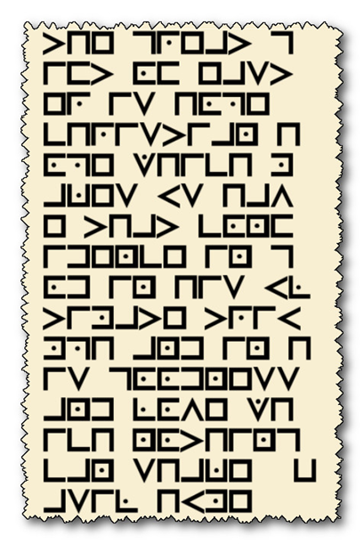
Cryptogram Puzzle

Halt! It is illegal to cross the border of Ribrutanesu with an encrypted message on your person. You must return the decryption to the nearest Baptist church. Our security services have discovered the encryption key below and a sample message. you must take expedite this task before you proceed. Assistance is available at https://tinyurl.com/2s4b3xzu Further Family Activities may also be found.

