1. Motivate

Finish the sentence: “Walk a mile in someone else’s shows, then …”
- you’ll be a mile away from them and you’ll have their shoes
- until then you can’t imagine the smell!
- you might be walking in the wrong direction
- you might understand them better
- until then you don’t have the right to judge them
- you’ll wish you had your own shoes back
- your feet will hurt … they don’t wear the same size
- you’ll realize the kind of miles they must walk

2. Transition

We can better share the gospel when we step into the shoes of others.
- Today we look at Paul’s description of how he adapted to minister to different groups of people
A video introduction to the lesson is available. To view, go to https://tinyurl.com/33a5arwt If you don’t have wi-fi where you teach, you should download the video file to your computer from https://tinyurl.com/mr3b2xja
3. Bible Study

3.1 Commissioned and Compliant

Listen for Paul’s motivation.

1 Corinthians 9:16-18 (NIV) Yet when I preach the gospel, I cannot boast, for I am compelled to preach. Woe to me if I do not preach the gospel! 17 If I preach voluntarily, I have a reward; if not voluntarily, I am simply discharging the trust committed to me. 18 What then is my reward? Just this: that in preaching the gospel I may offer it free of charge, and so not make use of my rights in preaching it.

What words or phrases does Paul write that speak of his motivation to preach or not preach the Gospel? Why must he do it?
- he can’t boast
- he is compelled to preach
- “Woe to me if I do not …”

What two things does he say about preaching and being rewarded?
- if he does so voluntarily, he anticipates a reward
- if not voluntarily, he is simply discharging (exercising) the trust (assignment) committed to him

What does he say about the reward?
- he offers the gospel message free of charge
- he doesn’t want to make use of his rights (a reward) in preaching it

Paul didn’t obey God merely because he had to—he found joy and reward in obedience. What helps move obedience from duty to desire?
- initially you obey and do what God intends for you
- but in your heart of hearts, you wish you didn’t have to be doing it
- as you do continue to obey, you began to realize God is at work in the situation
- even if you continue to be uncomfortable in the task, you are trusting God to accomplish His purposes through your obedience
- by and by you may become more comfortable in the task and realize God is at work

How can obedience still be genuine when we don’t feel enthusiastic about what God is asking?
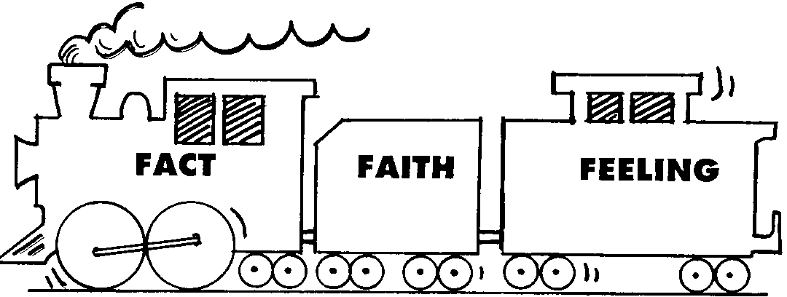
- it’s like the example from Campus Crusade of the old steam train
- it is a fact that God has directed you
- you have chosen to trust God and obey His calling
- you really don’t need the feelings of enthusiasm
- the train must have the engine (faith) and the coal car (faith), but doesn’t really need the caboose (feelings).

At the same time, what is the danger of serving God outwardly while resisting Him inwardly?
- your have the wrong motives, you are not trusting Him
- there’s a difference between not having feelings of enthusiasm and resisting God
- if you are resisting Him, you’ve left off the “coal car of faith”
- think of Abraham taking his son Isaac up the mountain for the sacrifice God declared
- we can imagine he was not feeling too enthused about the task, but he trusted God
- Hebrews 11:17-19 says that if he carried through with the sacrifice, he believed God would bring Isaac back to life

Our study today is speaking to the calling all believers have to be involved in the communication of the Gospel locally, regionally, and around the world.

Why do you think believers sometimes view sharing Christ as an option instead of a command?
- they say, “that’s the preacher’s job”
- they think people today might be offended
- I’m no good at debating unbelievers
- I’d be embarrassed at being rejected
- we shouldn’t be pushy

3.2 Identify and Adapt

Listen for who Paul ministered to.

1 Corinthians 9:19-23 (NIV) Though I am free and belong to no man, I make myself a slave to everyone, to win as many as possible. 20 To the Jews I became like a Jew, to win the Jews. To those under the law I became like one under the law (though I myself am not under the law), so as to win those under the law. 21 To those not having the law I became like one not having the law (though I am not free from God's law but am under Christ's law), so as to win those not having the law. 22 To the weak I became weak, to win the weak. I have become all things to all men so that by all possible means I might save some. 23 I do all this for the sake of the gospel, that I may share in its blessings.

How did Paul make adjustments to increase his effectiveness in sharing the gospel?
- to Jews became a Jew
- to those under the law, he observed the law (even though he knew his salvation did not depend on the law)
- to a Gentile (who would not observe the law), he did not observe the law
- to weak, he went along with their views

Why did he do so?
- he was not dogmatic about specific issues
- so he could get along with all kinds of folks
- so they would pay attention to him concerning salvation in Christ

How might Paul act in order to have opportunity to minister to Jews?
- participate in Jewish holidays
- observe Sabbath
- observe food restrictions

How might Paul act in order to have opportunity to minister to Gentiles?
- not observe Jewish restrictions on days and foods
- go with them to secular entertainment
- be knowledgeable about their religions
- be interested in their activities, even if particularly non Jewish in nature

What is the difference between relating to those around you and compromising God’s values?
Relating | Compromising
- goal is to gain a hearing for the gospel  - ultimate goal to win them to Christ  - free to act as a strong man for Christ, submitting to weaknesses and sensitivities of others | - hypocrisy  - vacillation  - weak capitulation to pressure from others

3.3 Discipled and Diligent

Listen for sports analogies.

1 Corinthians 9:24-27 (NIV) Do you not know that in a race all the runners run, but only one gets the prize? Run in such a way as to get the prize. 25 Everyone who competes in the games goes into strict training. They do it to get a crown that will not last; but we do it to get a crown that will last forever. 26 Therefore I do not run like a man running aimlessly; I do not fight like a man beating the air. 27 No, I beat my body and make it my slave so that after I have preached to others, I myself will not be disqualified for the prize.

What does faithful living require of the believer?
- strict training
- purposeful training
- goal oriented
- not aimless activity
- organized training

What is the promise given to those who live by disciplined faith?
- a crown that will last forever
- eternal rewards
- eternal life – union with God, Himself … now and beyond the end of life

Where are some areas in our lives where we might realize the need for discipline and self-control in your life?
- Bible reading, prayer time
- set aside TV watching, limit time on social media
- evaluate what are priorities in my life – where I spend time, money, energy
- more faithful church attendance
- involvement in church ministries
- careful not to become a work-a-holic

How could our church make adaptations so we can “step into the shoes of others” to gain a greater hearing of the gospel?
- backyard Bible Clubs in different neighborhoods
- visit and enjoy hospitality at each other’s homes (look up Josh Hunt’s “Friday Nights for Jesus” https://www.joshhunt.com/give-friday-nights-to-jesus/
- sponsor a Christian movie in the park during the summer – meet new people, they meet you
- set up a booth at a local town/neighborhood festival – hand out a free item and meet new people
- teens visit elderly neighbors who might need help with yardwork or other chores
- offer mother’s day out services once or twice a month
- set up a booth at local sports activities with inexpensive tail-gate refreshments in the parking lot
Use the last page as a handout so your learners can take home the application points of this week’s lesson.

Application
Pray.
- If you’re afraid, ask Jesus to take away your fear so that you can tell others about Him.
- Learn 15 second testimony https://tinyurl.com/5emdvbns

Learn.
- One way I’ve found to overcome the fear of witnessing is to learn how to do so effectively by asking someone who is consistent and confident.
- Ask them to show you how to share the gospel confidently and effectively.

Share.
- When you see an opportunity, take the leap and share the life-changing truth of the gospel.
- Discipline your heart and mind to look for and respond to those divine opportunities to share Jesus with others.
Fallen Phrases Puzzle
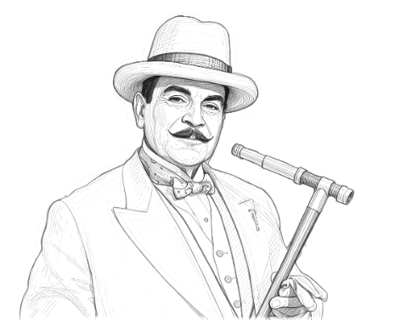


Mes amis, this decoding form was prepared with great care by our devoted team of decryptors. Alas, the adhesive used for the individual letters was… how shall I say… of a most inferior quality. The letters have fallen—straight down, yes—but certainly not in the correct order. To complicate matters, our loyal workers have departed for Disney World for the President’s Day holiday. Therefore, it is to you that I must turn. Begin, if you please, with the single fallen letters—they are simplicity itself. Then apply your little grey cells to the shorter words, selecting the letters that form sensible and proper words. When the task is complete, kindly forward your results to your church outreach pastor. Order, you see, must always be restored. Technical assistance will be provided at https://tinyurl.com/mr3b2xja . Other Family Activities may also be found.

