1. Motivate

What are some ways you can show others they are valued?
- a thank you note
- give them an award
- throw a party
- a special gift
- tell them specifically what it is you appreciate
- do something nice for them
- bake a cake with “thank you” on the icing
- give them a raise in pay
A video introduction is available. View it at
https://watch.liberty.edu/media/1_zvmdyns5 If you have no Wi-Fi where you teach, best to download to your computer from https://tinyurl.com/y4426dnk
- give them a promotion
- give words of praise and encouragement
- give them more authority

2. Transition

We show honor and respect to those who deserve it.
- God honors and respects all life.
- We are called to honor and respect human life as God does.

3. Bible Study

3.1 Human Life Is Precious to God

Listen for God’s attitude toward human life.

Exodus 20:13 (NIV) "You shall not murder. Matthew 5:21-22 (NIV) "You have heard that it was said to the people long ago, 'Do not murder, and anyone who murders will be subject to judgment.' 22 But I tell you that anyone who is angry with his brother will be subject to judgment. Again, anyone who says to his brother, 'Raca,' is answerable to the Sanhedrin. But anyone who says, 'You fool!' will be in danger of the fire of hell.

What is the intent of this commandment?
- to protect life that God has created
- life is a gift from God
- we are to treat life as God’s gift
- someone else is not to take it away arbitrarily

Why would violating it be an affront to God?
- we assume the authority that only God is to have
- a life that God has created is precious
- to take away that life is to take away someone who is precious to God

What are some ways our culture devalues human life?
- indiscriminate killings
- drive by shootings
- abortions
- human trafficking
- destroying another person’s reputation for personal gain

According to Jesus, what is behind the physical act of murder that we are to avoid as much as the physical action?
- anger and hate
- destroying their reputation
- demonstrating violent attitudes
- verbal assaults on another person
- the belittling of that person (to them or to others)

Jesus talks about calling people names or making derogatory comments. Using terms like “fool” or “moron” may have lost the cultural impact or implication it did in Jesus day. What modern-day equivalents to "Raca" does our society level at others?
- making accusations to one’s parentage, racial slurs
- vulgar sexual related accusations or comments
- obscene gestures
- lewd, rude, vulgar remarks made in anger
- gender put downs
- hateful comments meant to be overheard or meant to get back to someone
- political mud-slinging
- verbal abuse of a child or a spouse
- starting rumors to bring harm to someone’s reputation

What are some of the negative consequences of these expressions of anger in our culture?
- messed, dysfunctional up families
- divorces
- race relations
- family violence, domestic disturbances
- shootings
- gang violence
- actions against police

Why do you think Jesus zeroed in on the emotions behind our violent words and actions?
- Jesus wanted to deal with root cause
- dealing with symptoms (a bad cough) does not deal with the problem (pneumonia)
- what comes out of our mouths or actions of violence only reveal the problems in our hearts and minds
- it’s the anger and hate that is the problem, not the words or actions alone

3.2 God Has Authority over Life

Listen for David’s encounter with Saul.

1 Samuel 26:7-11 (NIV) So David and Abishai went to the army by night, and there was Saul, lying asleep inside the camp with his spear stuck in the ground near his head. Abner and the soldiers were lying around him. 8 Abishai said to David, "Today God has delivered your enemy into your hands. Now let me pin him to the ground with one thrust of my spear; I won't strike him twice." 9 But David said to Abishai, "Don't destroy him! Who can lay a hand on the LORD's anointed and be guiltless? 10 As surely as the LORD lives," he said, "the LORD himself will strike him; either his time will come and he will die, or he will go into battle and perish. 11 But the LORD forbid that I should lay a hand on the LORD's anointed. Now get the spear and water jug that are near his head, and let's go."

What was Abishai's reaction when he and David found Saul's entire camp asleep?
- God has solved your problems
- let me get rid of Saul with one spear thrust
- This is God's opportunity to you
- we can be done with being chased by Saul

Agree or disagree … “David had the right to kill Saul.”
Agree | Disagree
- Saul was trying to kill him  - Saul had repeatedly gone back on his promises to cease and desist  - David had already been declared to be the next king | - for the moment, Saul was the king God had put in place  - it was not David’s place to remove a king, it was God’s  - they were both Israelites, both of the same nation

How did David’s refusal to act with violence against Saul demonstrate respect for human life?
- it is God who made him king
- it must be God who ends his life, who ends his reign as king
- it is not the role of one man assume the authority of God over the life of another

Why isn’t it wise to take every opportunity we are given for personal advancement and advantage?
- the action might be contrary to God’s principles
- it might also be against God’s will for the current situation
- what looks good at the moment may have bad long range implications
- you need to consider whether or not you’re trying to take the control of things out of God’s hands into your own hands

What else can we learn from David’s words and actions in this passage?
- what appears to be God’s providence might not be
- don’t yield to the temptation to set aside what you know is the right thing to do
- sometimes you are confronted with a big temptation to violate what you know is right
- it’s not our place to destroy someone … either their life or their reputation
3.3 Treat Every Life as Equally Valuable

Listen for David’s interchange with Saul

1 Samuel 26:22-25 (NIV) "Here is the king's spear," David answered. "Let one of your young men come over and get it. 23 The LORD rewards every man for his righteousness and faithfulness. The LORD delivered you into my hands today, but I would not lay a hand on the LORD's anointed. 24 As surely as I valued your life today, so may the LORD value my life and deliver me from all trouble." 25 Then Saul said to David, "May you be blessed, my son David; you will do great things and surely triumph." So David went on his way, and Saul returned home.

Even if Saul continued to pursue David, what confidence did David express in the Lord?
- God rewards each person for their righteousness and faithfulness
- God delivered you into my hands today
- remember that I valued your life today
- God will value my life
- God will deliver me from all trouble

What did David affirm yet again he would not do to Saul?
- he had not attacked “the Lord’s anointed”
- he would not attack him

What were Saul’s parting words to David?
- may you be blessed, “my son”
- you will do great things, you will triumph

What is the significance of Saul’s statement to David?
- Saul seemed to realize the inevitable
- he knew deep in his heart that David would be king and would do well
- he knew that he, himself, had done wrong … had had the wrong attitude towards David
- it was sort of a confession

In this situation, David showed that he valued life. Where do you currently have opportunities to lift up the value of life?
- opposing abortion
- praying for protection of those whose lives are in danger for their ethnicity or their beliefs
- supporting adoption
- opposing human trafficking
- supporting ministries to people who are fighting against addiction
- supporting ministries to recovering addicts

What can you do to affirm someone who is struggling to understand that he or she has value in God’s sight—and in yours as well?
Use the last page as a handout so your learners can take home the application points of this week’s lesson.
- encouragement, mentoring
- prayer
- supporting ministries to those struggling in these situation
- affirming their lives by support
Application
Check your attitude.
- If you privately consider some people more important than others, confess that to God and repent.
- While the world deems countless people as inferior or less important, we are called to see all people as God sees them.

Check your words.
- Examine your involvement in devaluing life through the words you speak to others or about others.
- Words of anger, malice, bitterness, or even apathy do not honor the lives of those God loves.
- Repent and determine to speak only those words that build others up.

Check your actions.
- Look for concrete ways you can affirm the value of life in your spheres of influence.
- Practical actions can include counseling at a pro-life pregnancy center, helping a parent with a disabled child, bringing joy to the forgotten in a nursing home, or engaging with the work of praying for and supporting the persecuted.
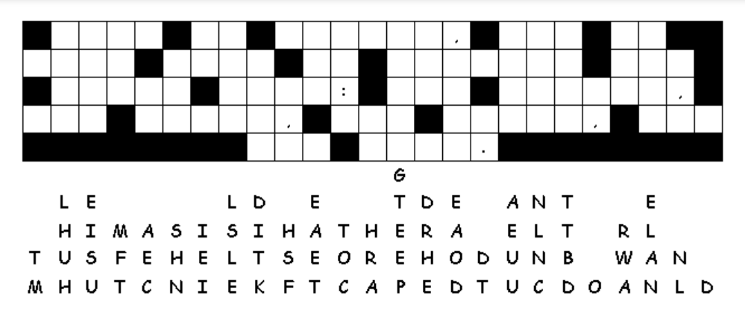Fallen Phrases
My diagnosis is that this textual failure has resulted from letters falling straight down in columns. Work on the two and three letter words first to see what letter combinations make sense. Then figure out the longer words. Beware of the infection of punctuation marks. If you get stuck go to https://tinyurl.com/y4426dnk . You’ll find other healthy Family Activities there also!

