1. Motivate

“If you were on a jury, what would make you trust one witness more than another?”
- if their story agreed with other witnesses – consistency of testimony
- their appearance … shifty eyed, sneaky looking vs plain, every-day person, well dressed
- they explain well what they knew or saw or heard
- how they dressed
- how they answered – straight forward or evasive – credible or not
- had all their facts in good order
- how they stood up to cross examination
A video introduction to the lesson is available. View it at https://tinyurl.com/48k2a8m7 If you don’t have wi-fi where you teach you must download the video file to your computer from https://tinyurl.com/4xbvx46e

2. Transition

Today we look at Jesus’ testimony before the leaders of the day.
- He told them they were ignoring the truth right before their eyes.
- He gives them evidence that He is the Messiah.
- We will consider how we respond to Jesus authority in our lives.

3. Bible Study

3.1 The Expert Witness: The Son’s Word and Authority

Listen for an assassination plan.

John 5:17-20 (NIV) Jesus said to them, "My Father is always at his work to this very day, and I, too, am working." 18 For this reason the Jews tried all the harder to kill him; not only was he breaking the Sabbath, but he was even calling God his own Father, making himself equal with God. 19 Jesus gave them this answer: "I tell you the truth, the Son can do nothing by himself; he can do only what he sees his Father doing, because whatever the Father does the Son also does. 20 For the Father loves the Son and shows him all he does. Yes, to your amazement he will show him even greater things than these.

What words and phrases point to as the source of Jesus’ power to act?
- the Son can do nothing by Himself
- Jesus did nothing by Himself (as a human)
- He does what He sees the Father do
- His power comes from the God the Father

What can we learn from the fact that the Son gives life to “whom He wishes” or “to whom He is pleased to give it”?
- Jesus is pleased to give new life, spiritual life, eternal life to all who believe
- Consider 2 Peter 3:9 (NIV) The Lord is not slow in keeping his promise, as some understand slowness. He is patient with you, not wanting anyone to perish, but everyone to come to repentance.
- We see agreement among the members of the Trinity – both the Father and the Son desire to give spiritual life to all people

What did Jesus say that suggests what the Father does through the Son is not limited? What was at least one greater work that the Son would do?
- you will be amazed
- even greater things than this healing God will do
- God the Father has/will raise people from the dead
- God the Son gives life to whom He is pleased to do so
- be raised from the dead

Note how the courtroom image of an expert witness helps us understand Jesus’s relationship with the Father and His authority over all.
- Jesus acts only with/by the authority/direction of God the Father
- God the Father will speak
- Those who hear/listen will live
- The Father has life in Himself
  - Elohim, God of all creation complete in and of yourself.
  - El Shadday the unmoving, unwanting changeless enduring all-powerful GOD.
- Jesus given the authority to judge
- Jesus sought not to please Himself but to please the Father
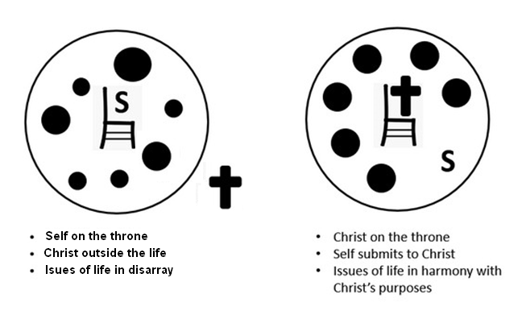
In what ways does this challenge modern notions of individual autonomy?
- humanism establishes man to be the deity in charge
- men choose what is “truth”
- we like to think we can run our own lives
- reality is when we run our own lives, we end up with “a big mess”

How can we join God and participate in His work?
- be convinced/convicted of God’s power, authority, and love for us
- listen to, heed God’s direction
- become involved in ongoing outreach of the church
- involvement in various church ministries – music, multi-media, greeting, prayer ministry, outreach, teaching, children’s ministries, office help

3.2 The Corroborating Witnesses: John the Baptist, Works, the Father, Scripture

Listen for three witnesses.

John 5:31-40 (NIV) "If I testify about myself, my testimony is not valid. 32 There is another who testifies in my favor, and I know that his testimony about me is valid. 33 "You have sent to John and he has testified to the truth. 34 Not that I accept human testimony; but I mention it that you may be saved. 35 John was a lamp that burned and gave light, and you chose for a time to enjoy his light. 36 "I have testimony weightier than that of John. For the very work that the Father has given me to finish, and which I am doing, testifies that the Father has sent me. 37 And the Father who sent me has himself testified concerning me. You have never heard his voice nor seen his form, 38 nor does his word dwell in you, for you do not believe the one he sent. 39 You diligently study the Scriptures because you think that by them you possess eternal life. These are the Scriptures that testify about me, 40 yet you refuse to come to me to have life.

Note the three witnesses Jesus referenced. John the Baptist, Jesus’ own works, God the Father.

In what way did John the Baptist prepare people to recognize Jesus? Why was his testimony significant to that audience?
- John’s testimony was true
- John received God the Father’s Truth
- he shared the “light” that God the Father gave him
- his uniqueness, eccentricity attracted people to what he had to preach

What are some examples of Jesus’ “works” (miracles or actions)? How do these serve as evidence of His authority?
- healings, water to wine, casting out demons, stilling the stormy sea
- preaching, answering challenges from the religious leaders
- all these showed His power over nature, power over evil spiritual forces

What events can you think of that speak to how God the Father bore witness to Jesus?
- the events of Jesus’ birth
- the voice when John baptized Jesus
- the experience of the three disciples on the mountain when Jesus was transfigured shining and blazing white and God spoke “This is My Son …”

If someone questioned Jesus’ authority today, how could you point to these same three witnesses as evidence?
- even though people claim these “witnesses” were just myths …
- there were multiple people who saw and heard these events
- the four gospel authors agree
- those peoples’ lives were changed as they experienced those witnesses
- peoples’ lives are still being changed by the Truth of the Gospel message

3.3 The Verdict of Rejection: Ignoring the Witness, Rejecting Christ

Listen for Jesus’ verdict.

John 5:41 – 47 (NIV) 41 "I do not accept praise from men, 42 but I know you. I know that you do not have the love of God in your hearts. 43 I have come in my Father's name, and you do not accept me; but if someone else comes in his own name, you will accept him. 44 How can you believe if you accept praise from one another, yet make no effort to obtain the praise that comes from the only God? 45 "But do not think I will accuse you before the Father. Your accuser is Moses, on whom your hopes are set. 46 If you believed Moses, you would believe me, for he wrote about me. 47 But since you do not believe what he wrote, how are you going to believe what I say?"

According to verse 43 - 44, whose approval are the people seeking instead of God’s?
- humans come along with a good story or idea
- people are quicker to accept human ideas that what God has to say
- you accept praise from one another
- you make no effort to receive God’s praise and blessing

Note the warning Jesus gave about accepting others while rejecting Him.
- Jesus says it won’t have to be He who accuses at the judgment
- It will be Moses … they set their hopes on him
- But he will see that they have rejected God
- If they believed Moses, they should believe Jesus
- In reality they have believed neither Moses nor Jesus

What does it mean to “not have the love of God” in you (v. 42)? How is that connected to rejecting Jesus?
- it’s not that God doesn’t love them, it’s that they don’t love God
- they/we have other things in their/our lives that are more important than God is
- idols can be other than a figurine that you bow down to
- idols can be our material stuff, money, relationships, popularity, power
- even as believers, we are tempted with these kinds of idols

Why do you think people sometimes reject truth even when there is strong evidence?
- they don’t like the Truth, they have their own agenda to follow
- they don’t want to give up those things that Truth speaks to
- they want to control their own lives, not willing to admit they are wrong

How can we guard against becoming familiar with Scripture but failing to truly believe and follow Christ?
- do more than just read scripture to say “yes, I’ve read the whole Bible”
- think about what it says, what it means, how it applies to your life right now
- admit, confess when you realize sin in your life, agree with God that it is sin
- repent from it, turn around the direction of your life
- surrender that area of your life to God’s authority and direction
Use the last page as a handout so your learners can take home the application points of this week’s lesson.

Application
Submit to authority.
- Reflect upon areas of your life where you have not submitted to God’s authority.
- Consider the difference it would make if you did so today.
- Write those things down and surrender them to Him.

Share gratitude.
- Gratitude helps with moments of skepticism.
- Share with your group or a friend, things you are grateful for in your life.
- Be sure to direct the thanks to God.

Celebrate with others.
- Find a way to celebrate with someone in your group or family, something that the Lord has done recently in his or her life.
- Spend time worshiping God for His faithfulness.
Fallen Phrases Puzzle
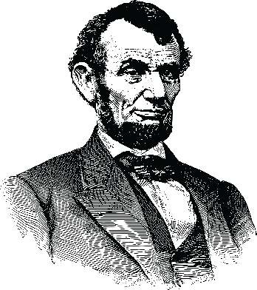



This word of encouragement comes to us from a humble church, situated upon the border that once marked the division of our nation. By an untimely and wayward storm, certain letters on the billboard have been cast down and disordered among their columns, and the civil authorities, not yet restored to their proper function, are unable to render aid. Therefore, we earnestly appeal to all who are able, that they might give their attention to this matter, and, in so doing, fix our hearts and minds upon the power and sovereign authority of Almighty God in these uncertain times. Reasonable assistance and additional enlightening Family Activities can be found at https://tinyurl.com/4xbvx46e

