1. Motivate

What area of your house tends to collect clutter the fastest?
- garage
- kitchen counter
An introductory video for the lesson is available. Go to https://watch.liberty.edu/media/t/1_brcix8bs to view. If you have no wi-fi where you teach, you should download the video file to your computer from https://tinyurl.com/2hvzywzv
- refrigerator
- back seat of the car
- workbench
- top of the bedroom bureau
- closet

2. Transition

Consider that our lives can become cluttered spiritually.
- That’s what happened to the Temple in Jerusalem when Jesus attended Passover.
- Clutter for them and for us can crowd out genuine worship.

3. Bible Study

3.1 Jesus Cares About True Worship.

Listen for mayhem.

John 2:12-17 (NIV) After this he went down to Capernaum with his mother and brothers and his disciples. There they stayed for a few days. 13 When it was almost time for the Jewish Passover, Jesus went up to Jerusalem. 14 In the temple courts he found men selling cattle, sheep and doves, and others sitting at tables exchanging money. 15 So he made a whip out of cords, and drove all from the temple area, both sheep and cattle; he scattered the coins of the money changers and overturned their tables. 16 To those who sold doves he said, "Get these out of here! How dare you turn my Father's house into a market!" 17 His disciples remembered that it is written: "Zeal for your house will consume me."

What do you notice about what was happening in the temple when Jesus arrived?
- men selling cattle, sheep, doves for sacrifices
- people who traveled long distances would purchase rather than herd them to Jerusalem
- men exchanging money to local (temple) currency

What does Jesus actually do?
- made a whip out of cords
- drove all the commerce out of the temple courts
- drove the animals out
- scattered coins of the money changers
- upset their tables

What words does He use?
- get these out of here
- how dare you!
- you’ve turned “my Father’s house” into a market

The temple was supposed to represent a specific location that was identified with the very presence of Jehovah God. How did this offend Jesus, the Son of God?
- cheapened their concept of God
- altered the purpose of the sacrifice system – ended up a commercial enterprise
- those who sold and did money changing often scammed/cheated the worshipers
  - if they brought an animal it was rejected, not suitable, as having a flaw,
  - then they were forced to buy one (probably surreptitiously one that had been previously rejected)
  - exorbitant exchange rates were charged

Why does Jesus call it “My Father’s house”? What does that reveal about Him?
- by claiming that God was His Father
- His statement implies His position
- He was the Son of God

How can religious activity ever become a distraction for us from actually honoring God?
- we get busy with all the details
- the decorations have to be just so
- the choice of music is debated
- we over worry about what to wear (or what other people wear or don’t wear nice enough)

What would “reverence” and “awe” in worship look like today?
- pay attention to the meanings of the hymns, anthems, choruses
- focus on who God is, His power, authority, and love for us
- see His holiness (separate from who and what is common)
- see the contrast of our own failings

3.2 Jesus Speaks with Divine Authority.

Listen for a curious response.

John 2:18-19 (NIV) Then the Jews demanded of him, "What miraculous sign can you show us to prove your authority to do all this?" 19 Jesus answered them, "Destroy this temple, and I will raise it again in three days."

After Jesus cleanses the temple, the Jews immediately ask for a sign. Why do you think they did that?
- this was an important business (the priests may likely been receiving a percentage of the gross)
- Jesus was upsetting the status quo … who did He think He was to mess with these important men in charge
- they wanted to get rid of this person causing mayhem
- they likely believed he DID NOT have any such authority, this was how they initiated an arrest

Why DID Jesus have the right to act the way He did in the temple?
- the Temple was considered the place within Israel where Jehovah God’s presence dwelled
- Jesus knew that this profaned that presence
- it was actions that took God’s Name in vain … not speech, but actions
- Jesus was doing away with the activities that mocked the spiritual significance of the Passover celebration
- you might even imagine that any righteous Jewish person had the right, even the responsibility to correct such profane activities

What does this statement reveal about Jesus’ identity?
- He was implying strongly that He did have the authority
- Even with the religious leaders inferring He was speaking of the physical temple
- He claimed something that seemed impossible (even if you understood what He was really meaning)
- He was speaking against the profaning “His Father’s House”
- He was making a strong statement about His divinity

Why was (is) it easier to demand signs than to submit to authority?
- when you argue about signs or authority it shows you are rejecting that person’s authority
- by making such a demand, you are saying that you are the authority
- rejecting God’s authority is rejecting God

What might be areas where we subtly ask Jesus to “prove Himself” before we obey Him?
- “I’ll do what you say if you do ___________ for me”
- you might ask, “Why didn’t you fix that problem? Why should I do what you say?”
- like Gideon, we ask for a “fleece” … we demand a certain condition
- we argue with God about why he should want us to do a certain thing
- we treat God’s rule in our lives like being on “Let’s Make a Deal”
- you could say, “Well I’m not to excited about what you say, but how about if I do this other?”

3.3 Jesus Is the True Temple

Listen for change in understanding.

John 2:20-25 (NIV) The Jews replied, "It has taken forty-six years to build this temple, and you are going to raise it in three days?" 21 But the temple he had spoken of was his body. 22 After he was raised from the dead, his disciples recalled what he had said. Then they believed the Scripture and the words that Jesus had spoken. 23 Now while he was in Jerusalem at the Passover Feast, many people saw the miraculous signs he was doing and believed in his name. 24 But Jesus would not entrust himself to them, for he knew all men. 25 He did not need man's testimony about man, for he knew what was in a man.

What misunderstanding do the Jews have about the raising the temple in three days?
- they think it’s the actual, physical building
- Jesus is talking about His body which will be executed and buried
- He is making a prophecy about the resurrection
- even the disciples missed what He was saying until AFTER the resurrection

If the temple was the place where God’s presence dwelled, what does it mean that Jesus calls His body the temple?
- it was more than a symbolic statement about the resurrection
- He was strongly implying that He had God the Father present within His life/body
- He body was the true temple, the place where God’s presence dwelled
- consider that this is true ALSO about the life of every believer!!!

In what way does Jesus replace or fulfill the temple system?
- we no longer are required to go through all the sacrifices
- Jesus was the ultimate and final sacrifice that accomplished the forgiveness of sins … all sins of every person who ever lives
- the sacrifice of his life was once and for all complete
- the life of every believer is a “temple” where the very presence of God dwells

Why is it better to have a relationship with a person (Jesus) rather than just a special building?
- Jesus (in Spirit) is everywhere we are
- God’s presence is not limited in time and space
- we can communicate with God through reading His Word and talking to Him in prayer
- He is present within our lives accomplishing His purposes, often miraculously
- He can be trusted to demonstrate His love, His power, and His authority in our lives

If Jesus cares about true worship, speaks with divine authority, and is Himself the true temple — what kind of response does He deserve from us?
- our trust
- submission
- obedience
Use the last page as a handout so your learners can take home the application points of this week’s lesson.
- worship

Application
Worship
- How can you worship, that is declare Jesus’ worth, in today’s services?
- How can you declare Jesus’ worth this week in your family?
- How can your worship influence those around you?

Authority
- How will someone know that Jesus is the person of authority in your life?
- Ask God to show you areas in your life where you are keeping within your authority.
- Each day talk to God and surrender everything to His authority.

The True Temple
- 1 Corinthians 6:19 says that your body is the “Temple of the Holy Spirit”
- Take care of your Temple
- This should involve not only physical exercise but spiritual exercise

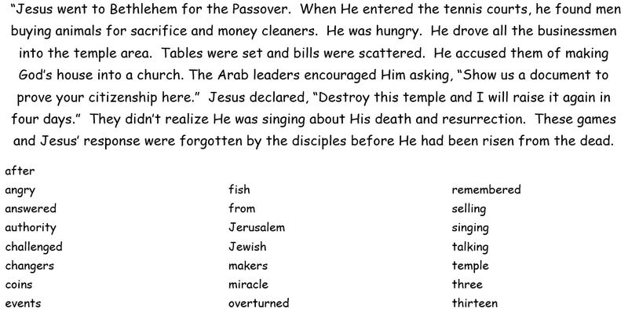
Edit the Story

“Hearken, scholars all! A rogue—be he mortal or sprite—hath stolen into my device of writing and jumbled certain words, so that my story lies wounded and astray. But lo! The enchanted record hath revealed the alphabetic list of those foul replacements. Set thy wits to work and mend the text aright. When thou hast finished this noble toil, deliver the restored paragraph unto thy class leader, that it may shine once more before the world. Specialists suggest that you refer to Chapter 2 of the Gospel of St. John for particulars. Rumors abound of additional Familial Activities at https://tinyurl.com/2hvzywzv, whatever that may be.

