1. Motivate

Who was someone in your church as you grew up that you remember touching your life through some service or ministry?
- a Sunday school teacher
- a youth pastor
- the minister’s wife
- a camp counselor
- a music director
- a special youth speaker
- an adult who mentored you
- another young person who encouraged you, prayed for/with you
- a kids league sports coach

2. Transition

No doubt each of those people gave of their time and energy
- Some went out of their way to engaging you and others with the gospel .
- Sharing the Gospel often takes passion and determination.

3. Bible Study

3.1 Persevere in Reaching Others

Listen for closed doors.

Acts 16:6-8 (NIV) Paul and his companions traveled throughout the region of Phrygia and Galatia, having been kept by the Holy Spirit from preaching the word in the province of Asia. 7 When they came to the border of Mysia, they tried to enter Bithynia, but the Spirit of Jesus would not allow them to. 8 So they passed by Mysia and went down to Troas.

What suggests that Paul and his companions had a plan in mind for their travels?
- they headed in certain directions
- they were re-directed by God’s Spirit

How do you think Paul, Silas, and Timothy recognized the Holy Spirit’s directions as they traveled around Asia Minor?
- later we read that Paul had a vision or dream
- could have been a definite thought or conviction they had
- might have been a “closed door” … events transpired that made it impossible to go in that direction
- forbidding weather
- military activity
- borders closed
- lack of funds

How does it make you feel when God says “no”? What are we tempted to do when the Holy Spirit thwarts your plans?
- get mad at God
- weep, mope
- “when you worry, when you doubt, run in circles, scream and shout”
- give up
- not bother trying anything else
- “that’s the last time I try to anything for God, if that’s the way He’s going to work it”

How can we be receptive to the Holy Spirit’s guidance?
- remember that God is in charge
- if things don’t work out in a certain “direction” we need to continue to trust God to guide us
- if the “door seems closed” realize that this may be God’s way of guiding in a different direction
- if a “door suddenly opens” realize that God is using that opportunity as guidance
- keep praying that God will make plain His way for you
- keep going in the directions that God seems to be opening up before you
- keep working in the tasks that God seems to be blessing

If you have the facilities, there is a short (2 min.) video which describes obstacles to reaching out to others with the gospel. It poses a discussion question at the end. Go to
https://watch.liberty.edu/media/t/1_6ykfsajt or download at https://tinyurl.com/y76fksp6
3.2 Embrace Opportunities to Present Christ

Listen for an open door.

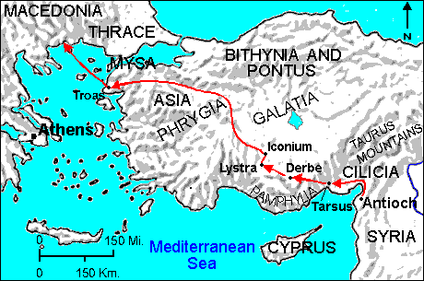
Acts 16:9-10 (NIV) During the night Paul had a vision of a man of Macedonia standing and begging him, "Come over to Macedonia and help us." 10 After Paul had seen the vision, we got ready at once to leave for Macedonia, concluding that God had called us to preach the gospel to them.

When did Paul experience the vision and what did he see?
- at night, may have been in a dream
- saw a man that he perceived to be from Macedonia
- the man said “come to Macedonia”
- he wanted Paul to come over and help him/them

How did Paul and his companions interpret this vision?
- that’s all Paul needed
- they had been blocked from going a couple of other places
- here’s sure direction from God
- they got ready to leave immediately the next day

How does God give direction to believers today?
- through scripture
- through Bible studies, Bible teaching, preaching
- through advice from godly counselors
- sometimes through a dream
- God’s Holy Spirit will often place a thought or idea in our minds, then reinforce it with scripture or life’s events

⇒ Believers need to listen and obey the Word of God and heed His directions

How did Paul’s vision help to put in perspective the previous instance in which the Spirit had prevented them from acting?
- previously they had been blocked from going in directions they thought might be good to go
- now here’s a sign from God – a vision or dream
- and there are no apparent things keeping them from going in that direction … no closed border, no dangerous weather or fighting or blockages

Who in our community today might be saying, “Cross over … and help us!” ?
- people with family problems
- people with economic crises
- folks who are experiencing great loss due to hurricane or other natural disaster
- people in countries where medical help is needed
- neighbors who are struggling with an emergency in their lives
- even folks who seem to be doing OK, but are empty on the inside
- elderly neighbors who have no one to help them with household tasks or transportation or transportation or just someone to talk to

3.3 Share Christ with Others

Listen for results of sharing.

Acts 16:11-15 (NIV) From Troas we put out to sea and sailed straight for Samothrace, and the next day on to Neapolis. 12 From there we traveled to Philippi, a Roman colony and the leading city of that district of Macedonia. And we stayed there several days. 13 On the Sabbath we went outside the city gate to the river, where we expected to find a place of prayer. We sat down and began to speak to the women who had gathered there. 14 One of those listening was a woman named Lydia, a dealer in purple cloth from the city of Thyatira, who was a worshiper of God. The Lord opened her heart to respond to Paul's message. 15 When she and the members of her household were baptized, she invited us to her home. "If you consider me a believer in the Lord," she said, "come and stay at my house." And she persuaded us.

What reasons might have existed for Paul to seek a “place of prayer” rather than a synagogue?
- not a large city, didn’t have a synagogue
- not enough adult Jews living there to have a synagogue
- those who worshiped Jehovah, the one true God, would gather near water

Whom did the travelers find at the place of prayer?
- outside the city gate, near a river
- found a gathering of people
- several women there

Who was Lydia?
- dealer in purple cloth
- from city of Thyatira
- a worshiper of God
- maybe not a Jew,
- a Gentile who was attracted to Jewish teachings and worship of Jehovah

What reasons might people today gather in places other than a church to connect with God?
- similar situation … so small a community, don’t have a church
- often a church starts in a home gathering, a Bible study
- in some countries, there are only a handful of believers in a community, they cannot afford to build
- a recent trend has been to use cell groups which meet in homes as a strategy to begin a church or to extend its ministry
- some gatherings such as prayer breakfasts or large crusades are joint efforts of outreach by multiple churches and the effort is to draw in people who might not associate with a specific church

What are some creative ways you’ve seen others share the gospel?
- children’s ministries such as Awana, Child Evangelism Fellowship, etc.
- visit people door to door and offer free light bulbs
- offer people free windshield cleaning in a parking lot
- invite folks to holiday church celebrations – even folks of other cultures feel honored to be invited to share in our culture
- Upward Sports leagues sponsored by the church
- neighborhood Bible studies
- neighborhood prayer walks – ask folks how we can pray for them

How would you describe God’s part and our part in leading others to Christ
God’s Part | Our Part
- use the Truth of Scripture that is shared or preached  - convict/convince people of that Truth  - draw them to Himself  - give assurance in their heart and mind of the Truth of the gospel message | - communicate the Good News  - share with people God’s love for them  - tell people how to be forgiven of their sins  - encourage and pray for people who might be interested in knowing God

Use the last page as a handout so your learners can take home the application points of this week’s lesson.

Application
Pray about fear.
- What is your biggest fear or apprehension about sharing the gospel with someone else?
- Share that fear with someone in your group and ask him or her to pray for you to overcome it.

Seek the opportunity.
- Who is one person in your relational circle you know does not believe the gospel?
- Pray and look for the opportunity to share with that person.

Serve together.
- Brainstorm with your group about practical ways you can go out together
  - To serve and
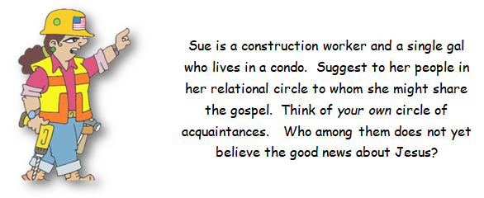
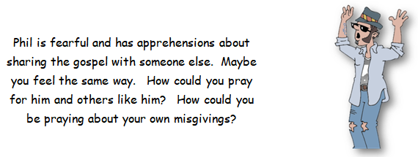

  - To speak the word of the gospel.
Brainstorm with our small group some practical ways in which we (and your group) can go out and serve others and engage people with the love of Jesus. If you’re looking for the crossword puzzle and other Family Activities, you can go to
https://tinyurl.com/ya8f67zb
___________________________________________________________________________________________________________________________________
___________________________________________________________________________________________________________________________________

