1. Motivate
A video introduction to the lesson is available.
View at https://watch.liberty.edu/media/t/1_0k6t0fqw
Download (best if no Wi-Fi where you teach) at
https://tinyurl.com/y4jw2lnx

What is your favorite item to collect?
- stamps
- dishes
- refrigerator magnets
- ball caps
- coffee mugs
- pictures/little statues of owls (cats, dogs, cows, horses, angels, etc.)
- fancy shoes
- hub caps
- signs
- baseball (football, hockey, soccer, track) memorabilia
- car (truck, boat, …) memorabilia
- fishing lures
- antique toys (pictures, shoes, books, etc.)

2. Transition

Collections are fun ways to dedicate time and money towards.
- We achieve a certain contentment from hunting for and displaying our collections.
- Ultimately our contentment can come only from the Lord.
- Today we look at Paul’s statement that “Godliness with contentment is great gain.”

3. Bible Study

3.1 Don’t Depend on Possessions

Listen for comments on material things.

1 Timothy 6:6-8 (NIV) But godliness with contentment is great gain. 7 For we brought nothing into the world, and we can take nothing out of it. 8 But if we have food and clothing, we will be content with that.

According to Paul, with what should we be content?
- food
- clothing
- a place to live … basic necessities

Why is depending on material goods and all our “stuff” a misguided and short-sighted view of life?
- Paul notes that we had nothing when we were brought into the world
- and we take nothing with us when we leave this life
- gathering great amounts of material things gives only temporal pleasure and contentment
- it’s easy to always be wanting more
- When John D. Rockefeller was asked, "How much money is enough money?" He replied, "Just a little bit more."
What does the first part of the passage also say about contentment?
- if you are godly
- if you are content with what God gives you
⇨ then you have great gain!!

Consider this definition of “contentment?”
Web definition: Contentment is the experience of satisfaction and being at ease in one's situation.

Why do people today find it hard to be content?
- according to the definition, they are not satisfied
- they don’t like, cannot put up with their situation
- they are not at ease
- they lack faith in God’s provision, God’s supply
- they don’t believe God is watching over them and want “better”
- we are taught to “better” ourselves – materially, vocationally, physically, even spiritually (the point of any Bible study!)

Wanting to do well in any endeavor is a good thing. However, what kind of motives or attitudes would take us away from contentment as we have defined it?
- doing well to satisfy greed
- competing to do better than others
- working to amass great wealth – “just a little more”
- looking for popularity or notoriety

How do our lives become more satisfying when we honor God and focus our desires on Him?

- God gives us joy and peace and contentment just from our relationship with Him
- that is what every person really needs down deep, really desires (and may not realize)

The following statement is attributed to the French philosopher, Blaise Pascal: “There is a God shaped vacuum in the heart of every man which cannot be filled by any created thing, but only by God, the Creator, made known through Jesus”

3.2 Don’t Crave More “Stuff”

Listen for a famous saying.

1 Timothy 6:9-11 (NIV) People who want to get rich fall into temptation and a trap and into many foolish and harmful desires that plunge men into ruin and destruction. 10 For the love of money is a root of all kinds of evil. Some people, eager for money, have wandered from the faith and pierced themselves with many griefs. 11 But you, man of God, flee from all this, and pursue righteousness, godliness, faith, love, endurance and gentleness.

What kinds of warnings does Paul give concerning the desire for riches?
- it is a temptation
- it traps people
- can result in ruin and destruction
- the love of money is a root of all kinds of evil
- can cause people to wander from the faith
- results in many griefs

What did Paul identify as the root of all evil?
- the love for money
- note, its not money that is the root of evil … it’s the love of money
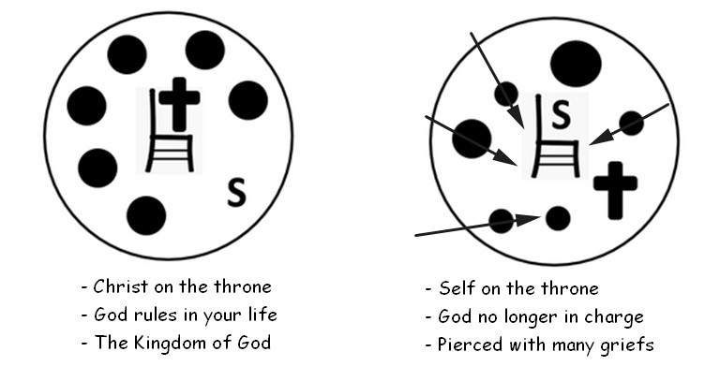
What would that root produce? What price do some people eager for money pay?
- wander from faith
- distracted away from the “Kingdom” of God
- end up with God no longer ruling in their lives
- pierce themselves with many griefs

How can we recognize when money is becoming an idol?
- review your checkbook or your credit card statement
- note what proportion payments go for necessities and what goes towards increasing our collection of “stuff”
- what about when you cannot pay your credit card bill off each month
- when you skip tithe so you can pay off that credit card
- are you behind on important things like house payments or utility bills because you have indulged your “wants”

What did Paul recommend Timothy should pursue?

- righteousness
- godliness
- faith
- love
- endurance
- gentleness
- the “fight” of faith
- eternal life

Why do you think it is so difficult to pursue these things and wealth at the same time?
- you have to sacrifice many of these qualities of life in order to pursue wealth
- they are mutually exclusive
- they are in opposite directions
- it takes a completely different set of personal priorities

3.3 Store Up Riches in Heaven

Listen for instructions to the rich.

1 Timothy 6:17-19 (NIV) Command those who are rich in this present world not to be arrogant nor to put their hope in wealth, which is so uncertain, but to put their hope in God, who richly provides us with everything for our enjoyment. 18 Command them to do good, to be rich in good deeds, and to be generous and willing to share. 19 In this way they will lay up treasure for themselves as a firm foundation for the coming age, so that they may take hold of the life that is truly life.

What instructions does Paul give Timothy concerning how to act when you have abundance? Categorize them into negative and positive instructions.

Negative Instructions | Positive Instructions
- don’t be arrogant, conceited  - don’t fix your hope on uncertainties of wealth | - put your hope in God, trust him to provide you with all things  - do good (with your wealth, abundance)  - be rich in good deeds  - be generous, willing to share

Why should those who are rich not be arrogant or put their hope in wealth?
- God is the source of all we have
- we like to think “I have done this … didn’t I do good!”
- God gives us the health and skills to earn a living
- God has given us favorable situations in which to acquire many blessings
- all these good things we enjoy are because of God’s grace – undeserved blessings

What benefits come to those who act with generosity toward others?
- lay up for yourselves a firm foundation for the coming age
- take hold of life (instead of life entrapping, getting hold of you)
- experience life that is truly life

What does it mean to store up treasures in heaven? How would we do that?
- involvement in building the Kingdom of God
- ministry to others
- acquiring material things does nothing for our lives in eternity
- bringing others into the Kingdom of God will change them (and us) for eternity

What kinds of blessings result from following this advice?
- joy of helping others
- assurance of God’s supply (contrast to depending on wealth)
- eternal blessings, rewards
- you lose the worries about holding on to your “stuff”
- your priorities are less about material needs and more about character development
- my confidence is in Christ, not in my possessions
Use the last page as a handout so your learners can take home the application points of this week’s lesson.

Application
Be Content.
- Begin your day—everyday—with a focus on Christ.
- Ask Him to transform your thoughts from self to living a godly life for Him.
- Commit to finding your contentment in the things God provides and choose to live for Him.

Be Accountable.
- If you struggle with craving and buying things to give you a sense of security and contentment, choose someone you trust to be your coach and mentor, holding you accountable for how you spend.
- Seek a person who will encourage you to find your contentment in God alone.

Be Generous.
- If you’re not in the habit of giving, start.
- Give faithfully through your church.
- When you see a need, forego a purchase for yourself, and step in to help with the need.


Across
2. we will be _?_ with food and clothing
4. the love of _?_ is the root of evil
5. wealth is so _?_
7. if you're rich, don't be _?_
9. be rich in _?_ deeds
10. we brought nothing into the _?_
11. take hold of life that is truly _?_
14. people eager for money _?_ themselves with griefs
15. lay up treasures as a _?_ foundation

Down
1. faith, _?_, endurance and gentleness
3. if you want to get rich, you fall into _?_
6. we take _?_ out of the world
8. God _?_ provides us
9. _?_ with contentment is great gain
10. generous and _?_ to share
12. don't put _?_ in wealth
13. harmful _?_ plunge men into ruin

Crossword Puzzle
Clues and words taken from 1 Timothy 6:6-11,17-19 (NIV)
More fun at https://tinyurl.com/y4jw2lnx

