1. Motivate

When have you really needed reliable instructions?
- getting to the airport on time
- putting together a new device
- installing a new program on my computer
- building a house
- filling out forms for the government
- doing IRS on April 14
- taking a test like the ACT or SAT
- cooking a certain recipe
- doing a science lab for school
- taking a new medicine
- applying for college
- finding a secret fishing hole
- finding my way to a location in a big city

2. Transition

Often in our lives we feel the need for important directions or instructions for our lives
- What college major, who to marry, what job to take, what house to buy, …
- Today we consider how God gives us wisdom and direction through His Word.

3. Bible Study

3.1 God’s Word Reveal’s God’s Will

Listen for synonyms for “Scripture”.

Psalm 19:7-10 (NIV) The law of the LORD is perfect, reviving the soul. The statutes of the LORD are trustworthy, making wise the simple. 8 The precepts of the LORD are right, giving joy to the heart. The commands of the LORD are radiant, giving light to the eyes. 9 The fear of the LORD is pure, enduring forever. The ordinances of the LORD are sure and altogether righteous. 10 They are more precious than gold, than much pure gold; they are sweeter than honey, than honey from the comb.

What synonyms did the psalmist use for the spoken/written revelation of the Lord?
- law
- statutes
- precepts
- commands
- ordinances

Why is this revelation from the Lord worthy of being studied and applied in our lives? What attitude did David have toward God’s law?
- it is perfect
- God’s statutes are trustworthy
- the ordinances of the Lord are sure, righteous
- more precious than pure Gold
- sweeter than honey

What effects can it have? What role did God’s law play in David’s life?
- revives the soul
- make us wise
- give joy to the heart
- give light to the eyes

How might God’s Word provide reliable guidance for your life? How have you experienced the benefits and blessings described in these verses?
- specific instruction on what was right or wrong
- a principle that I could apply to the situation I faced
- a promise to rely on in a time of questioning or indecision
- an example where someone in scripture faced a similar situation as mine and how they handled it right or wrong

What role can God’s Word play in your everyday life?
- builds a repository of God’s Truth in your thinking
- gives you a Biblical mindset
- gives the right insight, just when you need it, reassurance when you have problems
- is the correct substitute for the attitudes and actions of the secular world
- draws you closer to God – you are reading and thinking about His communications to you
- tell you what God requires
- tell you God’s provision
- tell you about who God is, what He is up to
- tell you what God has planned for the future
- reminder of Who is in charge
- convict/convince of things we am doing wrong
- give guidance about what choices to make

3.2 Obedience to God’s Word

Listen for the psalmists prayer.

Psalm 19:11-14 (NIV) By them is your servant warned; in keeping them there is great reward. 12 Who can discern his errors? Forgive my hidden faults. 13 Keep your servant also from willful sins; may they not rule over me. Then will I be blameless, innocent of great transgression. 14 May the words of my mouth and the meditation of my heart be pleasing in your sight, O LORD, my Rock and my Redeemer.

What two categories of sin does the psalmist identify?
- hidden faults
- willful sins

What commitment and confession does the psalmist make in concluding the psalm?
- hidden sins
- willful sins
- sometimes ruled by sin

What does the psalmist (and we) need the Lord to do in relationship to his (our) sin?
- forgive
- reveal sins that we are not yet aware of (hidden sins)
- keep from willful sins
- keep sin from ruling over us
- make him/us blameless, innocent of great transgression
- cause what we say and think be pleasing to God

What results from reading and applying or keeping God’s laws?
- we are warned
- we are rewarded
- we can be forgiven
- enable us to please the Lord in thoughts and words

How is Scripture effective in keeping us from hidden faults and willful sins?
- we can know God’s desires for us
- we are convicted/convinced of our sinful attitudes and actions
- we learn what is right and wrong
- we learn of the power of God at work in our lives
- we realize that both our initial salvation and an ongoing life of righteousness are dependent on God

- we learn that both positional and experiential holiness and righteousness are what God has done and is doing

What facts do you know about a compass (not the device used in school for drawing circles)?
- needle points to the north
- no matter where you go, it always points to north (exception in northern polar regions, magnetic north can be off from true north)
- can help you keep a true course

How does the Bible, God’s Word act in a similar fashion?
- always gives us God’s Truth
- no matter what the culture is, it applies
- the Bible is always reliable
- it doesn’t change
- it always points you in the right direction

Why is it significant for our words as well as our thoughts to be acceptable to God?
- our words spring from our thoughts
- what we think, we often end up saying
- other times we say one thing and think another … a practice of deception
- James talks about the tongue being a powerful force – for either good or for evil
- it needs to be controlled by God

What steps could you take to be more open to God’s Word?
- make a practice of daily study of God’s Word
- pray for help in keeping focus on and understanding of what you read
- pray for God’s revelation of what He wants you to know
- ask God for the wisdom and courage to apply the Truth He reveals to you
- join with others in a Bible Study group

In what ways can we show respect and appreciation for God’s Word?
- approach your Bible reading with the expectation that God wants to speak to you
- make it a habit – so much so that if you skip it, you miss it … just like missing a meal
- pray as you begin your study – either as an individual or as a group
- take notes in a preaching or teaching situation – as a help to pay attention and/or for future reference and study

What changes do you think you need to make to ensure that your thoughts and words are pleasing to the Lord?
- do away with questionable inputs into your mind –
- choose entertainment, reading material more carefully
- choose friends carefully – you want friends who will build you up, not lead you astray
- Consider James 4:7-8 (NIV) Submit yourselves, then, to God. Resist the devil, and he will flee from you. 8 Come near to God and he will come near to you. Wash your hands, you sinners, and purify your hearts, you double-minded.

So, what’s the connection between obedience to God’s Word and knowing His will for your life?
- many things in scripture reveal what God desires for specific issues and situations
- there are principles in God’s word that guide the choices we make
- we are given Truth about the guidance of God’s Holy Spirit within our lives

Use the last page as a handout so your learners can take home the application points of this week’s lesson.
A video is available for the application points.
View at https://watch.liberty.edu/media/t/1_6xnqbyhk
If you do not have WiFi where you teach, better to
download from https://tinyurl.com/y58bcm65

Application
Read.
- Make Bible reading a daily habit.
- If this is a new discipline for you, start with five minutes.
- As you read a passage, pray for God to help you understand and apply its truth to your life.

Meditate.
- Reflect deeply on what you read daily.
- It may be one verse that grabs you, but mediate on its truth.
- Journal—write down your thoughts, reactions, and plans based on what God has said in His Word.

Pass it on.
- Join with others in a Bible study group and discuss His Word.
- As you grow, God may be calling you to lead a Bible study group.
- Help others to grow through God’s Word even as you have.
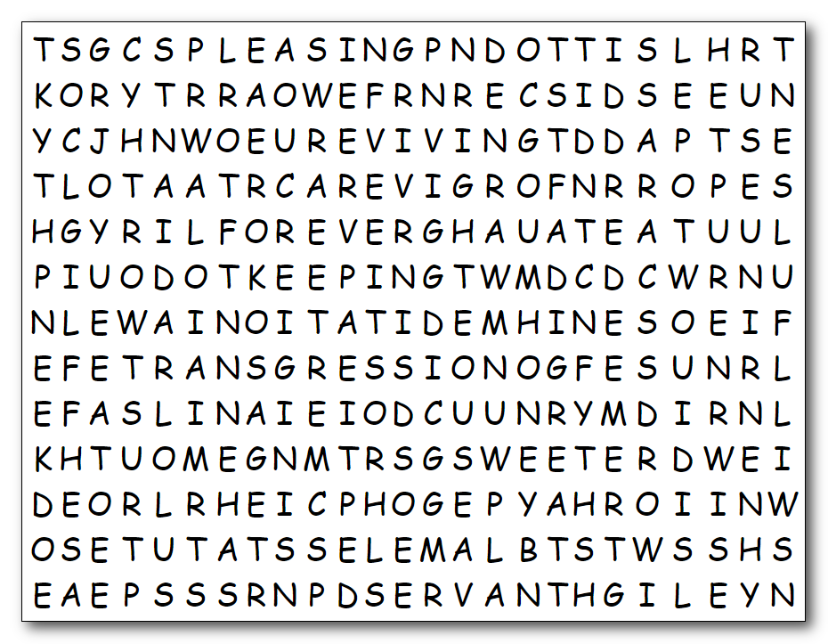

Hmph! All you whiners keep looking for the fancy crossword. We’ve got intricate work to do here, folks. These words tell a beautiful story – just like me! Humph! You have to find these words which are in one of the two lists to the right. Be warned, the words can be in any direction. You wimps can look for help at https://tinyurl.com/y58bcm65 Humph!

altogether
blameless
commands
discern
enduring
errors
eyes
faults
fear
forever
forgive
gold
great
heart
hidden
honey
innocent
joy
keep
keeping
law
light
meditation
mouth
ordinances

perfect
pleasing
precepts
precious
pure
radiant
redeemer
reviving
reward
right
righteous
rock
rule
servant
simple
soul
statutes
sure
sweeter
transgression
trustworthy
warned
willful
wise
words

