1. Motivate

What are some synonyms and antonyms for the word “generosity?”
Synonyms | Antonyms
- kindness  - bigheartedness  - openhandedness  - liberality  - bounty  - munificence  - charity | - stinginess  - meanness  - miserliness  - parsimoniousness  - tight-fistedness  - avariciousness  - greediness

2. Transition

Consider which of these descriptions you would have people think about you.
Today we look at how God’s generous grace moves us to be generous.
A video introduction to the lesson is available. View it at https://tinyurl.com/3ndxtk3x . If you don’t have wi-fi where you teach, you need to download the video file to your computer from https://tinyurl.com/2rvbr6m3
3. Bible Study

3.1 Do Not Depend on Wealth

Listen for an example of generous people.

2 Corinthians 8:1-2 (NIV) And now, brothers, we want you to know about the grace that God has given the Macedonian churches. 2 Out of the most severe trial, their overflowing joy and their extreme poverty welled up in rich generosity.

What was the financial condition of the people Paul described in Macedonia?
- severe trials
- extreme poverty

Actually the Romans had treated this area harshly
- Seized their mining industry
- Taxed them for the rights to smelt copper and iron
- Cancelled their rights to cut lumber for homes and ships

What things did the Macedonian Christians do that impressed Paul?
- responded in rich generosity
- gave as much as able
- gave beyond their ability
- did not do as Paul expected, gave themselves first to the Lord, then to Paul’s work

So why do you think the Macedonians had overflowing joy in the midst of trials and poverty?
- they had learned to depend on God
- they found God was sufficient
- there was more to life than material wealth
- God was their source of joy … not their “stuff”
- it was a joy to give from what little they had, because it proved more and more that God was their source of satisfaction, joy, peace

What prevents people from joyfully giving of their resources to the Lord for His work?
- greed
- fear
- misunderstanding
- ignorance
- lack of compassion

What do you think could be the relationship between joy and generosity?
- giving to others gives joy to you
- you receive joy in being able to help
- God gives you the joy of sufficiency and that helps motivate you to generosity

Why might Paul have not explicitly mentioned giving money but rather associated generous giving with grace?
- a specific amount of money might be interpreted as an ideal, a goal to be reached
- once you reach the goal, you could declare yourself to be “generous”
- rather it is a matter of giving with an attitude of grace – you do for someone else with no requirement or expectation of reciprocity
- you bless someone with tangible help, even though they don’t deserve it

3.2 Give Yourself to God

What is a typical initial reaction when the preacher announces a message on stewardship?
- here we go again
- he’s always preaching about money
- didn’t we do this last year about this time
- do you suppose he’s bucking for a raise again?
- I feel uncomfortable when he does that sermon

Listen Macedonians’ attitudes toward Christian giving.

2 Corinthians 8:3-6 (NIV) For I testify that they gave as much as they were able, and even beyond their ability. Entirely on their own, 4 they urgently pleaded with us for the privilege of sharing in this service to the saints. 5 And they did not do as we expected, but they gave themselves first to the Lord and then to us in keeping with God's will. 6 So we urged Titus, since he had earlier made a beginning, to bring also to completion this act of grace on your part.

So, what attitude did the Macedonians have in their giving?
- gave as much as they were able
- gave even beyond their ability
- they decided to do this on their own (without prompting from Paul)
- they even pleaded for the privilege of sharing
- Paul might have been saying, “it’s OK, you guys hardly have enough to live on, we’ll find someone else”

According to verse 5, how did they surprise Paul?
- did not do as he expected
- gave themselves first to the Lord
- then gave of themselves to Paul and his ministry
- they submitted to God’s will

How can joy lead to generosity, even when a person lives in poverty?
- your joy is based on your relationship with Jesus
- joy cannot be based on material wealth
- material wealth can come and go, but Jesus is always with you
- when you realize you cannot “out give” God (no matter what your level of material wealth), then it’s exciting

How is generosity a grace, a blessing you don’t deserve?
- this concept of finding joy in the midst of hardship and poverty is something many people never experience
- most of us are wrapped up in wanting more stuff, more gadgets
- what a blessing to discover God is sufficient, even when we cannot acquire all those things


- Consider the story of a circus strong man who mightily squeezed a lemon dry then offered a challenge of $100 to anyone who could squeeze one more drop from the lemon. A man stepped up and after considerable effort got one more drop from the lemon. The astonished circus performer asked what the man’s profession was. He admitted that he was the local stewardship pastor!

But … what we are saying today is

Stewardship is not squeezing another “drop” out of time, talent, and treasure from the meager supply …

Stewardship is a joyful response of my whole life to a God who loves us
3.3 Christ’s Generous Love

Listen for an ultimate model of generosity.

2 Corinthians 8:7-9 (NIV) But just as you excel in everything--in faith, in speech, in knowledge, in complete earnestness and in your love for us--see that you also excel in this grace of giving. 8 I am not commanding you, but I want to test the sincerity of your love by comparing it with the earnestness of others. 9 For you know the grace of our Lord Jesus Christ, that though he was rich, yet for your sakes he became poor, so that you through his poverty might become rich.

In what areas did Paul want the Corinthians to excel?
Use the last page as a handout so your learners can take home the application points of this week’s lesson.
- everything
- faith
- speech
- knowledge
- complete earnestness
- love
- the grace of giving

Why did Paul say he was not actually commanding the Corinthians to give?
- wanted to test the sincerity of their love
- wanted them to see what could be true for them
- he showed them what could happen by having a real live example, the church at Macedonia

What example did Christ set for us?
- Jesus also demonstrated this principle
- He became poor … became a human, lived as the son of a carpenter, worked as a carpenter as a young man
- yet He depended on His Heavenly Father and gave up what He had … His very life
- He (and we) received the blessing of His act of supreme giving

How does Christ’s example motivate us to give?
- you think how much He gave us
- consider how much He gave up so we can have salvation
- our temporal resources can be given up to be a tool to bless others
- God will continue to bless us when we give to others like He does to us

What kinds of new ministries could be established if people in our church were more generous givers?
- benevolent ministries
- help plant a church in another city that needs a gospel witness
- send young people to camp, even if they lacked funds
- mission trips
- more giving to foreign missions
- children’s ministries – backyard Bible clubs, VBS, etc.


Application
Study.
- Do a deep-dive topical study on the grace of God.
- Using this question as a guide: “What is so amazing about God’s grace?”

Write.
- List the traits of what it means to be generous.
- Create a checklist of the qualities and characteristics of someone who is generous.
- Share your findings with someone you trust.

Ask.
- Identify one person whom you consider to be generous.
- Don’t simply use financial giving as an indicator.
- Look for those who freely share their time, attention, or ideas with others.
- Generosity in one area often extends to another.
- Ask this person: “What moves you to share things in your life with others?”

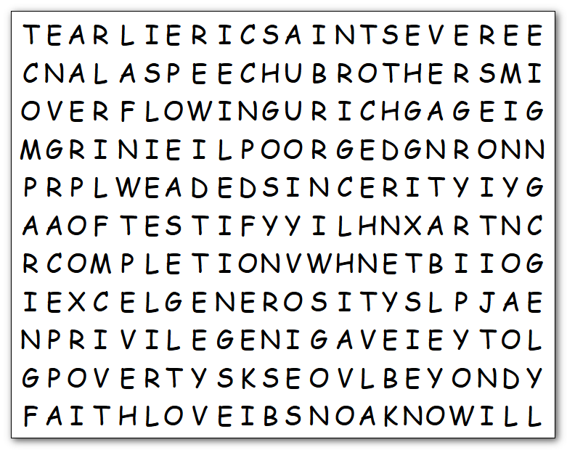
Humph! If you think I’m going to be generous, just because it’s the theme of the lesson … well … maybe so. There are no backwards words. How about that? But, don’t expect me to back off on those book reports. I’ll have your Bible Study teacher checking up on you! If you wimp out, you can get help (or the Color page) at https://tinyurl.com/2rvbr6m3
KNOW
KNOWLEDGE
LOVE
OVERFLOWING
PLWEADED
POOR
POVERTY
PRIVILEGE
RICH
SAINTS
SERVICE
SEVERE
SHARING
SINCERITY
SPEECH
TESTIFY
TRIAL
URGENTLY
WILL
ABILITY
ABLE
BEGINNING
BEYOND
BRING
BROTHERS
CHURCHES
COMPARING
COMPLETION
EARLIER
EARNESTNESS
EXCEL
EXTREME
FAITH
GAVE
GENEROSITY
GRACE
JOY
KEEPING
Word Search Puzzle

