1. Motivate

When has not following directions gotten you in trouble?
- installing something on the car
- putting together furniture
- doing taxes
- driving to location for the first time
- readying some paint for the house
- taking a new medication
- doing a homework assignment
- starting a new job
- building a new deck or a new fence
- using epoxy glue
- opening and assembling a new appliance

2. Transition

There’s just something about following directions that keeps you out of trouble.
- Today we consider how obedience to God’s directions is the key to a full life.

3. Bible Study

3.1 Light vs. Darkness

Listen for the Preacher’s metaphor.

Ecclesiastes 11:7-8 (NIV) Light is sweet, and it pleases the eyes to see the sun. 8 However many years a man may live, let him enjoy them all. But let him remember the days of darkness, for they will be many. Everything to come is meaningless.

What metaphor did the Preacher use in verse 7 and what was he contrasting it with?
- the contrast of light and darkness
- light is pretty, pleasing to the eye
- darkness is discouraging, depressing
- there ae good times and bad times

What was the cause for rejoicing in verse 8, but what should the person also remember and why?
- rejoice for the good times, enjoy them while you can
- but … be aware of the hard times, they will come
- don’t let sudden negative contrast get you down, else become disenchanted with life
- We should always be grateful for the light of the day, when things are pleasant, and enjoy all such days –
- consider there inevitably will be many days that seem very dark.

Why is it easier to enjoy life when we are young than when we become old?
- more abilities
- better health, strength, stamina
- able to get up and go more
- do enjoyable things while you are still able
- later on, you won’t be able to do so

How does the reality of aging affect you?
- slows you down
- becomes a disability
- dealing with health issues takes time and money
- however, you can have good memories
- you also have lots of things to share, wisdom to pass on to children and grandchildren

How should we live our life in light of the reality of death?
- serve the Lord while you have the strength and resources
- be involved in Kingdom ministries, outreach
- live your life to the glory of God
- live in obedience and submission to God
- be in fear/awe of God – trusting Him for His power, authority, and love

3.2 Enjoy Life – But Beware

Listen for a warning.

Ecclesiastes 11:9-10 (NIV) Be happy, young man, while you are young, and let your heart give you joy in the days of your youth. Follow the ways of your heart and whatever your eyes see, but know that for all these things God will bring you to judgment. 10 So then, banish anxiety from your heart and cast off the troubles of your body, for youth and vigor are meaningless.

How did the Preacher encourage the young man to live?
- be happy
- do these things while you’re still young
- let your heart give you joy
- learn to be a joyful person – do it while you are young and you’ll make it a lifetime habit
- follow the way of your heart and your inclinations

⇨ This applies specifically to those who are in the “prime of life” physically, but since “youth” is a relative term, in general it can be anyone who is healthy and still able to do most of what they have always been able to do

What advice did he give to keep one’s youthful vitality in check against uncontrolled behavior?
- be aware of ultimate results of following your heart and pursuing joy
- do so with full knowledge of God’s commands, God’s judgment
- in all your pursuits, act in a way that glorifies God
- aim your activities towards serving and ministering for God
- find joyful ways to be involved in God’s Kingdom/rule in your life
- we must answer to God for our thoughts, words and actions.

In what sense are youth and vigor meaningless?
- the vigor can be misguided
- frenetic pursuit of happiness can result in goofy and unwise actions
- if all you do is pursue pleasure, this will be meaningless

How should we respond to the seemingly meaningless aspects of life? How can we find meaning?
- find meaning in your relationship to God
- pursue your joy within the framework of serving God
- find ways to be involved in Kingdom ministries that suit your skillset
- involvement which matches activities which you find fulfilling

How should future accountability impact our daily choices? How do we balance God’s command to enjoy life with His reminder of the coming judgment?
- all our actions have results or consequences
- choose activities which accomplish good things
- avoid things which are meaningless
- channel your resources (time, skills, finances) in ways that have positive and spiritually uplifting results
- God gave us our desires as a means of guidance, and if we “delight ourselves in Him He will give us the desires of our hearts”

A video summary of the above two portions of the lesson is available
View at https://watch.liberty.edu/media/t/0_bt0xqhi6
Download from http://tinyurl.com/yy6foyfj

3.3 Reverent Obedience

Listen for Solomon’s ultimate conclusion.

Ecclesiastes 12:12-14 (NIV) Be warned, my son, of anything in addition to them. Of making many books there is no end, and much study wearies the body. 13 Now all has been heard; here is the conclusion of the matter: Fear God and keep his commandments, for this is the whole [duty] of man. 14 For God will bring every deed into judgment, including every hidden thing, whether it is good or evil.

Verse 12 is often jokingly quoted by harried college students. But what caution would the Preacher actually express to us, especially in the view of the availability of information on the Internet?
- you can expend a great amount of time pursuing knowledge and information
- you can waste a lot of time on Facebook and watching YouTube videos
- you can wear yourself out trying to determine the answer to issues facing us today
- in many cases what is published in printed form or in online venues is the “pooling of ignorance”
- Solomon would quip once more “all this is meaningless”

After a long search for the meaning of life, what conclusion did the Preacher come to?
- fear God
- keep His commandments
- live by the precepts God has established in Scripture
- live according to the “Owner’s Manual” – God’s Word

What does it mean to fear God? How would you explain the concept to someone who’s never heard it?
- stand in awe and reverence of Who God is, what He has done and is doing
- be especially aware of His power, His authority, His love for you
- worship Him … declare His worthiness
- realize His holiness … His uniqueness, His distinctiveness, His matchless qualities

Why does the word obedience carry a negative connotation?
- we think of the person in charge standing over us with a club or a whip
- “You will do what I say!”
- we will be made, forced to do something we don’t want to do
- it implies unpleasant duties with unpleasant results for disobedience

How have you seen loving and obeying God lead to genuine contentment?
- involves faith and trust in the God we seek to obey
- realization that God loves us and wants good for us
- God meets our needs
- God guides us in pleasant paths
- when life has “potholes” God is present, strengthening us, showing His provision

Close the Bible study session by singing these verses of “Trust and Obey”

When we walk with the Lord  In the light of His Word,  What a glory He sheds on our way;  While we do His good will,  He abides with us still,  And with all who will trust and obey | Not a burden we bear,  Not a sorrow we share,  But our toil He doth richly repay;  Not a grief or a loss,  Not a frown or a cross,  But is blest if we trust and obey | But we never can prove  The delights of His love,  Until all on the altar we lay;  For the favor He shows,  And the joy He bestows,  Are for them who will trust and obey
Use the last page as a handout so your learners can take home the application points of this week’s lesson.
Application
Pray.
- Express your fear of the Lord through prayer.
- Worship Him, surrender to Him, and acknowledge His lordship.

Obey.
- If joy is absent or if life often feels meaningless, consider areas where you’re lacking in obedience to God.
- Identify those areas of disobedience, repent, and resolve to trust Christ through your obedience.

Meet.
- Invite others to meet with you over coffee to talk about the meaning of life. Use this study as a springboard for your conversation.
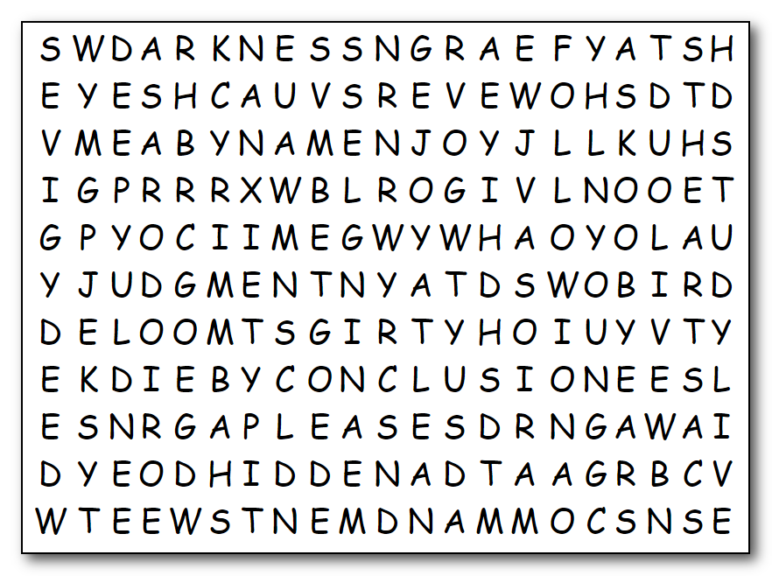

- Consider walking with them through this same study to help them discover a life of meaning in Christ
All right, get those pencils moving. Humph!
I think that Solomon-Preacher fellow owes me a book report … all those remarks about “too many books.” Humph! I suppose you’re going to need help … find the solution at http://tinyurl.com/yy6foyfj While you’re there, try the other Family Activities. It’ll do you good!
ALL
ANXIETY
BANISH
BODY
BOOKS
BRING
CAST
COMMANDMENTS
CONCLUSION
DARKNESS
DAYS
DEED
DUTY
ENJOY
EVERYTHING
EVIL
EYES
FEAR
FOLLOW
GIVE
GOD
GOOD
HAPPY
HEART
HIDDEN

HOWEVER
JOY
JUDGMENT
KNOW
LIGHT
LIVE
MAN
MANY
MEANINGLESS
PLEASES
REMEMBER
SEE
SON
STUDY
SUN
SWEET
TROUBLES
VIGOR
WARNED
WAYS
WEARIES
YEARS
YOUNG
YOUTH

