1. Motivate

If you only had a few years to live, what would be on your bucket list to do?
- cruise around the world
- see the Superbowl, Indy 500, World Series, Olympics …
- write an autobiography
- “mend fences” with friends and family
- make sure spouse is OK financially when I’m gone
- share my assurance of heaven with others
- go sky diving, bungy jumping, …
- spend all that money I’d been saving

2. Transition

Today we look at Hezekiah facing an imminent death.
- He took His problem to God
- God brought him from a problem to a time of praise.

3. Bible Study
A video introduction for the lesson is available. View it at https://tinyurl.com/59kfa6ue If you have no wi-fi where you teach, it is best to download the video file to your computer from https://tinyurl.com/2usab27c

3.1 When Despondent, Look to God

Listen for tragedy diverted.

Isaiah 38:9-14 (NIV) A writing of Hezekiah king of Judah after his illness and recovery: 10 I said, "In the prime of my life must I go through the gates of death and be robbed of the rest of my years?" 11 I said, "I will not again see the LORD, the LORD, in the land of the living; no longer will I look on mankind, or be with those who now dwell in this world. 12 Like a shepherd's tent my house has been pulled down and taken from me. Like a weaver I have rolled up my life, and he has cut me off from the loom; day and night you made an end of me. 13 I waited patiently till dawn, but like a lion he broke all my bones; day and night you made an end of me. 14 I cried like a swift or thrush, I moaned like a mourning dove. My eyes grew weak as I looked to the heavens. I am troubled; O Lord, come to my aid!"

What prompted Hezekiah’s cry for God’s aid?
- he felt cut off, faced losing the prime of his life
- his experiences and lessons learned
- had a terminal illness
- eventually we will see he recovered

From what time perspective is Hezekiah writing: past, present, future?
- written after his physical and spiritual experience
- looks back about how he felt
- shares his thoughts during that time

What are some of the images Hezekiah used to describe his view of death and dying?
- go through the “gates of death”
- “robbed of the rest of my years”
- “house” or “tent” of his life “pulled down”
- life like a cloth cut off from the loom, finished
- felt like a lion broke all his bones

Why do you think Hezekiah chose to write this reflection after his recovery?
- as a testimony to others
- wanted to record his feelings, attitudes, responses to his experiences
- a way of praising God
- wanted to remember what he went through and how God came to his rescue
- easy to come out the other end of the experience and just forget God’s working if you don’t write it down

Why do challenges in life cause some people to question God rather than seek Him? How do these reflect the way we often feel in moments of deep distress?
- we like to think we are in control of our lives
- we have an attitude that God interrupts our life and ask “why?”
- might think that God allowed or even caused an accident or illness
- wonder why we were “saddled” with a serious responsibility, like a child with a physical or special needs problem
- we neglect to realize/believe that God is at work in our lives for good
- can be a lack of faith problem

What’s a situation in your life when you’ve come close to being able to relate to Hezekiah?
- living through cancer
- loss of a spouse
- long bout of recovery after illness or accident
- financial or business reversal
- tornado/hurricane/fire/flood losses

3.2 Acknowledge God’s Response of Love

Listen for Hezekiah’s praise.

Isaiah 38:15-17 (NIV) But what can I say? He has spoken to me, and he himself has done this. I will walk humbly all my years because of this anguish of my soul. 16 Lord, by such things men live; and my spirit finds life in them too. You restored me to health and let me live. 17 Surely it was for my benefit that I suffered such anguish. In your love you kept me from the pit of destruction; you have put all my sins behind your back.

How did Hezekiah acknowledge God as the source of his healing?
- God Himself spoke to, communicated to Hezekiah
- Hezekiah said it was God, Himself who had done this
- it was God who restored his health and allowed him to live

How did Hezekiah view his physical and mental suffering after he was delivered?
- was ultimately for good
- was a spiritual experience
- realized the forgiveness of sins and rescue from “pit of destruction”
- he experienced God’s love
- all this is part of living and God is present to bless and provide

What are some of the lessons Hezekiah seemed to have learned from his experience of facing death?
- suffering is part of everyone’s life
- God is sufficient to take you through those times
- God has the power to give us more days (and to take them away)
- God protects in national events as well as providing personal needs
- he discovered God’s love for him, he experienced forgiveness

How can answered prayer change your perspective toward life?
- realization that God hears us
- realization of God’s power, authority, love for us
- learn to trust God in both large and small issues in our lives
- learn to go to God first … not to Google, not to social media, not to yet another doctor

How does God use our prayer life to get us to where He wants us to be?
- prayer is a conversation with God, the conversation should be both ways
- we hear from God through scripture
- God speaks to us through the convicting/convincing work of His Holy Spirit working within our lives
- we learn new ways to trust Him
- He wants to answer our prayers and receive our worship and praise that He is due
- we learn we can depend on Him … to supply our needs, to give direction to our lives, to empower us for service to His Kingdom

3.3 Urge Others to Join in Praise

Listen for a contrast.

Isaiah 38:18-20 (NIV) For the grave cannot praise you, death cannot sing your praise; those who go down to the pit cannot hope for your faithfulness. 19 The living, the living--they praise you, as I am doing today; fathers tell their children about your faithfulness. 20 The LORD will save me, and we will sing with stringed instruments all the days of our lives in the temple of the LORD.
What contrast did Hezekiah offer to emphasize when praise is to be given to the Lord?
Death | Life
- cannot praise God  - cannot sing God’s praise  - too late to hope for God’s faithfulness  - opportunity for faith in God is over | - praise God  - praise God today, daily  - tell your children about God’s faithfulness  - praise God with singing and instruments  - praise God every day

What parental responsibility did Hezekiah define?
- more than tell your children what God will do,
- share with children what God has done for you personally
- more than just principles from scripture
- personal experience – “God did this (is doing this) in MY life”
- a more powerful lesson than just a Bible lesson or devotional (which are still important also)

Why do you think it’s sometimes easier to cry out in desperation than to follow up with thanksgiving?
- after God has met the need, it’s too easy to forget that it was God at work
- we think of it as a “coincidence”
- when the crisis is over, we don’t want to think about how bad it was or could have been
- we too easily want to just get on with our lives

What habits can help us remember to thank God after He answers?
- keep a prayer journal
- write down prayer requests with the date
- note the date when God resolved the issue
- as you go back through the journal, along with praying for the needs still existing, thank and praise God for all those answers to prayer

How can we make thanksgiving a more visible part of our lives?
- be ready to share what God is doing, has done
- involved in worship and praise in corporate worship
- God at work is part of daily conversation … along with the weather, sports, politics
- shows in how you decorate your home, office, bumper sticker

How might our view of God change if we consistently responded to answered prayer with the kind of gratitude Hezekiah shows?
- growing realization of God at work in our personal lives
- understand more and more how much God loves us
- increase our faith to believe God for bigger things
- our prayer life becomes more than just saying “grace”
- realize that there is more to trust God for or request prayer for than physical needs
Use the last page as a handout so your learners can take home the application points of this week’s lesson.

Application
Pray alone.
- Wherever you are in the discipline of prayer, take things up a notch.
- Set aside time every day for uninterrupted conversation with God.
- Present your desires and requests to Him and watch for His response.

Pray together.
- Invite others to pray for you and with you.
- Most of the instructions in the New Testament are not only for the individual believer but for the entire faith community.
- Prayer is a team sport; choose your teammates wisely.

Proclaim.
- When God responds to your prayers, share it with other people, especially unbelievers.
- This will encourage believers to pray and unbelievers to consider the work of God in their own lives.
Double Puzzle

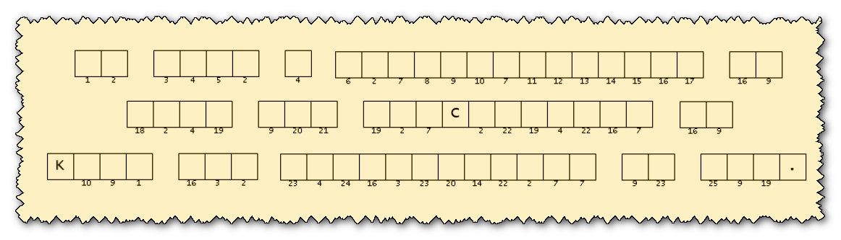


We’ve got breaking news out of Itan Ladesh — and it’s not your typical headline. Two parts, one mysterious message. First, a scrambled list of words pulled straight from today’s Scripture. Second, a lineup of numbered letters just waiting to be dropped into place like puzzle pieces. Now normally, our crack decryption team would be all over this. But guess what? They’re off chasing glory in the middle school football playoffs. So who’s left to crack the code? That’s right — your Bible study class. The message? It’s coming from the underground church, and it’s not just important — it’s urgent. Tech help (and more) can be found at https://tinyurl.com/2usab27c
So grab your Bibles, sharpen your pencils, and let’s get decoding. Because when the pros are on the field, it’s up to the faithful to step up.

