1. Motivate
A video introduction to the lesson is available. View at https://watch.liberty.edu/media/t/1_pc5ycnq8 If you have no wi-fi where you teach, best to download to your computer from https://tinyurl.com/3mzba6c2

What makes forgiveness difficult?
- you still are hurting
- they “done me wrong!”
- seems like you are condoning what the person did
- you don’t really feel like forgiving
- you might be able to say “I forgive” but the memory of the hurt or wrong is still there
- what they did was really bad … maybe even criminal
- down deep, you’d rather knock their block off
- you know you’re supposed to forgive, but you wish you didn’t have to

2. Transition

Forgiveness restores and strengthens relationships.
- Peter wanted to know more about forgiveness
- Today we look at Jesus’ answer and His further teaching on the subject

3. Bible Study

3.1 Love Keeps Forgiving

Listen for a limit.

Matthew 18:21-22 (NIV) Then Peter came to Jesus and asked, "Lord, how many times shall I forgive my brother when he sins against me? Up to seven times?" 22 Jesus answered, "I tell you, not seven times, but seventy-seven times.

What appears to be the attitude behind Peter’s question about forgiveness?
- typical of Jewish legalism thinking
- multiple times of forgiveness implies the person who offended is not truly repentant
- maybe the number of times agreed upon by Jewish scholars was a lower number, say 3
- Peter may have felt 7 was more than generous

Why do many people want to know the limits of forgiveness?
- they are legalistic in nature
- they really don’t want to forgive
- they feel they have reached their limit – then cannot handle it any more

How does Jesus’s reply challenge Peter’s (or our) attitude toward forgiveness?
- Peter knew the religious leaders had a limit of 3 or 4 times to forgive someone who repeatedly offended
- He figured 7 would be plenty, excessive even, Jesus’ answer implied no limit of forgiveness
- 77 or 70 times 7, either would be repeated forgiveness where you would lose count
What does the question imply that can occur even in the best of relationships?
- there are times when we offend or hurt someone we know
- there needs to be forgiveness offered when it does happen
- even though we are sinners, saved by grace, we will occasionally by word or action offend another person
- sometimes accidentally, sometimes thoughtlessly, and even sometimes out of anger

Whichever number Jesus used, why do you think he was not intending an exact number?
- Jesus was using hyperbole, exaggeration for effect
- you might keep track of 7 times of forgiveness
- most of us would lose track of how many times before we got to 77
- Jesus was telling us that we should just keep on forgiving

What makes it hard to forgive repeated offenses?
- they said they were sorry the first time
- doesn’t look like they were really regretting the original offense(s)
- they did it again and again
- it starts to hurt more and more
- we say, “fool me once, shame on you, fool me twice shame on me” (for falling for it again)
- this is getting tiresome
- we’re ready to cut off the relationship permanently, we don’t need that kind of aggravation

Note there are some things that unlimited forgiveness does not mean …
- We don’t bless wrongdoing.
- We don’t allow cruel people to hurt others without end.
- Neither should someone feel forced to endure an abusive relationship.
- We should forgive but might not continue to trust the offender.

3.2 God Extends Forgiveness to Us

Listen for a parable about forgiveness.

Matthew 18:23-27 (NIV) "Therefore, the kingdom of heaven is like a king who wanted to settle accounts with his servants. 24 As he began the settlement, a man who owed him ten thousand talents was brought to him. 25 Since he was not able to pay, the master ordered that he and his wife and his children and all that he had be sold to repay the debt. 26 "The servant fell on his knees before him. 'Be patient with me,' he begged, 'and I will pay back everything.' 27 The servant's master took pity on him, canceled the debt and let him go.

Look ahead to the next passage and note the contrast of how much was owed by each slave.
- 10,000 talents more than 100,000 years of wages
- 100 denarii three months of wages
- Note that selling the whole family into slavery would not come close to paying off the debt
- At the very least, it would punish the servant for acquiring such debt
Why is this request for mercy so unreasonable?
- the size of the debt could never be repaid
- the servant didn’t deserve mercy
- he really deserved harsh punishment for running up such a large, unpayable debt
- maybe he had even acquired that much money illegally by embezzlement

Jesus is speaking to an issue that is more than our interpersonal squabbles. What is the implication for us of the huge amount owed by the king’s slave?
- our sinfulness is a giant offense against God
- it is a “bill” which we cannot ever “repay” or work off
- just as hundreds of thousands of years of work cannot repay a debt, we could never do enough good works to counterbalance our sinful condition

Why do you think the master was willing to forgive such a huge debt?
- maybe he figured either way he would never see the money
- in any case he must have been a kind and loving person
- he chose not to be vindictive
- Jesus was using the illustration to point to our sin debt – (segue to next question)

How does this illustrate God’s attitude towards our sin debt?
- He is loving, forgiving
- He wants to forgive those who repent of their sin
- He loved us so much that He paid the debt with the life of His son
- we don’t deserve the forgiveness, but He seeks us out, offering the forgiveness

How dependent should your forgiveness be on someone else’s apology?
- consider that God has forgiven all people – whether they have received His offer or not
- we must confess and repent and receive that forgiveness by faith
- we can forgive without an apology
- it is the offender who will not know of our forgiveness until they apologize

What actually happens when you forgive someone?
- you choose not to hold the offense against them
- you know they did it, you know it was wrong, you know they deserve punishment somehow
- you choose not to act in punishment or retribution

Jesus began this parable stating “The Kingdom of Heaven is like …” What is the significance of this parable being a parable of the kingdom?
- the kingdom of God is the realm where God rules
- God is sovereign and will do as He pleases to do
- God’s sovereignty includes His choice to forgive
- we can experience God’s forgiveness for our sin debt

3.3 Forgiven by God, We Also Forgive

Listen for a lack of forgiveness.

Matthew 18:28-35 (NIV) "But when that servant went out, he found one of his fellow servants who owed him a hundred denarii. He grabbed him and began to choke him. 'Pay back what you owe me!' he demanded. 29 "His fellow servant fell to his knees and begged him, 'Be patient with me, and I will pay you back.' 30 "But he refused. Instead, he went off and had the man thrown into prison until he could pay the debt. 31 When the other servants saw what had happened, they were greatly distressed and went and told their master everything that had happened. 32 "Then the master called the servant in. 'You wicked servant,' he said, 'I canceled all that debt of yours because you begged me to. 33 Shouldn't you have had mercy on your fellow servant just as I had on you?' 34 In anger his master turned him over to the jailers to be tortured, until he should pay back all he owed. 35 "This is how my heavenly Father will treat each of you unless you forgive your brother from your heart."

How was the behavior of the first servant so incongruent with his own experience before the king?
- the contrast in the debts
- the first servant had been forgiven a gigantic debt, one he could never pay
- the second servant had a very doable repayment possibility
- yet the first servant refused to show any mercy like had been given to him

The glaring difference is that now the one owed the money is unwilling to forgive. Why do you think he took this attitude when he had just been forgiven so much?
- he was a jerk
- he needed a new source of money since his master found out about his embezzlement
- he really didn’t appreciate the forgiveness extended to him
- he was not really repentant

If we have been forgiven so much, why are we often unwilling to forgive someone else?
- somehow we don’t think of it as the same thing, we take God’s forgiveness for granted
- lack of love in our hearts,
- we would rather have revenge or somehow see our offender be punished in some way
- we consider the offense against so bad that it cannot be just set aside
- like the first servant, we don’t really appreciate the forgiveness God has extended us
- we so easily forget about God’s forgiveness when we are confronted by someone else’s offense against us

How does forgiving someone release us from a type of “prison”?
- in a sense you were controlled by the offense you had perceived
- it had become an obsession
- it affected your attitudes and actions in so many other areas of your life
- your normal relationships were skewed, twisted, distorted because you held that grudge

Use the last page as a handout so your learners can take home the application points of this week’s lesson.
Application
Seek God’s forgiveness.
- Confess any and all sin to God and ask His forgiveness.
- He has promised to forgive. “If we confess our sins, he is faithful and righteous to forgive us our sins and to cleanse us from all unrighteousness” (1 John 1:9).

Seek others’ forgiveness.
- To love your neighbor means forgiving, it also may call for asking forgiveness.
- If you have hurt or offended someone, no matter how unintentionally, apologize.
- Seek to restore that relationship by removing the offense.

Offer forgiveness.
- Regardless of who may have hurt you, forgive.
- It may just be a matter of forgiving in your heart, but you may need to tell the person who hurt you that you forgive them.
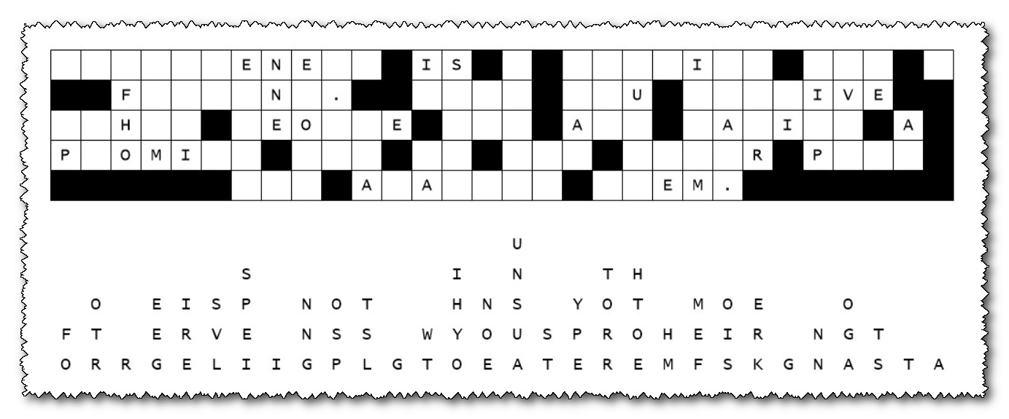
- Ask God for wisdom regarding the best way to approach the situation.
Well, our decoder interns have done it again. They used defective glue when attaching the letters to the message template and more than half the letters fell straight down. We need your help to put the letters back in place. Some columns are easy with only one letter fallen. In other places the letters that didn’t fall from the word will give you a clue. Then study the two and three blank words. Find letters which will make reasonable words. It’s a good idea to cross off the letters as you use them. When you figure it out, pass the message along to your class leader. Help is available at https://tinyurl.com/3mzba6c2 with other Fun Family Activities
Fallen Phrases Puzzle

