1. Motivate

If you could live anywhere in the world, where would it be?

- Disney World
- Hawaii
- in a big city
- on a farm in the country
- where I grew up
- somewhere I’ve never been before
- on the Mediterranean
- someplace warm
- somewhere with distinct seasons
- Tahiti
- on a sailboat that went from island to island
- an island in the Caribbean
- on a cruise ship

2. Transition

Certainly in this world, no matter where we live, God is with us.
- At the same time, each of those locations have some drawbacks.
- But when we are with God in Heaven, we can live forever in His very presence there will be no negatives
A video for the introduction to this lesson is available. View it at https://watch.liberty.edu/media/t/1_hjs59me9 If you have no Wi-Fi where you teach, better to download to your computer from https://tinyurl.com/scvggnx

3. Bible Study

3.1 With God Forever

Listen for things present, things absent.

Revelation 21:1-5 (NIV) Then I saw a new heaven and a new earth, for the first heaven and the first earth had passed away, and there was no longer any sea. 2 I saw the Holy City, the new Jerusalem, coming down out of heaven from God, prepared as a bride beautifully dressed for her husband. 3 And I heard a loud voice from the throne saying, "Now the dwelling of God is with men, and he will live with them. They will be his people, and God himself will be with them and be their God. 4 He will wipe every tear from their eyes. There will be no more death or mourning or crying or pain, for the old order of things has passed away." 5 He who was seated on the throne said, "I am making everything new!" Then he said, "Write this down, for these words are trustworthy and true."

What things are listed as present, what are missing in the new heaven and new earth?
Present In Heaven | Missing from Heaven
- dwelling of God with men  - He lives with them  - everything new  - drink without cost from the spring of the water of life | - no longer any sea  - tears wiped away  - nor death  - no mourning,  - no crying,  - no pain  - old order of things passed away

In what life situations are these verses comforting?
- when we are all very much aware of our declining health
- when we lose a loved one
- when we deal with houses and cars that are falling apart
- when we see the decline of our culture, our society due to sin

What is the significance of the absence of these things?
- all these things are the result of sin in our world
- if they are not there, then there are no results of sin
- and there is no sin to cause them!

What do you think is the significance of the newness? Why is it important to understand that heaven is a place where everything is made new?
- the old earth is so stained by sin, it will be replaced
- the new heaven is made even more beautiful
- Jerusalem had been destroyed at the time of John’s writing … it was rebuilt anew
- we are told that at salvation we are a new creation (spiritually) 2 Cor. 5:17 Therefore, if anyone is in Christ, he is a new creation; the old has gone, the new has come! , then everything (including us) will be literally new creations

What are the implications for us that this present earth will pass away?
- don’t get too attached to it
- makes you wonder about worries of global warming
- assuring that all the bad we see around us will end
- all the corruption, decay, abandoned buildings will be gone

In what ways is the promise that God will dwell with us meaningful to you?
- we will have His protection
- we are no longer separated from Him by space and time
- certainly God’s Holy Spirit dwells within us now, but this will be a more visible, discernable presence
- we will be truly awed and amazed
- we will worship Him, praise Him

What does it mean that God will wipe every tear from our eyes?
- we will be totally in awe and full of joy to be in His presence
- now the believer is free from the penalty of sin, and God has made it possible to be free from the power of sin as we submit to His authority in our lives
- then we will be free from the very presence and influence of sin in our lives
- all the evil and mortality that cause us sorrow will be gone

How can this vision of heaven have a positive effect on your attitudes and actions regarding health and relationship issues?
- our struggles are temporary
- we can be assured of the “light at the end of the tunnel”
- the results of the curse of sin will not last forever
- we can be assured of the restoration of a new and whole body
- issues between us and others will be resolved – our sinful inclinations will not be present in our hearts and minds

3.2 Our Relationship with Christ

Listen for more about eternal life.

Revelation 21:6-8 (NIV) He said to me: "It is done. I am the Alpha and the Omega, the Beginning and the End. To him who is thirsty I will give to drink without cost from the spring of the water of life. 7 He who overcomes will inherit all this, and I will be his God and he will be my son. 8 But the cowardly, the unbelieving, the vile, the murderers, the sexually immoral, those who practice magic arts, the idolaters and all liars--their place will be in the fiery lake of burning sulfur. This is the second death."

How did the Lord identify Himself and what does the phrase say about Him?
- the Alpha and Omega (first and last letters of Greek alphabet)
- we would say the A and Z
- the beginning and the end
- the originator of all things and the one who culminates all things

What does the Lord promise as the blessing of the redeemed?
- if you are thirsty (spiritually), you will be satisfied
- God will give refreshment from the spring of the water of life
- more of a spiritual satisfaction than physical
- we inherit all of God’s blessings
- we will experience a special father-son/daughter relationship with the very God of the Universe

What is the fate of the unbelievers who choose a lifestyle of wickedness and perversion over eternal life and the promise of victory?
- condemnation to the fiery lake of burning sulfur
- second death
- eternal torment

What symbolizes the second death and what does “second death” mean?
- symbolized by “fiery lake of burning sulfur”
- physical death is the separation of the soul from the body
- spiritual death is separation from God
- unless we are present at the rapture, we all experience physical death
- unbelievers will experience eternal separation from God … the second death

What are ways you can honor God whether you are still on earth or when you get to heaven?
- thank Him often
- participate in both corporate and individual worship
- pay attention to what He says
- be obedient and submissive to His direction in your life
- minister to others as God’s instrument

3.3 Reign with Christ Forever

Listen for what John saw.

Revelation 22:1-5 (NIV) Then the angel showed me the river of the water of life, as clear as crystal, flowing from the throne of God and of the Lamb 2 down the middle of the great street of the city. On each side of the river stood the tree of life, bearing twelve crops of fruit, yielding its fruit every month. And the leaves of the tree are for the healing of the nations. 3 No longer will there be any curse. The throne of God and of the Lamb will be in the city, and his servants will serve him. 4 They will see his face, and his name will be on their foreheads. 5 There will be no more night. They will not need the light of a lamp or the light of the sun, for the Lord God will give them light. And they will reign for ever and ever.

What are some major elements John saw in the garden of paradise? Think of these glimpses of heaven as a peek between the curtains of a stage play before it starts. What unusual things is John able to see?
- a river flowing from the throne of God and the Lamb
- a tree that bears twelve crops of fruit (different each month)
- the leaves that heal the nations
- possible to see the face of God
- names on foreheads of His servants
- again, no need for sun or artificial lights, God’s presence is the source of “light”

Note verse 3 where it says we will serve God … What kinds of things might this include?
- praise and worship
- perfect worship … no contention over worship styles
- will we also be creative?
- may mean full and active lives … all that we do will be an act of worship
- we will reign with Him … will we be given responsibilities within the new heavens and new earth?

In what ways do you feel prepared / not prepared to be in the presence of God?
Prepared | Not Prepared
- know Jesus as savior  - name written in God's book | - mind still full of earthly thoughts  - still lots of secular world view  - seems like there will be some drastic changes  - might take some getting used to

What could you be doing to prepare for heaven and show appreciation for God's promise?
- closer daily walk with Jesus
- learn to serve Him now – training for heaven
- claim the promises about heaven when beset with sorrow, frustrations of our earthly lives

Use the last page as a handout so your learners can take home the application points of this week’s lesson.

Application
Look to Christ.
- If you have not trusted Christ, place your faith in Him.
- He desires for you to come to Him and live with Him for eternity.

Focus on heaven.
- As a follower of Christ, your citizenship is in heaven (Phil. 3:20).
- Don’t let the temporary things of life consume you.
- “Seek the things above, where Christ is, seated at the right hand of God. Set your mind on the things above, not on earthly things” (Col. 3:1-2).

Invite others to heaven.
- Identify specific people you know who have no hope of eternal life because they have not placed their faith in Christ.
- Pray and seek opportunities to tell them how they can have an eternal life in heaven with Christ.
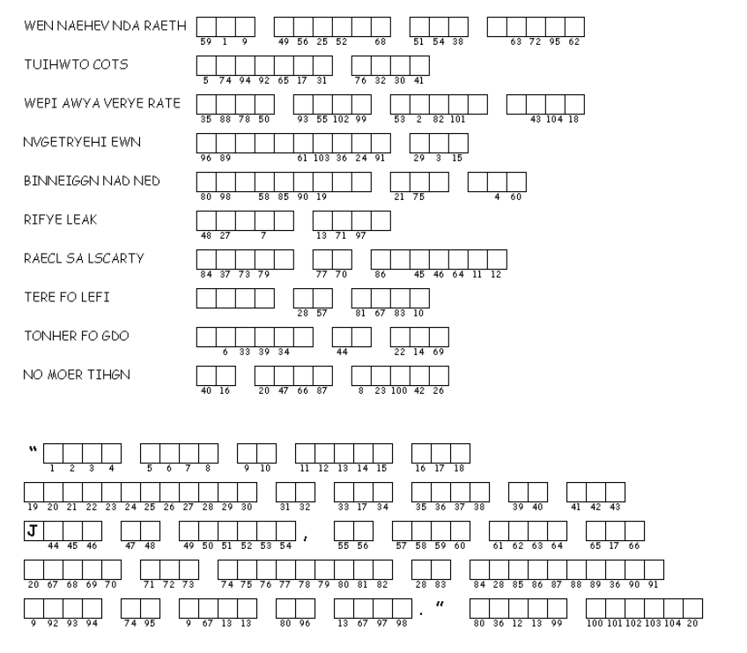

Unscramble each of the clue words. Copy the letters in the numbered cells to other cells with the same number. You’ll recognize the person who talked about heaven. Clue words and phrases taken from Revelation 21:1-8; 22:1-5 (NIV)
If you get stuck, go to https://tinyurl.com/scvggnx . There’s other great family activities there also.
Double Puzzle

