1. Motivate

What story, joke, or memory from your family of origin often gets retold?
- when the cat took down the Christmas tree
- the time we all rode the roller coaster, and someone got sick
- the trip to ___________
- when grandpa almost got arrested because he looked like some bad guy
- we got upgraded to a really fancy suite at Disney World
- the time the car got totaled but God protected us and no one even got a scratch

2. Transition

It’s a good practice to regularly remember things God has done for you.
- It can help you meet the challenges of following Jesus.
A video introduction to the Bible study is available. View it at https://tinyurl.com/593pvbx7 If you don’t have wi-fi where you teach, you must download the video file to your computer from https://tinyurl.com/yc5bw3ja
3. Bible Study

3.1 God Unfolds His Plan

Listen for crossing instructions.

Joshua 4:1-3 (NIV) When the whole nation had finished crossing the Jordan, the LORD said to Joshua, 2 "Choose twelve men from among the people, one from each tribe, 3 and tell them to take up twelve stones from the middle of the Jordan from right where the priests stood and to carry them over with you and put them down at the place where you stay tonight."

If you were an Israelite what details of the crossing of the Jordan river would you want to remember?
- how the priests just stepped into the water and it parted
- how the river bottom was dry as they crossed
- how the whole thing was organized
- how the water was kept back until the priests stepped onto the shore

Consider how long it would have taken …
- Say there were 2,000,000 people (some estimates are as high as 3 million)
- Assume 200 ft river bed
- Walking speed 3 mph, 5 ft intervals
- 100’ wide, 40,000 rows => more than 30 hours!!!
- 1000’ wide, 4000 rows => 3 - 4 hours
- 1 mile wide front => 0.5 – 1 hour

What was Joshua instructed to do? What were the tribal representatives to do with the stones they retrieved?
- after the people cross
- one man from each of the 12 tribes
- each picks up a stone from the middle of the Jordan
- big enough that you had to carry it on your shoulder
- from where the priests were standing with the Ark of the Covenant

How can we help other individuals or your church celebrate the spiritual victories they experience
- a “spiritual birthday party” for children, grandchildren
- keep a scrapbook of memories from church camp, retreats, youth outings
- take pictures, videos of youth activities
- write important dates in your Bible
- journal your spiritual experiences – include family members
- keep a record of church history – (written, pictures)
  - new buildings,
  - yearly VBS,
  - pastoral highlights
  - revival services, outreach ministries
  - musical presentations
  - even church sports teams

3.2 Create Reminders of God’s Workings

Listen for the purpose of a rock collection.

Joshua 4:4-7 (NIV) So Joshua called together the twelve men he had appointed from the Israelites, one from each tribe, 5 and said to them, "Go over before the ark of the LORD your God into the middle of the Jordan. Each of you is to take up a stone on his shoulder, according to the number of the tribes of the Israelites, 6 to serve as a sign among you. In the future, when your children ask you, 'What do these stones mean?' 7 tell them that the flow of the Jordan was cut off before the ark of the covenant of the LORD. When it crossed the Jordan, the waters of the Jordan were cut off. These stones are to be a memorial to the people of Israel forever."

Describe the scene for how the stones would create a teaching-learning situation.
- if you were out walking along the river you’d see a pile of stones
- would obviously not just be a place where stones got washed up
- children ask
  - “What’s this?”
  - “How did it get here?”
  - “Why did they put this pile of stones here so long ago?”
  - “Do they mean something, or what”?
- gives you a perfect opening/opportunity to describe what happened

What did this miraculous event say about God?
- remind the people of the miracle God performed stopping the flow of the river
- would be observable for generations to come
- would show God’s power
- showed God’s protection, deliverance
- God has power over natural elements

What indicates this witness of God’s power would have long-term effects?
- stones would last a long time
- not like a wooden sign that would fad or rot away
- would always be something that would trigger curiosity
- Joshu states it would “be a memorial to the people of Israel forever.”

What type of memorial might help you remember a time God worked on your behalf?
- could be a piece (door handle) of a totaled car God protected you
- a picture of the youth camp (the chapel, the bench, the cabin) where you were saved or dedicated your life to God
- you noted on the inside cover of your Bible the date and place where God spoke to you in a special way
- the printed program of a special concert where the songs/preaching spoke to you and it changed your life
- autograph of the speaker who prayed with you when you went to the altar

Why is it important for us to pass on the stories of God’s faithfulness to others?
- it is a testimony … telling what God did in your life
- communicates to others what God is continuing to do
- encourages, challenges others to trust God in similar situations
- when you share the story, people realize they are not alone in dealing with difficult issues

3.3 So, Don’t Forget

Listen for suggested conversation about the stones.

Joshua 4:20-24 (NIV) And Joshua set up at Gilgal the twelve stones they had taken out of the Jordan. 21 He said to the Israelites, "In the future when your descendants ask their fathers, 'What do these stones mean?' 22 tell them, 'Israel crossed the Jordan on dry ground.' 23 For the LORD your God dried up the Jordan before you until you had crossed over. The LORD your God did to the Jordan just what he had done to the Red Sea when he dried it up before us until we had crossed over. 24 He did this so that all the peoples of the earth might know that the hand of the LORD is powerful and so that you might always fear the LORD your God."

While the witness of the stones would be a means of instructing their descendants, who else needed to know, not only the meaning of the stones, but to know the Lord God?
- foreigners who came along would be told the story
- it would be a witness to Gentiles
- it would challenge other peoples to trust in Jehovah God
- it was done so that “the peoples of the earth might know that the hand of the Lord is Powerful”
Use the last page as a handout so your learners can take home the application points of this week’s lesson.

What else does the Lord want the peoples of the earth to know about Him?
- His love
- His available salvation
- His holiness, righteousness/justice
- their sinful condition and the solution He has provided

Why is it important for us to pass on stories of God’s faithfulness to future generations?
- makes the promises of God personal
- more than just a bunch of stories from the Bible
- this happened to US … to ME
- God’s blessing, rescue, provision is real

How do past victories serve as a testimony to God’s mighty nature to future generations?
- God did it before, He can do it again
- every generation faces similar challenges … the details might be different, but the principle of the need for God’s powerful intervention remains the same
- kids need to know that their parents faced similar struggles and that God was sufficient both then and now
- it is an encouragement to young people to hear specific examples of how God worked in the lives of someone they know
- future generations need to know both our struggles and God’s intervention in our lives

Think of your life as being a memorial (like the 12 stone monument) … that others, especially children and grandchildren are observing …

What are some messages you want your life to communicate about the Lord?
- His faithfulness
- His love, power, authority
- His sufficiency


Application
Remember.
- Make a list of events in your life when you felt certain God was at work.
- Write down some lessons from those times that you can apply to your present situation.

Recite.
- Choose a Bible verse that helps you remember God’s goodness and faithfulness.
- Read it each day this week and try to commit it to memory.

Repeat.
- Look for opportunities to share your memorized verse with others.
- Encourage them to share it as well.
Cryptogram Puzzle

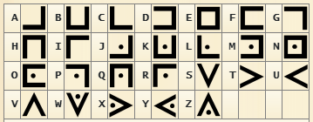
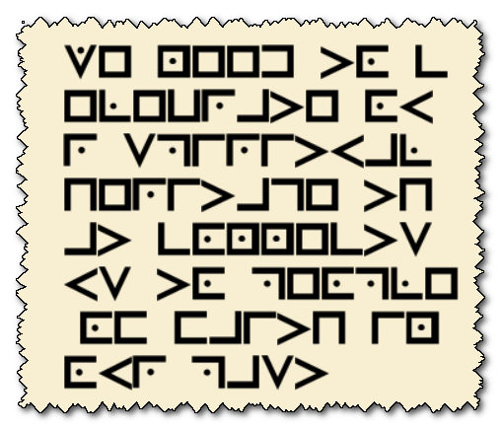

This coded message was found in a time capsule buried at the County Courthouse in Redobar, TX. It is written in an old time “pigpen cypher” used by frontier organizations. It was found in a very early edition Bible, so we believe it has significant meaning to Christians today. Our decryption team is occupied with middle school graduation this coming week, so we need your help. Use the key provided, it should work. Note the “Hello World” example. Technical help for decrypt analysis is available at https://tinyurl.com/yc5bw3ja

