1. Motivate

What are some interesting (or scary) scams or cons you’ve heard about?
- the Nigerian prince who needs to move his money
- computer solutions people who take control of your compute and basically hold it “captive” for ransom
- people who steal outgoing mail from your mailbox and use the checks
- car repair places that talk you into major expensive work
- driveway repair people that offer to apply a sealer to your asphalt driveway for cheap (it was excess from a previous job), it’s just old motor oil
- you send for a sample of vitamins and all of a sudden you are getting a monthly shipment charged to your credit card
- an ad shows up on Facebook for something free, but they want to upgrade you for a charge

2. Transition

Scammers tell you one thing but do something different.
- Not so with what God tells us.
- The Voice of God never disagrees with the Bible
A video introduction to the lesson is available. Watch it at https://watch.liberty.edu/media/t/1_l2n1viqd . If you have no wi-fi where you teach, best to download to your computer from https://tinyurl.com/4k9pje3e
3. Bible Study

3.1 Don’t Question God’s Word

Listen for a “crafty” lie.

Genesis 3:1 (NIV) Now the serpent was more crafty than any of the wild animals the LORD God had made. He said to the woman, "Did God really say, 'You must not eat from any tree in the garden'?"

The serpent is characterized as “crafty”. Note some synonyms of “crafty”.
- Cunning, sneaky
- Sly, shrewd
- Devious, wily
- Underhanded

What does that suggest about any person’s encounter with Satan?
- cannot be trusted
- will try to trick us
- lies to us, deceives us
- realize those temptations are bad for us

How did the tempter distort what God said?
- claimed God forbid them from eating from any of the trees
- cast doubt on God’s loving care for them
- implied that God was mean and spiteful

How would you describe the difference between asking questions about God’s Word and questioning His word? Give examples.
Questioning what God says | Questions about what God says
- “Why is God ‘jealous’ of me?” (Oprah)  - How could a God of love send someone to Hell?  - Why does a supposedly good God let bad things happen? | - What does that verse mean?  - Who said that?  - What is the antecedent for the pronoun?  - Who was God talking to?  - What other passages back up this one?  - What do we know about the church Paul was writing to (where, when, why)?

What can cause us to question God’s Word?
- we don’t understand the meaning of what we read
- we haven’t studied God’s Truth to know what is a lie from Satan
- we don’t really know what it says
- if we don’t have knowledge of what God has communicated to us, we can be easily fooled

3.2 Don’t Alter God’s Word

Listen for Eve’s initial response to the serpent.

Genesis 3:2-3 (NIV) The woman said to the serpent, "We may eat fruit from the trees in the garden, 3 but God did say, 'You must not eat fruit from the tree that is in the middle of the garden, and you must not touch it, or you will die.'"

How did the woman respond to the tempter?
- tried to defend God
- gave a version of what God had said
- said they were allowed to eat of (most of) the trees in the garden.
- only the tree in the middle of the garden was forbidden
- and … they weren’t even to touch it
- the penalty for doing so was to be death

Check what God originally told Adam in Genesis 2:16-17 (NIV) And the LORD God commanded the man, "You are free to eat from any tree in the garden; 17 but you must not eat from the tree of the knowledge of good and evil, for when you eat of it you will surely die."

Why might she have added the “must not touch it”?
- note that God had originally told Adam before He had created Eve
- Adam might have added the additional warning, “don’t even touch it”

What kinds of things get “added” to what God has said to us? What have you heard someone declare that a Christian should never do that is probably not found in the Bible?
- go to movies
- play sports on Sunday
- smoke, spit, chew or go with girls who do
- consume alcohol
- wear lipstick, paint your nails, wear pointy toed high heel shoes

Is it in the Bible or not?
- God helps those who help themselves.
- Gentleness and self-control. Against such things there is no law. (yes)
- Cleanliness is next to godliness.
- Hate sin, love the sinner.
- God works for the good of those who love him. (yes)
- Money is the root of all evil. (it’s the root of evil)
- Offer your bodies as living sacrifices, holy and pleasing to God. (yes)
- This too shall pass.
- If anything is excellent or praiseworthy—think about such things. (yes)
- The lion shall lay down with the lamb. (See Is 11:6 and Is 65:25)

Why does God give prohibitive commands, anyway?
- it’s like the owner’s manual for an electronic device or a car
- do what it says, and the device will last longer
- God’s specifications are for the good of our lives
- they protect us from evil

3.3 Don’t Contradict God’s Word

Listen for more ways Satan tempts us.

Genesis 3:4-6 (NIV) "You will not surely die," the serpent said to the woman. 5 "For God knows that when you eat of it your eyes will be opened, and you will be like God, knowing good and evil." 6 When the woman saw that the fruit of the tree was good for food and pleasing to the eye, and also desirable for gaining wisdom, she took some and ate it. She also gave some to her husband, who was with her, and he ate it.

What did the tempter seem to suggest about God’s intentions?
- said “you will not surely die”
- basically said God had lied
- said God was withholding a good thing from them

What steps define the woman’s fall into disobedience?
- looked at the tree (again)
- saw it looked like good food
- looked pretty (pleasing to the eye)
- looked like it would be a good source of wisdom

Note the man’s role and responsibility in this incident of contradicting God’s Word.
- “You” pronouns used by Satan were plural
- Indicates Adam was probably present in this interchange
- Note also the “he was with her”
- Had nothing to say initially
- After Eve ate the fruit, she offered it to Adam
- He ate it also

What are some current examples in our culture that are contradictions of God’s Word?
- gender “confusion”
- abortion not considered “murder” – fetus is merely “tissue”
- use of mind-altering drugs
- substance abuse in general
- humanism … people are the deities
- rejection of existence of God

How are people tempted to change the meaning of God’s Word to align with our preferences?
- reject Scripture as God inspired
- point out alleged “contradictions” in Scripture
- interpret certain passages out of context
- claim the Bible is a collection of myths
- believe that some Bible directives no longer apply to today’s world
- use the “cafeteria” method – pick and choose which Bible teachings they will accept

Paul said, “But when you are tempted, he will also provide a way out so that you can stand up under it.” 1 Cor. 10:13 (NIV) How can we recognize these places of escape from Satan’s temptations?
- scripture memorization can bring the right thoughts to our minds
- the earliest point of escape is not to go near the temptation to start with
- focus on Jesus, not on how tempting something is
- what you fill your mind with on a daily basis is important … doesn’t give Satan the same odds
- be on very familiar speaking terms with the Lord … just like you recognize someone’s voice on the phone, you recognize (and listen to) his voice speaking to you
Use the last page as a handout so your learners can take home the application points of this week’s lesson.

Use the last page as a handout so your learners can take home the application points of this week’s lesson.
Application
Evaluate.
- List the most common ways the world rejects God’s Word today.
- Consider why people choose to reject God and His Word.

List.
- Write down some decisions you need to make and note the different “voices” that are advising you.
- Consider if those voices line up with God’s Word. Pray for wisdom and discernment to do that which lines up with God’s commands recorded in Scripture.

Study.
- Develop a plan of Bible study for the next twelve months where you intentionally learn more of God’s Word than you already know.
- Identify books and Bible studies that will deepen your understanding of God’s Word.
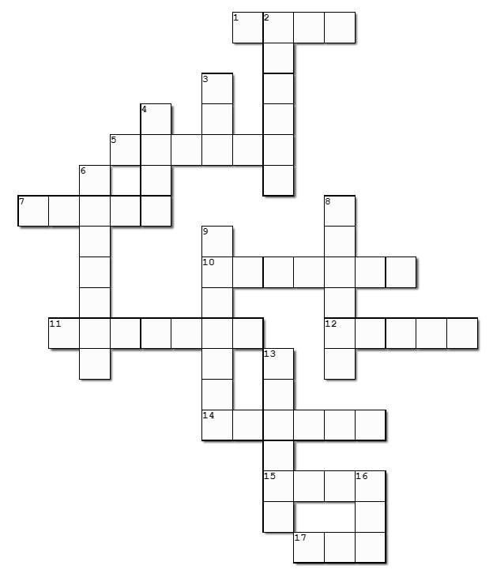
Remember, all the clues and words come from Gen. 3:1 – 6 (NIV). Help and more Family Activities are available at https://tinyurl.com/4k9pje3e
