1. Motivate

What’s the most dependable thing you’ve owned?
- car that’s been in the family since I was in high school
- pet dog
A video introduction is available for this lesson.
View it at https://watch.liberty.edu/media/t/1_y72mpibg
Download from https://tinyurl.com/y3kbm85k
- a set of tools
- computer
- TV
- cooking utensils … never break down
- recliner, couch, big green chair,
- Bible
- kitchen table

2. Transition

We depend on lots of different things … things we’ve listed … and things like electricity, water, and internet.
- We need to learn to always depend on God.
- God is greater than any challenge we face.

3. Bible Study

3.1 When Problems Arise

Listen for King Asa’s response to trouble.

2 Chronicles 14:9-11 (NIV) Zerah the Cushite marched out against them with a vast army and three hundred chariots, and came as far as Mareshah. 10 Asa went out to meet him, and they took up battle positions in the Valley of Zephathah near Mareshah. 11 Then Asa called to the LORD his God and said, "LORD, there is no one like you to help the powerless against the mighty. Help us, O LORD our God, for we rely on you, and in your name we have come against this vast army. O LORD, you are our God; do not let man prevail against you."

After the ten-year period of peace, who came forward to threaten the peace and security Asa and the people of Judah enjoyed?
- a military leader named Zerah
- had a vast army (thousands upon thousands)
- equipped with 300 chariots

How was Asa’s going out to face Zerah an expression of his loyalty to the Lord?
- Asa was the leader of God’s people
- he was in charge of protecting the country
- he was responsible for the safety/security of the land God had given them

Even as he positioned himself for battle, what did Asa choose to do first?
- called on the Lord
- prayed to God

What words or statements in his prayer are affirmations of his faith in the Lord as his God?
- there is no one like you
- you are able to help the powerless against the mighty
- help us
- we rely on you
- in your name we confront this vast army
- You are our God
- don’t let mere men prevail against You

When might you feel like the odds were stacked against you? When have you faced the reality of your own limitations?
- when you lost a job
- when your work mates conspired against you and dumped you
- when several tragedies struck at the same time – finances, health, loss of property
- flood, fire, weather threatens your home
- children rebel
- loss of spouse to death, divorce
- insurance canceled, right when you need it

What are possible meanings of the appeal “do not let man prevail against you”?
- this military leader, Zerah was a mere man
- his army was made up of just men (though lots of them)
- God is greater than any man, than any army of men
- God is greater than any circumstances you face
- Asa was telling God that he trusted Him, in His greatness, His power, His authority

How does crying out to God actually help a person overcome his or her problems and enemies?
- we are telling God we are trusting in Him, and not in ourselves
- we are demonstrating faith, trust in Who God is and in His attributes/characteristics
- God wants us to come to Him
- He wants us to express our faith and dependence in Him
- When we trust God and not ourselves, God will work to accomplish what is best for us and the best timing

What does dependence on God look like in the daily routine of a believer?
- expressing to Him daily our dependence
- realization and declaration of my own limitations and God’s omnipotence, omniscience, sovereignty, and love for us
- don’t go off on our own with no thought for God’s presence and guidance
- depend on God for strength and wisdom for all our actions and responsibilities
One of our teacher resources says, “Rather than be passive against the threats of evil, people of God are to rise up and confront them.” What would be some examples of “threats of evil” God wants us to confront in our society?
- human trafficking
- dangerous actions and policies of various political factions
- substance abuse, opioid crisis
- materialism
- world terrorism
- gang violence
- threats against religious freedoms
- need for the spread of the Gospel message at all levels – local, national, international

3.2 Facing Your Problems

Listen for the result of Asa’s dependence on God in this situation.

2 Chronicles 14:12-15 (NIV) The LORD struck down the Cushites before Asa and Judah. The Cushites fled, 13 and Asa and his army pursued them as far as Gerar. Such a great number of Cushites fell that they could not recover; they were crushed before the LORD and his forces. The men of Judah carried off a large amount of plunder. 14 They destroyed all the villages around Gerar, for the terror of the LORD had fallen upon them. They plundered all these villages, since there was much booty there. 15 They also attacked the camps of the herdsmen and carried off droves of sheep and goats and camels. Then they returned to Jerusalem.

Who is credited with the victory over the Ethiopians?
- the Lord struck down the Cushites before Asa and Judah
- the Cushites fled
- they were crushed before the Lord and His forces

What essential role did Asa and his army play in the military campaign?
- Asa and his army pursued them to Gerar
- many Cushites fell, could not recover
- the men carried off a large amount of plunder
- they destroyed the villages around Gerar
- gathered much booty
- attacked camps of herdsmen
- carried off much livestock

What words and phrases describe the utter defeat of the Ethiopians?
- struck down
- great number fell
- could not recover
- crushed before the Lord
- terror of the Lord fell on them

Why might Asa and the people have attacked and plundered Gerar and the other settlements of the region?
- possibly the villages were supportive of Zerah and his forces
- villages may have been taken over by Zerah’s support forces
- need to destroy the enemy totally – not just lop off its “head”

What was the return to Jerusalem a sign of?
- mission completed
- defeat of the enemy was total
- no remaining opposition

What is the relationship between our role and God’s role in a crisis?
Our Role | God’s Role
- trust  - obedience  - ministry  - service to others | - intervene in our situation  - demonstrate power, authority  - do the right thing at the right time (that is to act in a righteous manner)  - rescue  - demonstrate His love for us

So, what does it mean and how does it work to depend on the Lord?
- talk to God daily, even multiple times a day
- declare your dependence
- tell God you’re giving up your independence
- bring your troubles to God
- bring your joys to God – rejoice with God over victories
- give Him the credit, the glory
- remember to thank Him and let him know of your gratefulness

Maybe it’s not you struggling with a great challenge or difficulty. Perhaps someone close to you is the struggling one. What can you glean from this session that will help you offer encouragement to that individual?
- offer to pray for/with them … right then, not at some undetermined later time
- share what God has done for you in the past
- share your constant dependence on the Lord
- offer to help in a tangible way as they might need it

Even as your point them toward the Lord, refrain from
- imposing guilt,
- minimizing the problem, or
- reprimanding him or her for her feelings of despair.

Use the last page as a handout so your learners can take home the application points of this week’s lesson.

Application
Share.
- Share with your group one of the challenges you are facing that, from your perspective, is an impossible challenge.
- Ask them to pray with you regarding that situation.

Invite.
- Invite someone else to walk alongside you in a difficulty you’re facing.
- Ask this person to “check in” with you regularly and encourage your continued trust in God.

Retreat.
- Take some dedicated time this week to have a personal prayer retreat.
- Get away from any distractions.
- Leave your cell phone in your car.
- Spend a few hours—or a full day—in dedicated prayer about the challenges you are facing.
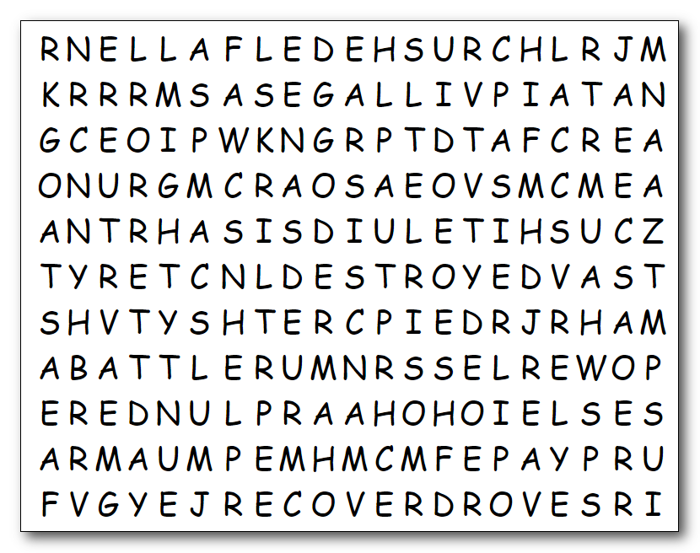
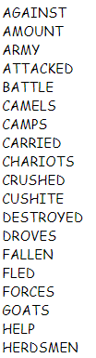
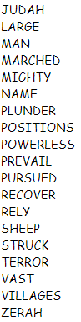

Humph! War and mayhem … and that’s just the puzzle. You need to attack the puzzle. You must prevail. Those words are coming at you left, right, up, down and even diagonally. Good luck on any plunder, however. Humph! You’ll probably need help … go to https://tinyurl.com/y3kbm85k
There’s easier activities there for wimps. Humph!

