1. Motivate

Who was a big influence in your life when you were young?
- parents
- an older sibling
- a teacher
- a youth leader at church or from a Christian organization such as Young Life, Fellowship of Christian Athletes, or (if you’re old enough) Youth for Christ
- a scout leader, AWANA leader
A video for the introduction is available.
View at https://watch.liberty.edu/media/t/1_5f4yo5r1
Download from https://tinyurl.com/yy22d995
- a grandparent or other favorite relative
- a pastor

2. Transition

Consider that now, as an adult, you have influence on younger people around you.
- You have an opportunity to be a positive influence on them.
- You are called to use your influence for God’s kingdom and for His honor.

3. Bible Study

3.1 Influence Others

Listen for a cycle of events.

Judges 4:1-5 (NIV) After Ehud died, the Israelites once again did evil in the eyes of the LORD. 2 So the LORD sold them into the hands of Jabin, a king of Canaan, who reigned in Hazor. The commander of his army was Sisera, who lived in Harosheth Haggoyim. 3 Because he had nine hundred iron chariots and had cruelly oppressed the Israelites for twenty years, they cried to the LORD for help. 4 Deborah, a prophetess, the wife of Lappidoth, was leading Israel at that time. 5 She held court under the Palm of Deborah between Ramah and Bethel in the hill country of Ephraim, and the Israelites came to her to have their disputes decided.

What spiritual assessment of Israel opens chapter 4? What cycle of spiritual ups and downs do we see?
- previous judge passed away
- people sin by disobedience
- God allows oppression by nearby nationalities
- the people cry out to God and God raises up a leader

What are some of the details of the opposing forces?
- King named Jabin, reigned in Hazor
- army commander Sisera from Harosheth Haggoyim
- had 900 iron chariots
- oppression lasted 20 years

What do we learn of the judge or leader whom God raised up at this time?
- a woman, Deborah (only woman judge)
- she was a prophetess
- wife of Lappidoth
- “held court” -- judged people’s disputes
- had a specific meeting place under the “Deborah Palm”

What characteristics are necessary for leaders now as well as then?
- people trust you
- wisdom
- insight into the heart of a problem
- willing to go before … not just point the way
- a visionary, able/willing to dream big

What additional characteristics or attributes are need for spiritual leadership?
- close walk with God, surrendered to God
- knowledge of God's Word
- the spiritual gift of leadership, administration
- faithfulness

Who’s a “Deborah” in your life when you need to make difficult decisions?
- parent
- older sibling
- favorite relative
- sometimes a friend who was a good listener

3.2 Encourage Others

Listen for God’s call.

Judges 4:6-9 (NIV) She sent for Barak son of Abinoam from Kedesh in Naphtali and said to him, "The LORD, the God of Israel, commands you: 'Go, take with you ten thousand men of Naphtali and Zebulun and lead the way to Mount Tabor. 7 I will lure Sisera, the commander of Jabin's army, with his chariots and his troops to the Kishon River and give him into your hands.'" 8 Barak said to her, "If you go with me, I will go; but if you don't go with me, I won't go." 9 "Very well," Deborah said, "I will go with you. But because of the way you are going about this, the honor will not be yours, for the LORD will hand Sisera over to a woman." So Deborah went with Barak to Kedesh,

Whom did Deborah call and of what did she remind him? Note how specific the commands were.
- called for Barak from Kadesh
- told him to go
- take 10,000 men
- lead to Mt. Tabor
- we’ll take care of the Canaanite army – iron chariots and all
- told him where, how many, and guaranteed the outcome of victory

What assurances of victory are evident in her reminder?
- Jehovah commands
- the God of Israel has commanded

How did Barak respond to her?
- if you go with me I will go
- if you don’t go with me I won’t go

What was he going to lose because of his reluctance to take the lead?
- the honor of (guaranteed) victory would not be his
- the Lord will hand the general over to a woman
- a woman will get credit for killing the Canaanite General

Deborah agreed to accompany Barak in this battle. Why does a task seem easier with someone standing with you?
- mutual support
- encouragement
- they can "watch your back" (both literally and figuratively)
- share ideas, work off each other's ideas

When has God used someone to encourage you to step into a ministry opportunity?
- pastor invited to go with him door to door
- church staff asked you to teach
- music minister asked you to join the worship team
- you were asked to preach when the pastor was going to be away
- your Bible study teacher asked you to substitute for him/her
- you were asked to help plan VBS/Christmas pageant/other special event
- invited to help staff men’s/women’s ministry team

Who are some persons in your circle of influence, whom you could be encouraging in matters of faith?
- your own children or grandchildren,
- niece or nephew
- promising young person in your church
- young married couple in your church
- a Christian acquaintance with whom you exercise together, do your daily neighborhood walk together
- a person in your fellowship who is new to the faith

How can you encourage them to take on leadership responsibilities? In what ways can we be an influence for God where we live?
- answer questions they have about the Christian walk
- pray for them/with them
- have conversations of encouragement
- communicate leadership or ministry skills you see in their lives
- suggest their name to church staff when leadership openings occur

3.3 Honor God

Listen for reasons to praise God.

Judges 5:1-5 (NIV) On that day Deborah and Barak son of Abinoam sang this song: 2 "When the princes in Israel take the lead, when the people willingly offer themselves-- praise the LORD! 3 "Hear this, you kings! Listen, you rulers! I will sing to the LORD, I will sing; I will make music to the LORD, the God of Israel. 4 "O LORD, when you went out from Seir, when you marched from the land of Edom, the earth shook, the heavens poured, the clouds poured down water. 5 The mountains quaked before the LORD, the One of Sinai, before the LORD, the God of Israel.

For what does Deborah praise the Lord?
- princes of Israel took the lead
- people willingly offer themselves in service
- God went out ahead of them

What imagery suggests that the Lord goes before His people? How does He demonstrate His power?
- the earth shook
- the heavens poured
- clouds poured down water
- the mountains quaked before the Lord

If you wrote a song about God’s work in your life, what would be its theme? What kinds of victories (should) cause us to praise the Lord?
- leading and guiding
- providing
- God’s intervention
- the wisdom God gives
- rescue from problems
- answers to prayer
- God changes the lives of those you’re burdened about

What could you do this week to praise the Lord for His faithfulness in your life?
- talk to God – praising Him
- tell God you are trusting Him
- make a list of all the things God has accomplished in your life
- read through 101 Reasons to Praise God at http://average-heros.tripod.com/id17.html
- when your kids, grandkids make the right decisions
- God's healing of our bodies

How does praising God affect our view of victory? What are the benefits of celebrating what God has done?
- we give the credit to God, not to ourselves
- we learn more and more to depend on God
- we learn that God's power is always available, always sufficient, even abundant
- it also is an encouragement to others, encouraging them to trust God in their battles
- it gives us assurance the next time we are confronted with a problem
Use the last page as a handout so your learners can take home the application points of this week’s lesson.
Application
Thank someone.
- Send a note of thanks to someone who has been an influence in your life.
- Encourage the encourager!

Praise.
- Follow the example of Judges 5.
- Look at how God has worked in your life and praise Him.
- Make time in your day for listening to praise music.
- Use this as a time of personal praise and worship.

Embrace the call.
- Consider how God may be calling you to be involved in a specific ministry in your church or community.
- Find a godly person to counsel and encourage you.
- Or be that person, the one who encourages someone else to embrace God’s call in his or her life.
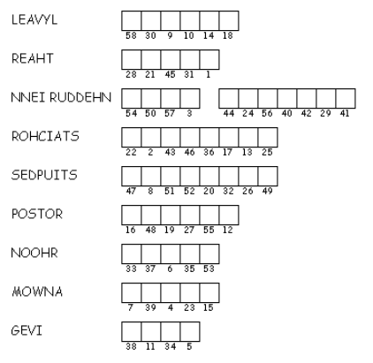
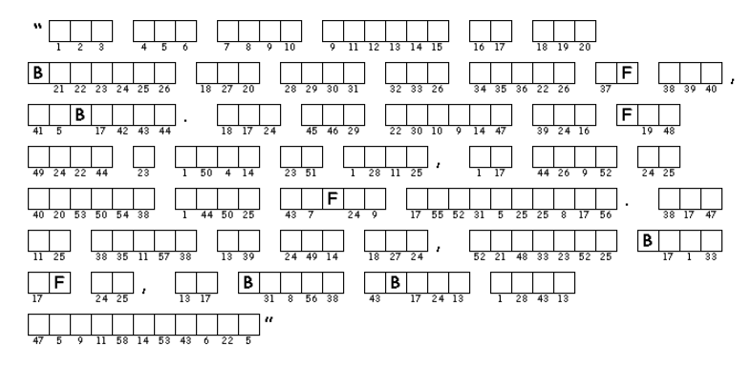

Unscramble each of the clue words. Copy the letters in the numbered cells to other cells with the same number. The clue words come from Judges 4:1 – 9 and 5:15. (NIV) The quote is from a book about Deborah by Jill Eileen Smith. The solution and other Family Activities are at
https://tinyurl.com/yy22d995

