1. Motivate

What are some things others might fear that cause you no fear at all?
- heights
- math
A video introduction is available. View at https://watch.liberty.edu/media/t/1_spv7o5am
If you have no wi-fi where you teach, best to download to your computer form https://tinyurl.com/w9hdc6bn
- carrying a gun
- spiders
- snakes
- roller coasters
- Friday the 13th
- driving fast
- diving off the high dive
- speaking before a large audience

2. Transition

Probably all of us have at least a few things we fear or dread.
- Today we study Abram’s actions when he had a specific fear.
- We learn that we can trust God when we are overwhelmed with fear

3. Bible Study

3.1 Trust God Despite Circumstances

Listen for how Abram didn’t trust God.

Genesis 12:10-13 (NIV) Now there was a famine in the land, and Abram went down to Egypt to live there for a while because the famine was severe. 11 As he was about to enter Egypt, he said to his wife Sarai, "I know what a beautiful woman you are. 12 When the Egyptians see you, they will say, 'This is his wife.' Then they will kill me but will let you live. 13 Say you are my sister, so that I will be treated well for your sake and my life will be spared because of you."

What situation resulted in Abram’s traveling to Egypt?
- famine
- drought
- crops failed, lack of food

What fear surfaced for him as he arrived there?
- realized that his beautiful wife would be desirable to other more powerful men
- he considered his own life in danger due to her beauty
- he believed he might be killed so they could claim her as a bride

What was his plan to alleviate his fear of being harmed?
- they would tell folks they were brother and sister
- they might still desire to steal her from him
- but they wouldn’t have to kill him to get her

What were the flaws in taking such an approach?
- either way she would still be in danger
- it was a lie
- he could still lose her

What are some ways fear can lead to sin? What are some situations that can cause us to fear instead of trusting God?
- when our job is threatened in some way
- when our physical safety is threatened
- our family’s safety is at risk
- danger of major financial loss
- physical health threatened by pandemic
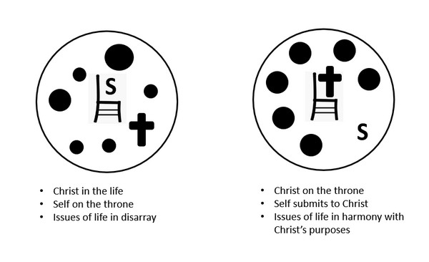

We contrast the Spirit led life on the right with what we call the “carnal” Christian on the left.

In what kinds of situations can we be tempted to respond as a carnal Christian; professing love for God but living for yourself; protecting yourself, your rights, your dreams?
- when your job is at risk
- when you want to remain one of the group
- if you are afraid of being made fun of
- if threatened by the government

What are some ways that we can return to God’s promises as New Testament believers?
- be aware of what those promises are
- be reading God’s Word daily
- meditate, carefully consider what you read
- apply those promises, those commands to the situations you are facing each day
- memorize verses with promises

How might insisting your own way on social media be expressing fear or acting in fear?
- afraid that if your opinion does not prevail, things will really go bad
- “people need to be confronted with how they are wrong, and I am right”
- it’s probably better to spend your time and energy in praying about some issues
- remember that God is more powerful than any political or idealistic group of people
- remember that God can accomplish His purposes no matter what any worldly ideology seems to be prevailing

3.2 Our Fear Can Affect Others

Listen for how Abram’s fear affected others.

Genesis 12:17-20 (NIV) But the LORD inflicted serious diseases on Pharaoh and his household because of Abram's wife Sarai. 18 So Pharaoh summoned Abram. "What have you done to me?" he said. "Why didn't you tell me she was your wife? 19 Why did you say, 'She is my sister,' so that I took her to be my wife? Now then, here is your wife. Take her and go!" 20 Then Pharaoh gave orders about Abram to his men, and they sent him on his way, with his wife and everything he had.

What happened to Pharaoh and his household because of Abram’s deceptive plan generated by his fear?
- God inflected serious diseases on Pharaoh and his household
- somehow Pharaoh realized the reason for the various illnesses
- God judged Pharaoh’s action of taking another man’s wife into his harem

What perceptions about Abram are implied by the Pharaoh’s comments to him?
- Pharaoh realizes Abram has not been honest
- he did NOT portray Sarai as his wife
- instead, he told the lie that she was a sister
- (actually, she was a half-sister, so Abram thought he could get away with a deception, a half-truth)

What action did Pharaoh take?
- confronted Abram
- told him he had lied
- gave him back his wife
- told him to leave
- had him specifically escorted out of the country
- sent him on his way with all his possessions

What implies Pharaoh may not have trusted Abram to depart on his own?
- gave orders to his men
- appears to have been escorted out of the country

How does the enemy use fear to wreak havoc in our lives?
- we focus on the problem instead of on God’s power, authority, love
- all we can do is think of the problem
- we elaborate all the possible implications
- plants thoughts of how bad it will be
- causes us to focus on ways we can solve things in our own strength and thinking

How can fear affect our witness?
- we say we trust God
- but if we are going round and round with worry and fear, we’re not demonstrating that trust
- we portray God as maybe not sufficient for our needs

3.3 Return to Trust and Worship of God

Listen for how Abram gets back on track.

Genesis 13:1-4 (NIV) So Abram went up from Egypt to the Negev, with his wife and everything he had, and Lot went with him. 2 Abram had become very wealthy in livestock and in silver and gold. 3 From the Negev he went from place to place until he came to Bethel, to the place between Bethel and Ai where his tent had been earlier 4 and where he had first built an altar. There Abram called on the name of the LORD.

Where did Abram go after being expelled from Egypt?
- north into the Negev area
- from place to place
- ended up in Bethel
- between Bethel and Ai
- where he had first built an altar

What may have been the spiritual significance of eventually returning to Bethel?
- was a place where he had previously built an altar
- a place where he met with God
- no doubt brought back memories of talking, listening to God
- after the events in Egypt, maybe he realized he had been depending on his on wisdom, not on God’s sufficiency

What did he do once he arrived?
- called on the name of the Lord
- prayed
- renewed his relationship with God
- we might surmise there was repentance and confession

What are some obstacles we face to returning to God after failure?
- pride
- maybe we need to be rescued out of a mess we have made
- harder to get out of trouble than into it
- we might have a lack of faith
- we think we’ve permanently messed up our relationship with God
- fear of having committed the “unpardonable sin”

How does God’s Word, our roadmap, help us get back on track after unwise “detours?”
- teaches us about confession
- tells us to repent
- assures God’s forgiveness
- reminds us of God’s strengthening power for the future

Use the last page as a handout so your learners can take home the application points of this week’s lesson.

Application
Reflect.
- Be honest.
- Take some time and ask yourself how your level of faith and level of fear have been affecting you and those around you.
- Identity a specific fear that you need to focus less on and then shift that focus more on the Father.

Confess. 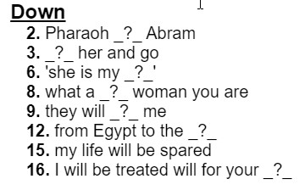
- Take a quick break and self-evaluate if there are any half-truths that you may be covering up due to fear.
- Confess it today. Remember concealing keeps you from healing.

Worship.
- Do an Internet search for a list of different names of God that are found in the Scriptures.
- Take some time and contemplate each title.
- Allow each name of God to deepen your understanding and fear of Him, while at the same time increasing your faith in His mercy
