1. Motivate

When have you thought, “uh oh, brace yourself”?
- on a roller coaster
A video introduction to the lesson is available. To view it, go to https://tinyurl.com/uz26d2cx . If you have no wi-fi where you teach, you must download the video file to your computer from https://tinyurl.com/4cpzu6n6
- when the breaks on your car went out
- when the doctor says, “I have bad news”
- when stopped by a policeman
- when the teacher hands back the exams
- when your daughter’s boyfriend comes to speak to you (the dad) by himself
- at the start of a race
- when your son begins to kick what would be the winning field goal
- you wake up late having missed the alarm
- you get notified that all flights have been cancelled for the next two days

2. Transition

Sometimes those moments affect you personally, other times it is friends or family.
- It’s normal to look out for yourself.
- But, let the fear and majesty of God compel you to look out for others.

3. Bible Study

3.1 We Are All God’s Handiwork

Listen for Job’s motivation.

Job 31:13-15 (NIV) "If I have denied justice to my menservants and maidservants when they had a grievance against me, 14 what will I do when God confronts me? What will I answer when called to account? 15 Did not he who made me in the womb make them? Did not the same one form us both within our mothers?

What example did Job use in these verses to show he treated others as equals, worthy of his just attention, and with respect for common rights?
- when his servants (employees) had a grievance
- he made every effort to respond justly
- he felt he had acted with accountability before God

What two reasons, expressed through rhetorical questions, did Job give for his attitude toward others?
- it was God who created him
- it was God who created others
- both deserved just and righteous treatment

In verses 13–15, what reason does Job give for treating his servants justly?
- he is accountable to God
- God has created both him and his servants
- in that sense, they are both equal
- he is no more deserving of justice than they are
How does his view of God as Creator shape how he views other people?
- he will treat them fairly
- he will be willing to apply what we call the “Golden Rule” … do unto others as you would do unto yourself
- he will not take advantage of them just because he is the boss

How does Job’s logic in verse 15 apply to the unborn—those who cannot speak or advocate for themselves?
- like his servants, they are individuals, each is formed by God in his/her mother’s womb
- they have no chance (as unborn) to declare a grievance
- certainly, taking their life would be a grievance if they could voice it
- it is unjust to take a life … any life … a fetus is a life

Why do you think Job frames compassion for others as a matter of reverence toward God rather than kindness alone?
- mere kindness is between you and the object of your kindness
- you might do so, hoping to receive kindness back
- you might even do so with no expectation of reciprocity
- still, it is just between you and them
- Job treated it as

How can a humble view of ourselves lead to fair treatment of others?
- if I think I am better than others, more deserving than others
  - then I will always act in my own favor
  - so called “justice” is always in my favor
  - laws and precepts don’t apply to me
- humility is NOT thinking less of myself
- humility IS thinking of myself less
- if I put others ahead of myself
  - I am willing to favor them before of me
  - give them the benefit of the doubt

3.2 Accountable to Help Others

Listen for specific people in need.

Job 31:16-20 (NIV) "If I have denied the desires of the poor or let the eyes of the widow grow weary, 17 if I have kept my bread to myself, not sharing it with the fatherless-- 18 but from my youth I reared him as would a father, and from my birth I guided the widow-- 19 if I have seen anyone perishing for lack of clothing, or a needy man without a garment, 20 and his heart did not bless me for warming him with the fleece from my sheep,

Who are those Job specifically identified he had been diligent to help in time of need?
- the poor
- widows
- fatherless (orphans)
- needy

What did he imply he had done for each group?
- provided for their desires
- helped needs of a widow (an indigent if no close relatives)
- guided widows, helped orphans, provided clothing for needy

How does our abundance create a responsibility to help those who are in need?
- God provides us all that we have
- He intends that we be His instruments in helping those in need
- should not have the attitude that our resources are all ours, acquired by our own skill and effort, to be used for our own desires
- should have the attitude that we are merely stewards for all that God has provided
- we are to use our resources at God’s direction, with the same motive of love as God’s

What does this passage suggest about God’s concern for people affected by tragedy (loss, disaster, disability, or injustice)?
- people in need can use help
- often their problem is NOT of their own making (widow, fatherless, weather related tragedy, accident …)
- we are blessed by our helping others … by God, by the heart warming feeling of seeing someone’s needs being met

What excuses do people make for not helping people in need?
- I have enough of my own responsibilities to meet
- those people’s problems are of their own making
- I earned my own way, they didn’t, they don’t deserve any of my money/stuff
- we are too often stingy
- let them pay their own way

How can we train our eyes to see the needs of those who are vulnerable?
- only by God’s help
- see situations/people as Jesus sees them
- think how you would feel in their situation
- don’t hang on so tightly to your money, your “stuff”
3.3 Seek Justice for Others

Listen for hyperbole, exaggeration for effect.

Job 31:21-23 (NIV) if I have raised my hand against the fatherless, knowing that I had influence in court, 22 then let my arm fall from the shoulder, let it be broken off at the joint. 23 For I dreaded destruction from God, and for fear of his splendor I could not do such things.

What situation is described in verse 21?
- raised my hand against the fatherless
- we might take that as striking, doing harm
- may also mean voting against or taking legal action against
- Job says if he’d done that, may God take his arm away (with the hand that was raised against the orphan or needy)

What cultural issues today may require you to stand alone in doing right?
- might get ridiculed, misunderstood
- probably will cost time, energy, finances
- may be told you have wasted your money, time
- may not be appreciated by the recipients, probably will be no reciprocity
- some may take it as a put down of the people you’re trying to help

Job treats neglect of the needy as a serious moral failure. What forms of “looking away” or “ignoring” might be common for believers today?
- claim it’s the government’s responsibility
- “those kind of people just waste what is given them”
- by getting a handout they don’t learn to provide their own needs
- “those folks start to expect help as due them”
- those people with an unwanted pregnancy have it coming for living “that kind of life”

In light of these kinds of excuses we might use, how does Job 31 challenge that mindset?
- Job knows he has resources and is well able to help
- Job figures God expects it … God is a loving, generous deity
- doesn’t want to be known for even having an ATTITUDE of rejecting other people’s needs

What are some ways our church can work against injustice toward the vulnerable in our community?
- have a well thought out benevolent ministry
- often the needy show up at the church – have a plan how to help (voucher program, groceries to give out)
- transport to a city mission ministry
- involvement in food pantry
- support ministry to unwed pregnant women
- support of AA or similar ministry

Application
Use the last page as a handout so your learners can take home the application points of this week’s lesson.
P ray for help.
- Every day this week, ask God to reshape your perspective.
- Specifically regarding powerless people who need you to help them.

Share your concern.
- Talk with others in your Bible study group.
- Consider specific ways God intends for growing believers to look out for people in need.

Meet a need.

- Take the initiative to serve God.
- Locate and volunteer at a Christ-centered pregnancy clinic or a shelter for individuals or families in crisis.
Fallen Phrases Puzzle
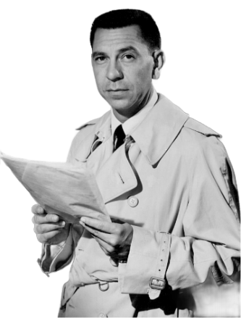
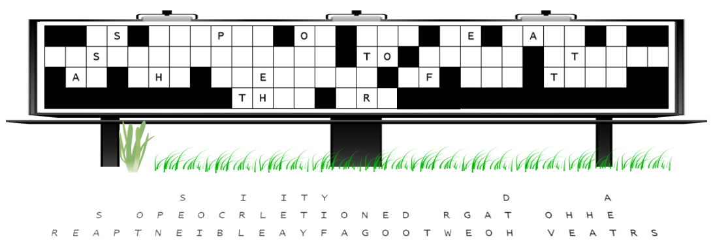
Jack Webb: Dragnet
“All right. Here’s the situation. We’ve got a vandal. One individual. He knocked a number of letters off your church sign. No witnesses. No motive yet. The maintenance crew is tied up—clearing snow from the parking lot. That leaves us with you. The letters fell straight down. Gravity did its job. Order did not. Your assignment is simple. Start with the columns that have a single letter—those are easy. Then move on to the two- and three-letter words. Pick letters that make sense. Real words only. When the job is done, notify your benevolence pastor. Just the facts. Names have been changed to protect the innocent, so don’t hesitate if you need help to go to https://tinyurl.com/4cpzu6n6. Youngsters can find the color page there also.

