1. Motivate

What advice would you include if you wrote a how-to book on growing older?
- buy low, sell high
A video introduction to the lesson is available. View it at https://watch.liberty.edu/media/1_b9027g2f If you have no Wi-Fi where you teach, better to download to your computer from https://tinyurl.com/y4jx837v
- plan ahead
- read God’s Word every day
- exercise … keep moving
- keep learning
- as Hercules Poirot said, “keep the little grey cells working”
- find a hobby
- listen to music
- make music
- as the hymn says, “Trust and Obey”
- allow God to produce in you the Fruit of the Spirit … love, joy, peace, patience, kindness, goodness, faithfulness, gentleness, self-control
- take your vitamins

2. Transition

Many books exist on how to live.
- One Book should be at the top of every person’s list.
- God’s Word gives trustworthy guidance for all of life.

3. Bible Study

3.1 Guiding Your Daily Walk

Listen for how to be blessed.

Psalm 119:1-4 (NIV) Blessed are they whose ways are blameless, who walk according to the law of the LORD. 2 Blessed are they who keep his statutes and seek him with all their heart. 3 They do nothing wrong; they walk in his ways. 4 You have laid down precepts that are to be fully obeyed.

What is the path of blessedness presented in these verses? Who will be blessed by God?
- people who walk according to God’s law
- those who keep His statutes
- when you seek Him with all your heart
- walk in His ways
- obey God fully

What does God expect from us in relationship to His Word?
- read it
- study and meditate on what He has to say
- apply it to your life
- obey it

How do we seek God with our whole heart?
- daily conversation with God
- prayer, study and meditate on Scripture
- make choices according to God’s principles

How is the way the psalmist described the law of the Lord different from the way we typically think about law?
Psalmist’s “Law” | Typical concept of “Law”
- God’s Truth  - 10 commandments  - God’s principles for living  - similar to an “owner’s manual” which describes how to live | - established by legislature, executive  - enforced by police  - punishment carried out by judge and jury  - enforcement by fear of punishment

Why does it exhort us to seek Him with “all your heart”? Is obedience not enough?
- more than just outward obedience
- includes submission of the heart and mind
- includes attitudes
- contrast small child told to “Sit down!” … responds “I’m sitting on the outside, but standing up on the inside”

Consider this translation of verse 4. Psalm 119:4 (HCSB) You have commanded that Your precepts be diligently kept.

What does it mean to keep God’s precepts diligently? Let’s list some synonyms of the word “diligent.”

- hardworking
- industrious
- meticulous
- conscientious
- thorough
- careful
- painstaking
- persistent

If we are to keep God’s precepts, why must we be diligent?
- cannot keep them haphazardly
- must be paying attention
- God’s precepts are important … cannot let spiritual issues lapse

How has God’s Word provided guidance for you?
- encouragement
- salvation message – experience God’s forgiveness
- often a specific Truth presented that applies to what is happening in my life that very day
- principles to live by
- fills your mind with what God wants … instead of how the world wants you to think and live by

3.2 Leading You to Live Unashamed

Listen for more benefits of keeping God’s Word.

Psalm 119:5-8 (NIV) Oh, that my ways were steadfast in obeying your decrees! 6 Then I would not be put to shame when I consider all your commands. 7 I will praise you with an upright heart as I learn your righteous laws. 8 I will obey your decrees; do not utterly forsake me.

Notice how the psalmist moves from the third person “those, their, they” to the second person “we”, to the first person “I.” What does this progression show you about the psalmist’s heart?
- not speaking in generalities
- he’s not preaching to others only
- it is we who need to apply this Truth to our lives
- takes it personally
- applies to us, our fellowship also
- applies to me specifically

What does the psalmist desire?
- his ways will be steadfast in obedience
- doesn’t want to be put to shame
- to learn God’s righteous laws
- for God not to forsake him

Consider Deuteronomy 31:8 (NIV) The LORD himself goes before you and will be with you; he will never leave you nor forsake you. Do not be afraid; do not be discouraged.

So why would the psalmist pray “do not utterly forsake me”?
- writer promises to obey God’s decrees
- struggling with an issue of faith
- being honest with God
- The psalmist intensely desired the Lord’s presence.
- Without it, he knew he would be overwhelmed by the threats and cares of the world.

How can we avoid treating God’s Word like helpful hints rather than commands to be diligently kept? What specific steps can you take to increase the influence of God’s Word in your life?
- get into the habit of daily reading and meditation on God’s Word
- if we skip a day, we should feel “hungry” like if we skip a meal
- participate in group Bible studies
- talk to God about your spiritual struggles
- confess them to Him … acknowledge your actions and attitudes as sin
- tell Him you are trusting Him for enabling to live according to His Word

3.3 Keeping Us from Sin

Listen for why God’s Word is treasured.

Psalm 119:9-11 (NIV) How can a young man keep his way pure? By living according to your word. 10 I seek you with all my heart; do not let me stray from your commands. 11 I have hidden your word in my heart that I might not sin against you.

What key question does the psalmist consider in beginning a new stanza?
- how to live a pure life
- advice for young people – so they can grow old successfully

What is the answer to the question? How has the psalmist guarded himself against sin?
- live according to God’s Word
- seek God with all your heart
- don’t stray from God’s commands
- Hide God’s word in your heart … memorize Scripture

How can treasuring God’s word resulted in changes in your life?
- initially, salvation – experience the reality of sins forgiven
- God speaks to you about various aspects of your life where you need to change
- you learn of God’s power at work in your life to help you overcome the influence of sin
- learn to trust God in times of stress or emergency
- assurance of God’s love when you feel down
- answers to prayer for provision, guidance, wisdom, healing

Why do some believers today not treasure the Scriptures as they should?
- you have to make the decision, choose to set aside the time to read, study
- we are busy people in today’s society
- we are motivated by lots of other things
- we have lots of options for entertainment and what we fill our minds with
- we tend to treasure material things more than spiritual things

What specific steps can you take to increase the influence of God’s Word in your life?
- resolve to spend time daily in God’s Word
- make the decision to read through the whole Bible in one year
- pay attention to what is said in a preaching service … take notes to help you stay focused
- ask God to help you keep your mind from wandering as you read the Bible or hear a sermon
- memorize scripture – various apps exist for helping you do so

Use the last page as a handout so your learners can take home the application points of this week’s lesson.

Application
Read.
- If God’s Word has not been a part of your life, begin now.
- Take time every day to read Scripture and meditate on what you read.
- A good place to start is the Gospel of John.
- Before you read, ask God to speak to you. He loves you and desperately wants to meet you in that time with Him.

Store.
- Consider practical ways to store up God’s Word in your heart.
- For example, download an audio Bible and commit to listening to God’s word during your morning and evening commute.
- Use an app like Scripture Memory Bible to help you memorize Scripture.
- If you have children, use your dinner table as a time to teach your kids the Word of God.

Teach.
- Commit to helping others know God’s Word.
- Multiply your group’s ministry by starting a new Bible study.
- Reach out to those not currently in a group and let God use you to help them discover the rich guidance from His Word.
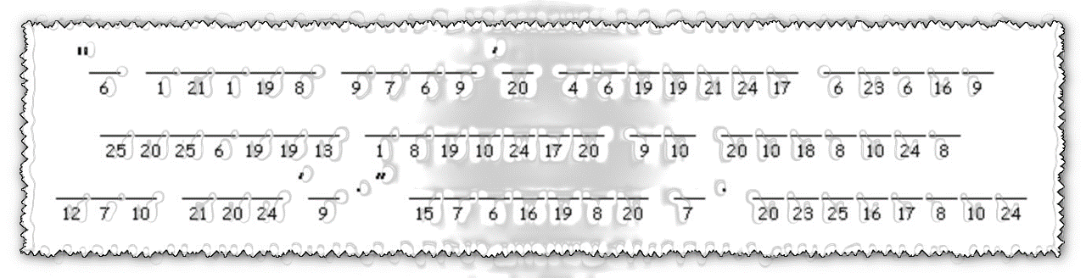
This was found on a slip of paper in the bus station phone booth (the only one left in the city). We think it is the partial key for international secret code.

Radio reports tell us the message above was found in the gutter outside the United Neihuslands consulate. See if this key works for the message. Who sent it and what does it say? Your pastor may be involved.

Help and more Family Activities at https://tinyurl.com/y4jx837v

