**1. Motivate**

What are some of your first memories of church?

* children’s Sunday School classes, youth group
* trying to sit quietly during a sermon

A video introduction to the lesson is available. View at <https://watch.liberty.edu/media/1_xks7amfi> If you have no Wi-Fi where you teach, best to download to your computer from <https://tinyurl.com/y2ohhwtf>

* church camp
* a revival service
* the choir, the piano and organ
* the hymns were sung too slow/too fast
* the nursery
* the basement where the big coal furnace was, the bell in the steeple
* what they Sunday School “opening exercises” before we went to our classes
* holiday special programs where you memorized your part
* pins for perfect SS attendance

**2. Transition**

Regular attendance as a family required commitment.

* God calls us to commitment not just to the church but most importantly to Christ.
* And commitment to Christ includes a commitment to His Body, the Church.

**3. Bible Study**

3.1 One Body in Christ

Listen for a comparison to the human body.

Romans 12:3-5 (NIV) For by the grace given me I say to every one of you: Do not think of yourself more highly than you ought, but rather think of yourself with sober judgment, in accordance with the measure of faith God has given you. 4 Just as each of us has one body with many members, and these members do not all have the same function, 5 so in Christ we who are many form one body, and each member belongs to all the others.

According to Paul, how should Christians think about themselves?

* don’t be proud and braggadocios
* realize how much we need each other
* get real … you’re not the most important knife in the drawer
* be thankful for those around you who are also members of the Body of Christ

Note the analogy he used to describe the diversity with unity that is essential to health. How did he apply that to being one body in Christ?

* the physical body
* the human body has many parts which do different things
* they all need each other
* the Body of Christ, the Church, has many members
* each will have different functions
* we need each other’s abilities in our spiritual lives

How does the analogy of the human body help us better understand how the church should work?



It’s more important to have an eye than an ear

* we realize that different parts of our body depend on each other
* feet depend on eyes to see where to walk
* hands depend on feet to get them to the right object
* blood depends on heart
* all the body depends on the blood
* And all the people within a congregation   
  (and even believers from elsewhere) have much to contribute to each other

Agree or disagree

|  |  |
| --- | --- |
| Agree | Disagree |
| * you need the eye to see things, hearing is secondary * you could learn to read lips * you could still drive | * you miss a lot around you * lots of jobs you couldn’t do * you don’t get to enjoy music, either listening or making it |

⇨ The point is, that both are equally important … Paul is saying no one believer is more important than the other … *all* are equally important.

How should these concepts keep a person from feeling superior or inferior to other Christians?

* no one person can do everything
* no single person has the capability to accomplish the mission of the church
* God does enable us for a particular ministry … if you neglect that task, someone else will be in need in some way

What does it look like when a believer *under*estimates his or her value to the church?

* it is hard to find people to fill positions
* people are down on themselves
* they are reluctant to volunteer or even respond to invitations to serve

How could that kind of thinking hinder spiritual health … both for the church and for the individual?

* the spiritual gift goes unused
* they miss out on the blessing of serving
* the person does not grow spiritually, rather stagnates
* the other members of the Body of Christ miss out on the blessing the person could have been
* the Body becomes incomplete (it loses an “eye” or a “foot” or some other member)

What should be our attitude about service to the church provided by fellow believers?

* thankful to God
* support, encouragement, mentoring
* work to make our own ministry a complement or counterpart to theirs

3.2 Using Gifts to Support the Body

Listen for using Spiritual gifts in the church.

Romans 12:6-8 (NIV) We have different gifts, according to the grace given us. If a man's gift is prophesying, let him use it in proportion to his faith. 7 If it is serving, let him serve; if it is teaching, let him teach; 8 if it is encouraging, let him encourage; if it is contributing to the needs of others, let him give generously; if it is leadership, let him govern diligently; if it is showing mercy, let him do it cheerfully.

On what basis are persons gifted?

* it is God’s grace
* God blesses us with capabilities that we don’t deserve
* similar to salvation, it is a gift … you don’t earn it
* often one’s spiritual gift goes along with training and skills used in the secular world (bus mechanic, teacher, financial advisor, web master)

How should that affect our attitude toward the gifts we have, that others have, and the way we use them?

* our skills are not necessarily self-made … God gave us those skills
* we are given those skills to be used for the ministry of God’s Kingdom
* we use them to minister to others
* we are part of a team that contributes to the overall outreach and discipleship task of the church

What are some words or phrases which Paul uses to tell us the attituded with which we should use a Spiritual gift.

* use it in proportion to your faith
* use it generously
* use it diligently, cheerfully

What obstacles often prevent us from using our gifts as God intended?

* too busy with our secular pursuits
* fear of making a mistake
* not realizing the concept of *each* believer having a spiritual gift
* not aware of a need where one has a specific skill or gift

When have you seen the benefits of someone using his or her spiritual gifts in the church?

* a teacher who prepared each week for class
* I remember a Youth for Christ director – enthusiastic, excited for the spiritual growth of teens in several school districts
* the lady who faithfully rocked babies in the nursery
* the folks who faithfully prayed for needs within the church
* the people who called on folks in the hospital
* the people who worked to clean each week
* the guy who mowed the lawn and tended to the flower beds
* the elders and deacons who gave guidance to the church ministries

3.3 Serving the Lord Together

Listen for attributes that enhance the unity in the church.

Romans 12:9-16 (NIV) Love must be sincere. Hate what is evil; cling to what is good. 10 Be devoted to one another in brotherly love. Honor one another above yourselves. 11 Never be lacking in zeal, but keep your spiritual fervor, serving the Lord. 12 Be joyful in hope, patient in affliction, faithful in prayer. 13 Share with God's people who are in need. Practice hospitality. 14 Bless those who persecute you; bless and do not curse. 15 Rejoice with those who rejoice; mourn with those who mourn. 16 Live in harmony with one another. Do not be proud, but be willing to associate with people of low position. Do not be conceited.

What are some ways Paul identified for how love will manifest itself in relationship to others?

* honor others above yourselves
* serve the Lord with zeal, with fervor
* joyful in hope
* patient in affliction
* faith in prayer
* share with those in need
* practice hospitality
* bless those who persecute you (not curse them)

How might these actions contribute to the unity of the body?

* everyone is working for the help and blessing of everyone
* no one is trying to gain advantage for only themselves
* we demonstrate the same kind of love for each other that God showed us – unsolicited, even undeserved kindness

Consider three of these commands. How might they be either the easiest or the hardest to obey?

|  |  |  |
| --- | --- | --- |
| Command | Easiest to Obey | Hardest to Obey |
| Hospitality  Joyful in hope  Praying for each other | * something you do as part of your culture * some people are naturally joyful, optimistic * we do that all the time, pray for physical needs | * some of those people we help are just moochers * it’s a crazy world with masks and social distance * some of those people have *same* boring request every time |

⇨ We must take care neither to take these commands lightly nor become cynical in attitude. They are all important to the growth of the Body of Christ, the Church

What would your church look like if all members loved each other in the way described in these verses?

* church growth –
* many people attracted to such a joyful and vibrant body of believers
* needs met
* spiritual growth

Use the last page as a handout so your learners can take home the application points of this week’s lesson.

* miracles start to happen
* lives changed

Application

Think.

* Think about the love of Christ for you.
* Consider all the ways Jesus has loved you and consider His call on your life to love His bride in the way He loves you.
* Ask yourself: “How should I live differently in light of God’s love for me?”

Minister.

* Identify the spiritual gift(s) God has given you and get busy using it.
* Ask your pastor or others in your group how you might utilize your gift to minister, strengthen, and support your church.

Motivate.

* As the body of Christ, we have a responsibility for each other.
* Maybe you know a fellow believer who is either not connected to a local church or is not using his or her spiritual gift.
* Lovingly confront and encourage the person to carry out his or her role in the body of Christ

This is just like a secret message from Spiros the Spy. To create the key, unscramble each of the clue phrases. Hint: they are from Romans 12:3 – 16 (NIV), Then copy the letters in the numbered cells to the cells with the same number. If you’re stuck go to <https://tinyurl.com/y2ohhwtf>. And it’s no secret … there’s **more** Family Activities there.

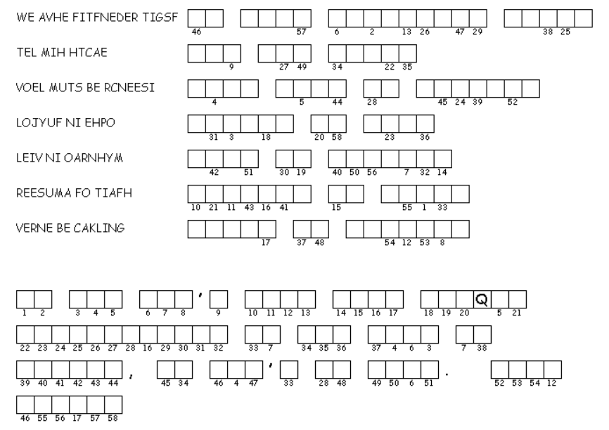Double Puzzle