1. Motivate
A video is available for the introduction.
View at https://watch.liberty.edu/media/t/1_mekxqxjq
Download (best if noWiFi where you teach)
at https://tinyurl.com/yyrkkwwy
What’s your favorite way to relax?
- read a book
- watch tv
- morning coffee watching the sun come up
- a glass of iced tea sitting in the shade
- candle light and soft music
- a good night’s sleep
- sit and watch the grand kids play
- a walk through the neighborhood after supper
- fishing or golf or ___________ with friends

2. Transition

What is relaxing for one person may not be for another.
- But we all need some times of relief from the daily grind.
- Today we discover that rest is a gift from God.

3. Bible Study

3.1 Day of Rest Commanded

Listen for who should rest.

Exodus 20:8-11 (NIV) "Remember the Sabbath day by keeping it holy. 9 Six days you shall labor and do all your work, 10 but the seventh day is a Sabbath to the LORD your God. On it you shall not do any work, neither you, nor your son or daughter, nor your manservant or maidservant, nor your animals, nor the alien within your gates. 11 For in six days the LORD made the heavens and the earth, the sea, and all that is in them, but he rested on the seventh day. Therefore the LORD blessed the Sabbath day and made it holy

How is the Sabbath to be honored?
- keep it holy – distinct, unique, different, separate
- refrain from work
- you and your whole family, even the servants and the animals are to rest

What is the rationale for resting from work?
- we model God’s treatment of “work” days
- He “worked” six days in creation
- then “rested”, ceased “work” for the 7th day

Why do we often struggle to slow down and take a break?
- we have very crowded schedules
- always lots to do
- we have so many “inputs” into our lives
- there are multiple opportunities to spend our time, our energies, our attention
- if we don’t keep going, someone else will pass us in achievement or rewards
- we might have the feeling that to sit and do nothing productive is unspiritual
What distractions can keep us from a time of resting and reflecting on the Sabbath?
- a big project at work
- teachers have test papers, homework to grade
- the lawn and garden need attention
- we’ve got that boat and the beach and lake beckon – the lake is most always beautifully smooth on a Sunday morning
- our favorite team is playing at home this weekend and tickets are available

What benefits of practicing a day of Sabbath rest resonate with you?
- we so often feel frazzled, drained in our responsibilities and commitments
- it’s good to be able to set those things aside and fiddle unproductively
- emotionally and physically it’s good to just sit and maybe even drowsily nod off
- spiritually it’s good to take time away from the work week and focus on Who God is and what He is doing

What positive actions can you take to honor the Lord’s day?
- worship
- praise
- set aside special time to spend with Him
- take time away from your work activities – don’t become a workaholic

3.2 Holiness of a Day of Rest

Listen for consequences.

Exodus 31:12-14 (NIV) Then the LORD said to Moses, 13 "Say to the Israelites, 'You must observe my Sabbaths. This will be a sign between me and you for the generations to come, so you may know that I am the LORD, who makes you holy. 14 "'Observe the Sabbath, because it is holy to you. Anyone who desecrates it must be put to death; whoever does any work on that day must be cut off from his people.

Who is the ultimate authority behind the message in these verses?
- God told Moses
- Moses passes it on to the people – and to us in writing

What is the purpose for sabbath observance given in these verses?
- it was a sign to the people from God
- we are to know that He is Jehovah … The God Who IS
- He is holy, distinct, different, unique, separate
- We are to likewise be holy, distinct, different, unique, separate
- the Sabbath day of rest is to be holy, distinct, different, unique, separate

Based on what these verses are saying, how important or significant is it to honor God on the Sabbath?
- God considered it very important
- He proscribed extreme harsh penalty
- we tend to ignore that significance in our culture today
- God wanted to make sure people received the rest and renewal that is required by the way our bodies and minds are designed/created

What does it mean to keep a day “holy”?
- separate
- unique
- different from other days
- distinct

What might need to change so that our Sabbath practices improve our relationship with God?
- more regular in church attendance
- less secular pursuits
- slow down hectic pace
- make sure to spend time with God
- both corporate worship, personal worship

What are signs of people being addicted to work?
- leave home early, come home late
- no time for family
- lose track of time and miss meals
- bring work home and spend all “spare” time at home doing that work
- constantly on the phone dealing with work issues
- forget promises to family to do things with the kids
- forget important dates – birthdays, anniversaries, appointments
- never take a vacation – have exceeded the allowed number of banked vacation days

What is the tension between working too much and resting too little?
- either extreme is dangerous
- work too much and you miss out on the restoration God knows you need
- rest to much and you end up a lazy bum
- need a careful balance

How does rest provide us with new ways to grow as Christians?
- set work aside for the purpose of spending time with God
- set weekend trips to sports or recreation aside to spend time worshiping with fellow believers
- set aside secular pursuits in favor of focusing on spiritual things
- attend a spiritual retreat

3.3 Rest and Our Relationship with God

Listen for a Sabbath/Creation connection.

Exodus 31:15-17 (NIV) For six days, work is to be done, but the seventh day is a Sabbath of rest, holy to the LORD. Whoever does any work on the Sabbath day must be put to death. 16 The Israelites are to observe the Sabbath, celebrating it for the generations to come as a lasting covenant. 17 It will be a sign between me and the Israelites forever, for in six days the LORD made the heavens and the earth, and on the seventh day he abstained from work and rested.'"

What is the purpose of sabbath suggested in these verses?
- a day of rest, recuperation
- again, it is said to be holy, distinct, different, separate, unique
- it demonstrates God’s model of living, of existence

What happens to people who try to take on too many responsibilities?
- they get stretched too thin
- their energy and attention run out
- they end up not having the capability to do justice to anything
- they wear out – physical and emotional “tanks” are empty

If God is omnipotent – all powerful, we might conclude He wouldn’t need rest. So why did He rest?
- He wanted to demonstrate to His creation what is needed for them
- His “resting” on the 7th day was actually part of creation
- He was creating the cycle of work and rest, just like He was creating land, stars, animals, people, etc.

What difference does it make that God told His people to rest?
- God told and showed his people the right balance
- God created us and knows we need the time aside from normal responsibilities
- God knows our bodies and minds and spirits need renewal every so often
- when God has decreed the time of rest, then we are not being lazy when we take the time every 7th day to recoup

By the time of Jesus’ life on earth religious leaders of Israel had placed extreme boundaries on Sabbath observation … Jesus stated both implicitly and explicitly these were mistaken.

However … what reasonable boundaries we can adopt for ourselves to help us keep a Sabbath rest.
- put a priority on our worship time on Sundays
- cut back on the busyness and expense of recreation
- make every effort to set aside our work responsibilities
- make sure to allow down time for physical, emotional, and spiritual rest and renewal

Use the last page as a handout so your learners can take home the application points of this week’s lesson.
Application
Rest.
- Take a day off from any work.
- Rest your mind and body—and don’t convince yourself you are not being productive.
- Proper rest will make you more productive.

Refresh.
- Spend time in prayer and worship, both by yourself and with others.
- Let the things of God fill your mind and renew you.
- Memorize Philippians 4:8: “Finally, brothers and sisters, whatever is true, whatever is noble, whatever is right, whatever is pure, whatever is lovely, whatever is admirable—if anything is excellent or praiseworthy—think about such things.”
Pssst … You can get help at https://tinyurl.com/yyrkkwwy
Don’t tell them I said so.

Reflect.
- Use a journal and write down what God is teaching you.


- Record your evaluation of the past day or week, because such reflection will spur you on to greater things.
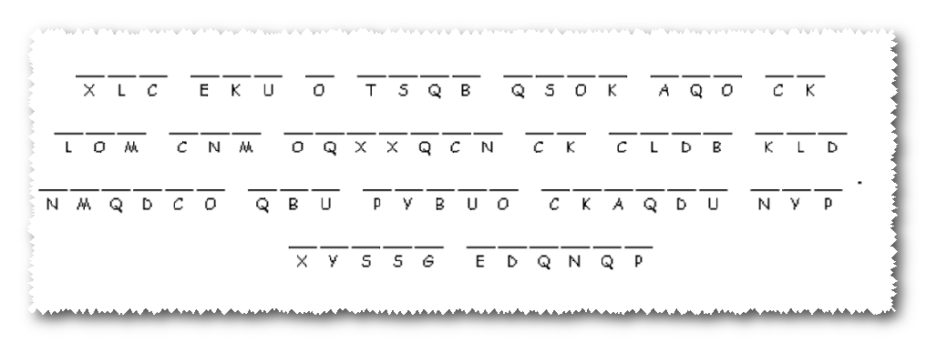

‘
Look, here’s the partial key to the message! It’s not in good shape, it’s been floating in the gutter. Some of the letters are missing. It’s called a “one time pad” cipher. Look up the letter under the blank in the lower row of the key to get the right letter for the blank. Your leader went through a lot to get this to you.

