1. Motivate

When have you been overcome by gratitude?
- people visited you in hospital
- God somehow sent a financial gift just in time to help us
- our children showed up to help us celebrate an important anniversary
- neighbors got together to help us rebuild
- I was given an award totally unexpected
- the item I really needed was put on sale, half off of half off
- when I was in grade school our parents surprised us with a gift of a trip to Disney
- the Christmas gift I was wanting but knew was too expensive showed up under the tree anyway
- Dad got me a really nice car to take with me to college

2. Transition

We might not always be overcome, but we often receive blessings we didn’t expect
- Certainly God demonstrates His grace on us daily as He provides our needs and more
- Express gratitude and trust in the One who hears our prayers.

3. Bible Study

3.1 Thankful for Love and Truth

Listen for ways to praise God.

Psalm 138:1-2 (NIV) I will praise you, O LORD, with all my heart; before the "gods" I will sing your praise. 2 I will bow down toward your holy temple and will praise your name for your love and your faithfulness, for you have exalted above all things your name and your word.

What words indicate the depth of the praise David gave to the Lord?
- with all my heart
- sing praise
- bow down
- exalted above all things

What motivated David to write this song to God?
- God’s love for him
- God’s faithfulness
- demonstration of God’s power, authority, and love
- fulfilling of God’s promises, God’s word to him

What do you think David meant when he said he praised the Lord “before the ‘gods’ ”?
- we might say, “in their face”
- to people who worshiped other deities
- before people of other cultures

In what circumstances today might we choose to worship the Lord before other "gods"?
- give thanks to God for successes
- declare your trust in God, even though tragedy has struck
- take the opportunity to pray with someone who is struggling with some problem … don’t just tell them you will, stop right there, even in public and pray with them
- letters to the editor expressing your thanks to and faith in God’s power, authority, and love – in the context of an ongoing current event
- prayer before a meal in a public restaurant
- asking your server in a restaurant if they have a prayer request as you pray before your meal

Verse 2 in the KJV reads, I will worship toward thy holy temple, and praise thy name for thy lovingkindness and for thy truth: for thou hast magnified thy word above all thy name. What do the words “lovingkindness” and “truth” mean in relationship to God?
- God is faithful in His love for us
- He demonstrates it to us daily
- God is true to His word, His promises
- God does what He says He will do
- we can depend on Him
- we can depend on demonstrations of His kindness and provision

How has God displayed love and truth in your life recently?
- answers to prayer
- protection
- meet daily needs, daily “bread”
- physical healing, recovery
- helped the kids, grandkids in school, with their relationships

Why do we often fail to give God thanks for what He has done?
- we take God’s working in our life for granted
- we act like we expect God to do good things for us as if we deserve it
- we fail to focus on who God is and what He has done/is doing for us daily
- pride in what we accomplish for ourselves, forgetting God’s part
- lack of faith … “I can do it myself” … “I did it myself”

How do the Psalmist’s words remind us to express our thanks to God
- we worship and serve the same God
- God was faithful to David, He is faithful to us
- God loved David, He loves us also
- God still deserves our praise and expressions of thankfulness
- God is still powerful and loving and interacts with us personally
- God still answers prayers, meets needs as we trust Him and seek Him

3.2 Thankful for God’s Provision

Listen for reasons to praise God.

Psalm 138:3-6 (NIV) When I called, you answered me; you made me bold and stouthearted. 4 May all the kings of the earth praise you, O LORD, when they hear the words of your mouth. 5 May they sing of the ways of the LORD, for the glory of the LORD is great. 6 Though the LORD is on high, he looks upon the lowly, but the proud he knows from afar.

How had the Lord met David’s needs?
- answered David’s prayers
- made him bold
- enabled him to be “stouthearted”
- gave him “strength in my soul” (KJV)

Whom did David want to join him in praise to God?
- all the kings of the earth
- today it would be all the presidents
- all the prime ministers
- all the dictators
- all the business tycoons
- all the political leaders

What might influence the kings or peoples of the earth to praise the Lord?
- we as believers living lives that glorify and praise the Lord
- God demonstrates His power, authority and love
- John 13:35 (NIV) By this all men will know that you are my disciples, if you love one another." … when we demonstrate God’s love to them
- when we take the Good News of the Gospel to them – we obey the Great Commission
- God uses the preaching of His Word to convict/convince people of their need for Him

According to this passage, what things display God’s glory?
- note the synonyms of “glory” … magnificence, splendor, beauty, wonder, grandeur, brilliance
- what God says
- God’s ways, what God does
- His creation
- His workings in our lives
- His workings in the life of the Church – local congregation, the Body of Christ around the world

3.3 Thanking God for Protection

Listen for God’s protection.

Psalm 138:7-8 (NIV) Though I walk in the midst of trouble, you preserve my life; you stretch out your hand against the anger of my foes, with your right hand you save me. 8 The LORD will fulfill [his purpose] for me; your love, O LORD, endures forever-- do not abandon the works of your hands.

How does the Lord demonstrate His care for those He loves? List the assurances from the Lord that David claims in these verses.
- preserves us in our troubles
- protects us from our enemies
- reaches down to intervene in our lives

What hope did David place in the Lord? On what are these assurances based?
- he knew God had a purpose for him
- he believed, was convinced that God could and would accomplish that purpose
- David was convinced of God’s power, authority, and love for him that would work in his life
- he knew God would not abandon him or give up on him

How have you found God’s words and ways to be reliable?
- scripture gives assurance
- Bible passages hold Truth that convicts/convinces us of Who God is and what He is doing
- God’s promises can be depended on
- the Good News (Gospel) of salvation changes people’s lives

When has God protected you without your awareness at the time?
- God intervenes, changes your schedule to cause you to miss being in an accident
- when a parent intervened without your knowledge
- a mentor, boss, or supervisor who put in a good word for you outside your knowledge
- a teacher defended you when you were suspected of less than stellar work or behavior

How does a thankful spirit give you courage as you face challenges in life?
- you are focusing on God … who He is … His attributes
- you are not focused on the problem, the trouble, the impossibility of the situation
- that’s why it’s so important to review the “101 Reasons to Praise God”
http://average-heros.tripod.com/id17.html
- or make your own list of things to thank God for – example https://pcchighroad.wordpress.com/2013/09/09/100-things-to-praise-god-for/

What’s happened recently in the life of our group to cause us to say, “God is faithful”?
- healing
- regain strength after physical problem
- protection of kids, grandkids
- God’s working in the life of kids, grandkids – see them make positive spiritual decisions

Use the last page as a handout so your learners can take home the application points of this week’s lesson. There is a video clip available for this application section. Watch it at https://watch.liberty.edu/media/t/1_ps1al6wa or download from https://tinyurl.com/y8y5rev5

Application
Be thankful.
- Every day this week tell God something you are thankful for.

Write out your thanks.
- Make a list—a long list!—of all the reasons you have to be thankful.
- Pray through the entire list and thank God for the different ways He has blessed and touched your life.

Thank someone.
- Write a handwritten note to someone for whom you’re thankful
- Tell that person why you thank God for him or her.
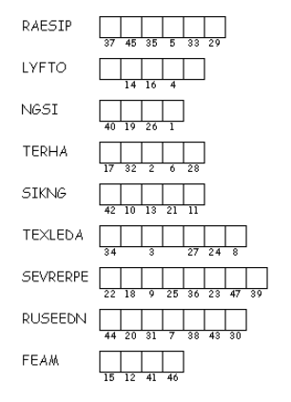
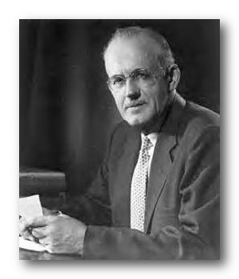
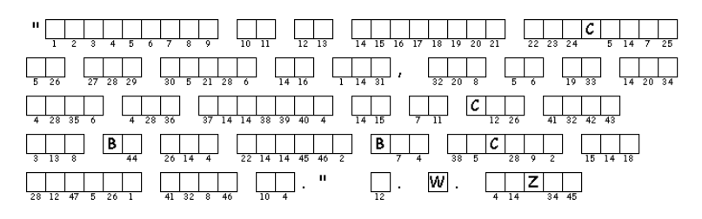
- Include a prayer of thanksgiving.
So … solve the puzzle to find out who I am and what I said. Unscramble each of the clue words. They come from Psalm 138:1-8 (NIV) Copy the letters in the numbered cells to other cells with the same number. Find the solution at https://tinyurl.com/ybqjcraz There’s other fun activities there for the whole family.

