1. Motivate

What are some ways where people in a fight or conflict with someone else might signify they wish to give up or surrender?
- throw in the towel
- wave a white flag
- ask a neutral third party to approach the other side
- ask for a cease fire
- throw down their weapons and come out with hands up
- just plain run away

2. Transition

Today we want to talk about surrender in the context of prayer … surrender to God
- We consider how to approach prayer with humble submission to the will of God.

3. Bible Study

3.1 Surrender and Submission to the Lord

Matt. 6:10 (NIV) your kingdom come, your will be done, on earth as it is in heaven.

What is the petition of this portion of the Lord’s Model Prayer?
- that the Kingdom of God would come
- the Kingdom of God is the realm where God rules
- Jesus prays that the sovereign rule God the Father will be absolute on earth, just the same as it is in heaven
- not that God’s sovereignty is in question, but Jesus declares His trust that it is, indeed, sovereign
- He is praying that men and women everywhere will submit to the will of God

How does this request continue the theme of honoring God that is at the heart of this section of the prayer?
- those who submit to God’s rule in their lives are honoring Him
- we declare our trust in His love and wisdom to direct our lives
- this is an expression of worship and adoration to trust and submit to God

What obstacles can keep us from surrendering our will to God’s will?
- our own sinful nature
- our rebellion (both active and passive) against God’s puposes
- Satan’s influence in the world
- temptations to which we succumb
- unbelief … that God’s will is the best for us

What does it mean and what would it be like for God’s will to be accomplished in earth, as it is in heaven?
- God’s purposes be accomplished
- people put their trust in Christ to receive God’s forgiveness
- lives would be lived to the honor and glory of God, instead of for personal gain
- evil actions and attitudes would be done away with

3.2 Surrender to the Lordship of Christ

Listen for how to come to God.

James 4:6-10 (NIV) But he gives us more grace. That is why Scripture says: "God opposes the proud but gives grace to the humble." 7 Submit yourselves, then, to God. Resist the devil, and he will flee from you. 8 Come near to God and he will come near to you. Wash your hands, you sinners, and purify your hearts, you double-minded. 9 Grieve, mourn and wail. Change your laughter to mourning and your joy to gloom. 10 Humble yourselves before the Lord, and he will lift you up.

What ten imperatives from James define and describe how to be in right relationship with God?

- submit to God
- resist the devil
- come near to God
- wash your hands
- purify your hearts
- grieve
- morn and wail
- change laughter to mourning
- change joy to gloom
- humble yourself before God

What three promises are attached to these imperatives?
- the devil will flee
- God will come near to you
- God will lift you up

Consider the words “He gives us more grace” and “gives grace to the humble.” What does this mean?
- grace means blessings from God that we don’t deserve
- these blessings are given to people who don’t assume they deserve them (humble)
- humility is when you have an honest view of your own needs, your own helplessness to live effectively for God

What is the relationship of grace to being reconciled to God?
- we are reconciled to God by confession, repentance, and faith in His forgiveness made possible by the redemptive work of Christ
- we do not deserve the availability of this reconciliation
- this blessing of forgiveness and reconciliation is God’s grace

How does “submitting to God” fit into this concept?
- I quit trying to live the Christian life on my own
- I admit not only my sinful nature (in receiving salvation) but my lack of the ability to live a life pleasing to God
- I submit to His leadership, His enabling, His empowering in my life
- With that attitude of trust in God, I have the attitude of humility and faith that God awards with His grace, His blessings

What is the relationship of being reconciled to God with being reconciled to others?
- by our sinful nature we are at odds with God and often with others
- when we receive God’s forgiveness we realize we don’t deserve it and should realize that we should and are able to offer that same forgiveness to others who have wronged us

We are told to “resist the devil” … what are some synonyms of “resist?”

- oppose
- refuse to accept
- refuse to go along with
- defy
- stand firm
- defend against
- withstand
- keep from

What are some ways in which we can resist the devil?
- obeying God
- draw near to God
- cleanse your hands as listed previously
- purify your hearts
- joining forces with other resisters (instead of people who go along with Satan)
- remove yourself from situations where the devil’s temptations are strong
- be reading and applying God’s word (remember Jesus use of scripture when He was tempted)

3.3 Surrender your Plans to God’s Plans

What ways do we have to manage our time?

- day timers
- calendar on our phones
- Computerized calendars
- secretaries
- honey-do lists
- a 5-year personal plan
- a written long range plan
- a degree plan (college student)

Listen for what James might say about our time fetish.

James 4:13-17 (NIV) 13 Now listen, you who say, "Today or tomorrow we will go to this or that city, spend a year there, carry on business and make money." 14 Why, you do not even know what will happen tomorrow. What is your life? You are a mist that appears for a little while and then vanishes. 15 Instead, you ought to say, "If it is the Lord's will, we will live and do this or that." 16 As it is, you boast and brag. All such boasting is evil. 17 Anyone, then, who knows the good he ought to do and doesn't do it, sins.

If your classroom has the capability, this scripture portion is available in video form which illustrates the concepts. View at https://watch.liberty.edu/media/t/1_98y4d6ao
Download from https://tinyurl.com/yd5jdctx
Right click on the video as it begins and choose the “Save” option.

Whose attention did James want to get?
- those who think they have life all figured out
- those who believe everything is under control
- those who ignore God’s direction in their lives
- boasters, braggarts

What are some mistakes we tend to make in planning for our future?
- when we will do some future venture
- where we will do this activity
- the specific endeavor we will carry out
- how well we will do
- (sounds like a well thought out business plan)

What imagery did James use to emphasize the brevity of life?
- like a mist
- present for a little while
- within minutes or hours it is gone
- in the perspective of history, our “three score and ten” is pretty short

What kinds of events can so easily alter our carefully made plans?
- an accident
- a natural disaster (earthquake, blizzard, flood, etc.)
- a missed airplane connection due to weather or mechanical problem
- a health emergency (stroke, heart attack, even longer term health traumas)
- a turn of the economy
- a terrorist event
- a government decision (our government or some other)

What does he say we should do instead?
- take the attitude that plans are made with the understanding of God’s overall control
- we make plans as we believe God would direct us, but we acknowledge His ultimate control
- involve God in your choices and plans before you make them

Note that James says that it is evil if we do not include God in our plans. List some ways to keep in submission to God as we pray.
- pray about major decisions
- daily ask God for guidance in that day’s activities
- make decisions based on the principles of God’s Word
- declare your dependence on God for “daily bread” … finances, safety, health, relationships, wisdom, etc.

Use the last page as a handout so your learners can take home the application points of this week’s lesson.

Application
Evaluate.
- Evaluate the things you pray for.
- Consider if you are more focused on what you want or what God wants.

Surrender.
- Ask God to reveal areas of your life that you have not surrendered to Him.

Fast.
- One day a week, add fasting to your prayer life.

- This is to help you focus on God and break the power of “self.”
Another message from headquarters. My sources tell me it is a quote from Billy Graham. Use the table above to determine the letters of the message about prayer. If you get stuck go to https://tinyurl.com/ybr53nqs . There’s other clever Family Activities for you to investigate also.

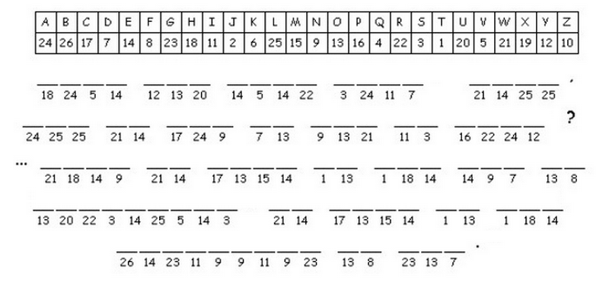
Cryptogram

