1. Motivate
Am Introduction Video is available.
View at https://watch.liberty.edu/media/t/0_tjworqbq
Download (best when no WIFI where you teach)
from https://tinyurl.com/y2gdt9os
What are things you worried about as a teenager?
- Getting homework done
- Impressing the opposite sex
- will our football team win
- will I remember my place in the marching band drill
- what to wear
- there’s a math test today
- making it home before curfew
- why did I get a pimple the day I had a first date with that good looking guy/girl
- why do Mom and Dad hassle me about talking on the phone
- getting caught sneaking out at night
- getting a speeding ticket when Dad let me drive
- getting a scratch on the car

2. Transition

Even when we’re mature adults, some of those worries come back
- Now we have additional needs and responsibilities to concern us
- Today we consider the fact that when your life is centered in Christ, you find all you need.

3. Bible Study

3.1 Don’t Worry

How would you define worry?
- excessive thought about potential problems
- obsession about possible lack of resources
- too much focus on what might happen that is going to cause us problems
- habitual, constant anxiety about necessities of life

Listen for why not to worry.

Matthew 6:25-30 (NIV) "Therefore I tell you, do not worry about your life, what you will eat or drink; or about your body, what you will wear. Is not life more important than food, and the body more important than clothes? 26 Look at the birds of the air; they do not sow or reap or store away in barns, and yet your heavenly Father feeds them. Are you not much more valuable than they? 27 Who of you by worrying can add a single hour to his life? 28 "And why do you worry about clothes? See how the lilies of the field grow. They do not labor or spin. 29 Yet I tell you that not even Solomon in all his splendor was dressed like one of these. 30 If that is how God clothes the grass of the field, which is here today and tomorrow is thrown into the fire, will he not much more clothe you, O you of little faith?

What things does Jesus say we tend to worry about?
- life’s physical necessities (what we will eat or drink)
- about our bodies (what we will wear)

What reasons then, does He give that we should not worry?
- life itself is more important than what we eat, what we drink
- our God given bodies are more important than what we decorate them with
- God feeds the little birdies just fine, they don’t worry about it, they just eat
- Worrying does not add an hour to your life nor a cubit to your height

What elements of God’s creation did Jesus use to illustrate God’s reliability as a provider? Why?
- birds – they don’t plant and reap or gather, but God feeds them
- wild flowers – they don’t sew fancy clothes, but they are more beautiful than anything the most rich people can afford
- God gives his creation food and adornment,
- and we are more important to Him than anything else in His creation

Why do some of us worry about clothes more than others?
- influenced by our friends
- pay too much attention to advertisement
- appearance is part of our job or responsibility
- lack of concern for more important issues

How do you think God feels about our society’s preoccupation with food?
- maybe He just shakes his head in wonderment
- He is concerned we are missing out on other areas of our lives which are more important
- saddened by our lack of focus on the important issues, such as our spiritual well being

What are some consequences of being enslaved to worry?
- ulcers
- loss of sleep
- loss of an attitude of gratefulness and praise
- distraction from other important elements of life
- loss of focus on the right things

How do you know when you’ve crossed the line from reasonable concern to harmful worry?
- when the object of the “concern” becomes surrounded with negative thoughts
- when you start to think about all the bad things that could happen
- when you are unable to thank God for the good things you do have, the good things He has done
- when it starts to affect your health

3.2 Trust God

Listen for who Jesus says does worry.

Matthew 6:31-32 (NIV) So do not worry, saying, 'What shall we eat?' or 'What shall we drink?' or 'What shall we wear?' 32 For the pagans run after all these things, and your heavenly Father knows that you need them.
What are different translations of the word used for the people described in verse 32? Ask the class to check some different versions of the passage, either in their printed Bibles or online (BibleGateway.com).

- idolaters
- Gentiles
- heathen
- nations
- pagans
- unbelievers

- People who don’t know God and the way he works (The Message)

What are some ways people deal with worry in their lives?
- “When you worry when you doubt, run in circles, scream and shout”
- Go into a “blue funk”
- kick the dog
- lose sleep
- substance abuse – chocolate chip cookies
- take it out on other family members

What additional reasons did Jesus include for not worrying?
- worrying is what unbelievers (pagans) do
- God knows your needs
- He loves you and wants to provide all your needs
- you need to trust Him

Why do we sometimes have difficulty in trusting God to provide?
- the need is so big
- our faith is so small
- we are not in daily communication with God who would be telling us in His word of His love, His power, His sovereignty and ability to know of and to meet our needs
- our priority is on the wrong things (material things, not spiritual)
- we look at the problem, not at the God who can solve the problem

How would worry affect our witness?
- people (both believers and unbelievers) see how we react to life’s needs
- believers claim that they trust God
- If they get all worked up and come apart at the seams over their needs, then they are not demonstrating trust, faith in God
- Jesus said we end up acting like pagans in this respect

How does praising God and giving Him glory keep you from worrying?
- focus on Who God is
- focus on His knowledge of us
- focus on His love for us
- we’re not looking at our need (desire) for stuff – food, clothes, etc.
- we’re looking at the One who provides them
- we’re looking at His power and ability to make them available

3.3 Seek God’s Kingdom Above All

Listen for what is most important.

Matthew 6:33-34 (NIV) But seek first his kingdom and his righteousness, and all these things will be given to you as well. 34 Therefore do not worry about tomorrow, for tomorrow will worry about itself. Each day has enough trouble of its own.

What is the summary truth Jesus declared?
- seek first God’s Kingdom and His righteousness
- God’s Kingdom is the realm where God rules
- allow God to rule in your life
- Colossians 3:15 (NLT2) And let the peace that comes from Christ rule in your hearts. For as members of one body you are called to live in peace. And always be thankful.
- Note: “rule in your hearts” carries the idea of a sports umpire, making a call, enforcing a rule
- God’s peace will dictate how we respond to a situation

How is an earthly kingdom different from God’s kingdom?
Earthly Kingdom | God’s Kingdom
- man rules  - the kingdom is temporal (temporary)  - it can be defeated  - it is political or geographical | - God rules  - the kingdom is eternal  - God reigns supreme, undefeatable  - it is spiritual, it crosses human boundaries

So, what does it mean for us to “seek first His kingdom”? How do we do that?
- God's kingdom is the realm where God rules
- seek to be part of that kingdom
- seek to have your life ruled by God
- seek to allow Him to work out His righteousness through you
- do not place priority on tomorrow’s problems, worries
- deal with today – one day at a time needs our attention

How do our priorities affect our worries?
- priorities are the things which fill our thoughts
- they take up our time, our money, our energy … all our resources

How can we follow Jesus’ word not to worry about tomorrow yet still plan for the future?
- learn good financial management principles and put them in practice
- consider “Financial Peace University” www.daveramsey.com
- be sure to be tithing – shows trust, demonstrates worship, shows obedience
- if our resources are expended on things which really don’t matter then they are squandered – lost
- if our priorities are focused on God – on pleasing, on serving, on trusting Him then our resources are well spent!
Use the last page as a handout so your learners can take home the application points of this week’s lesson.
Application
Confess.
- To overcome worry, confess the areas where you struggle to trust God.
- Admit your struggles with life-long worry and allow God to begin working in you.

Memorize.
- Hold strongly to the promises of God by memorizing Matthew 6:33:
- “But seek first his kingdom and his righteousness, and all these things will be given to you as well.”
- Continually remind yourself of God’s promise to provide.

Share.
- Find someone you trust and share the things that cause you to worry and the areas of your life where you lack a trust in God.
- Invite this friend to pray with you and for you.
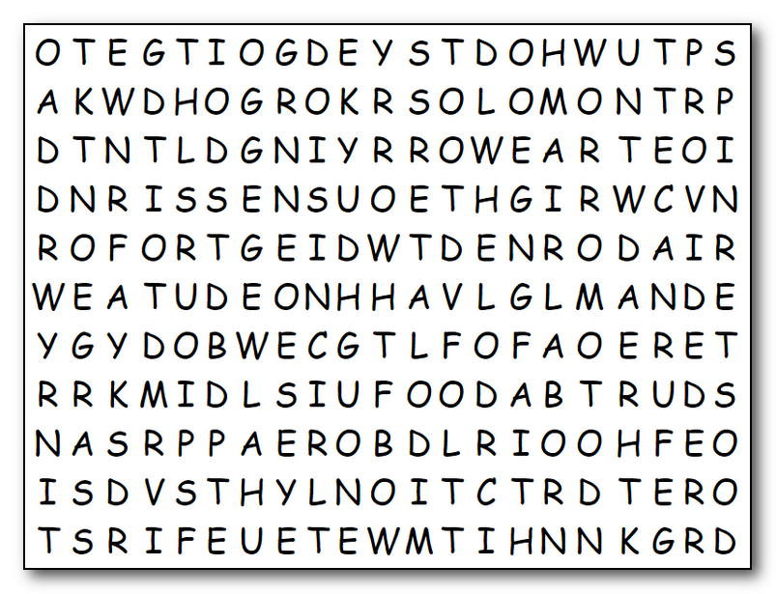

Humph! I can see you’re worried … but your Bible Study said “Stop It!” If you get to work “toot-sweet” (pardon my French), you can do it. Humph! And besides, you can look up the solution (you cheater) at https://tinyurl.com/y2gdt9os . Oh yes, words are up, down, backwards, and diagonal. Deal with it! Humph!
ADORNED
BIRDS
BODY
CLOTHING
CUBIT
DRINK
EAT
ENOUGH
FAITH
FIRST
FOOD
FURNACE
GATHER
GRASS
HEIGHT
IDOLATERS
KINGDOM
LABOR
LIFE
NEED
PROVIDED
REAP
RIGHTEOUSNESS
SEEK
SOLOMON
SOW
SPIN
SPLENDOR
THREAD
TODAY
TOMORROW
TROUBLE
WEAR
WILDFLOWERS
WORRY
WORRYING
WORTH

