1. Motivate
Who, in your view, is one of the greatest leaders of our time?
- Abe Lincoln (although not exactly of “our time”)
- Franklin Roosevelt
- Dwight Eisenhower
- Winston Churchill
- Ronald Reagan
A video introduction to the lesson is available. View it at https://watch.liberty.edu/media/t/1_hv6ylkv0 If you have no wi-fi where you teach, best to download to your computer from https://tinyurl.com/274yr3d9
- George Bush (Jr. or Sr.)
- Vince Lombardi
- Paul Brown
- Tom Landry
- Woody Hayes
- Lou Holtz

2. Transition
Great leaders have different leading styles.
- Today we consider Jesus as a leader
- Jesus is a leader who leads and cares for His people.

3. Bible Study
3.1 The King Who Shepherds His People
Listen for a prophesied leader.
Micah 5:2-5a (NIV) "But you, Bethlehem Ephrathah, though you are small among the clans of Judah, out of you will come for me one who will be ruler over Israel, whose origins are from of old, from ancient times." 3 Therefore Israel will be abandoned until the time when she who is in labor gives birth and the rest of his brothers return to join the Israelites. 4 He will stand and shepherd his flock in the strength of the LORD, in the majesty of the name of the LORD his God. And they will live securely, for then his greatness will reach to the ends of the earth. 5 And he will be their peace.

What is the historical significance of Bethlehem Ephratah?
- prophesied to be a place where a great leader/ruler emerges
- small and insignificant town
- but a powerful ruler will come from there

What promise does the Lord make to Israel?
- will go through a time where it feels abandoned
- at the appointed time when all events coincide
- God will send a great leader who will shepherd his flock in the power and majesty of God
- He will be leader in a global sense
- He will bring peace

What are some ways we need to see peace?
- national peace
- international peace
- in the environment
- in families
- peace from the pandemic
- peace in politics
- peace from violence, terrorism

What distinguishes the new kind of king the Lord promises?
- powerful
- a shepherd
- worldwide influence
- will accomplish peace
- bring security

How is this ruler still at work in our lives today?
- provides peace with God
- works to bring peace with one another
- watches over us
- guides and protects
- rescues us from sin … the penalty, the power, and eventually the presence of sin

3.2 Wise Men Seek Him … Still
Listen for who are the Magi.
Matthew 2:1-6 (NIV) After Jesus was born in Bethlehem in Judea, during the time of King Herod, Magi from the east came to Jerusalem 2 and asked, "Where is the one who has been born king of the Jews? We saw his star in the east and have come to worship him." 3 When King Herod heard this he was disturbed, and all Jerusalem with him. 4 When he had called together all the people's chief priests and teachers of the law, he asked them where the Christ was to be born. 5 "In Bethlehem in Judea," they replied, "for this is what the prophet has written: 6 "'But you, Bethlehem, in the land of Judah, are by no means least among the rulers of Judah; for out of you will come a ruler who will be the shepherd of my people Israel.'"

What was extraordinary about the visit of these men from the east?
- they came a long way
- they were gentiles, why/how would they be interested in a royal birth
- they were led there by a star
- they came without knowing the whole story, the specifics of where to go
- (some people quip that if they were “wise women” instead of wise men, they’d not have had to ask for directions and they would have brought something useful, like a casserole!)

The Magi knew of the king of the Jews because of the special star they saw, what did they not know?
- where He was born, when He was born
- who He actually was
- that He was the Messiah – the “Sent One”
- that He was not a political king

How did King Herod react to the visit of the Magi?
- he was disturbed
- this caused all Jerusalem to also be disturbed
- when the king was unhappy, they knew there would be trouble

Why was a powerful king disturbed by the presence of a helpless baby?
- if he was the king, he didn’t want any competition
- when someone came along informing him of the birth of “the” king of the Jews, it threatened his power and authority
- the Magi seemed to be learned and informed men, what did they know that Herod did not

Herod deceitfully used religion for personal ends. In what ways do people do this in our society today?
- join a church to look good, to gain a good image in the eyes of others
- go to church to make business or social contacts
- participate in various church activities to establish a position of power
- so they can play on the church baseball team
- to meet other singles
- for the inexpensive church dinners
- they like the music

Herod wanted to keep other people from showing allegiance to this “new king” – what kinds of things might keep you from truly worshiping when you come to worship services?
- distractions (people talking, personal problems, health problems)
- the environment (too hot, cold, uncomfortable, bright, dim)
- style of worship, music
- poor preaching
- wandering mind
- falling asleep

If the scholars knew what the scriptures said about the promised Messiah, why do you think they did not go worship Him themselves?
- they didn’t believe the gentile astronomers/astrologers
- they figured the Messiah would make a more grand and glorious entry onto the scene
- the appearance of the Messiah would be more obvious
- they thought His role would become evident when He assumed political or military power

They missed the Truth God had placed in scripture. What are some things we can do so we do not miss Truth God wants us to know as we study His Word?
- ask God to reveal it to you
- read it with an open mind
- learn some good study techniques
- look for what it says, what it means, what God wants you to do about it

3.3 The Truly Wise Still Worship the King
Listen for the response of the Magi.
Matthew 2:9-11 (NIV) After they had heard the king, they went on their way, and the star they had seen in the east went ahead of them until it stopped over the place where the child was. 10 When they saw the star, they were overjoyed. 11 On coming to the house, they saw the child with his mother Mary, and they bowed down and worshiped him. Then they opened their treasures and presented him with gifts of gold and of incense and of myrrh.

Let’s enumerate all the milestones have we seen in the whole lesson which lead the wise men to Jesus.
- when they were in their homeland in the east, they saw the star
- they made the connection between the star and the appearance of a new king who deserved their worship
- they traveled a long way for a long time
- they had to consult with local experts and deal with local politicians
- they followed the star which appeared again for the final destination

What words and phrases describe the worship exhibited by the wise men?
- they were overjoyed
- bowed down and worshiped
- opened treasures, presented them to him

How do these elements of worship suggest to us how we can better worship Jesus, the Messiah?
- worship should be a joyful expression (not a drudgery, not a time of frustration)
- the focus should be on Jesus … not on self or a pastor or a worship style
- we need to bow down … physical kneeling models and demonstrates spiritual submission
- God deserves our treasures … not our leftovers

Some significance can be inferred from the nature of the gifts
- Gold: a royal gift for a king
A video is available which brings out these points.
Download at https://tinyurl.com/ycxa6mgv
- Frankincense – a symbol of Jesus death, rising as incense to satisfy God's holiness
- Myrrh – used for embalming – symbolic of Jesus death

List the contrasts between those who worshiped the baby Jesus
Shepherds | Magi
- Jews  - “blue collar” workers  - outcasts  - poor  - came a short distance | - Gentiles  - royalty  - honored visitors  - very rich  - came a long distance

The thing that was the same for both groups was that they came to worship Jesus!

⇒ They came to declare the worth of the Christ Child … He is worthy of our praise
Use the last page as a handout so your learners can take home the application points of this week’s lesson.
Application
Trust your Shepherd.
- Trust Jesus to guide you with care. Consider if there is an area where He is calling you to obedience, but you are resisting.
- If so, acknowledge Jesus as your caring shepherd and trust His guidance.

Acknowledge your King.
- The wise men bowed down in recognition of the King.
- Bow or kneel when you pray this week as a physical sign that you recognize Jesus as King.
- Consider setting up a prayer place where you can make this a regular part of your quiet time with Him.

Share about your Shepherd King.
- Use a concordance or online Bible to find occurrences of the word “shepherd” throughout the Bible.
- Note how this increases your understanding of the ways Jesus cares for His people.
- Find someone you can share this truth with this week.
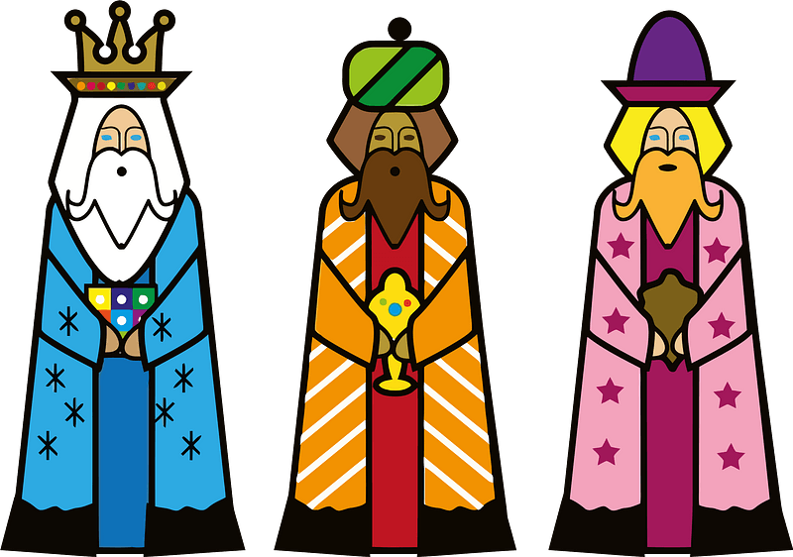
Crossword Puzzle
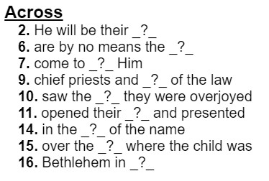
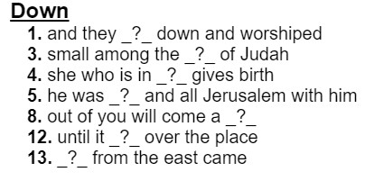
If you get stuck, you can get help at https://tinyurl.com/274yr3d9. And there are other Family Activities there for your enlightenment!

