1. Motivate

Why do you think the drive to acquire more “stuff” motivates so many people in our culture?
- bombarded by ads
- we compare each other’s cars, houses, etc.
- we measure our success by what we own, what we can buy
- we are offered unsolicited credit cards so we can buy more stuff
- materialism has become an idol for so many people
- consider the object we place in a prominent place in our homes and spend many hours sitting in front of it, gazing into its screen (the only thing we don’t do is bow down to it)
- Facebook and Amazon track what we look at or consider purchasing and display it for us to drool over some more
- our “stuff” becomes the most important thing in our lives

2. Transition

Today we will study what John says about loving God.
- We will see that how we live reflects the reality about our relationship with God.
A video introduction is available. View at https://watch.liberty.edu/media/t/1_f2tslsnr If you have no wi-fi where you teach, best to download to your computer from
https://tinyurl.com/tjj9n7sw
3. Bible Study

3.1 Walk in Obedience

Listen for the word “know” in this passage.

1 John 2:3-6 (NIV) We know that we have come to know him if we obey his commands. 4 The man who says, "I know him," but does not do what he commands is a liar, and the truth is not in him. 5 But if anyone obeys his word, God's love is truly made complete in him. This is how we know we are in him: 6 Whoever claims to live in him must walk as Jesus did.

What does this passage say about someone who truly knows God?
- obey His commands
- God's love made complete in him
- walk as Jesus did (this is where the WWJD concept is derived)
- we imitate Him

What do you think John meant by the phrase, "the truth is not in him"?
- he is fooling himself
- he makes claims that are false
- nothing he says can be trusted
- also, God's Truth is not in him – either such a person does not know Truth or does not apply what he does know

How do we get the Truth "in us"?
- read it
- apply it to your life – see that what it says applies to you personally
- put it into practice – the specific commands, the principles
- give God's Truth the highest priority in your life
- of all possible "theories" floating around concerning how to live, God's Truth is the one we give credence to and live by

What does it mean to say that the love of God is perfected in the one who obeys Him?
- the more we obey God’s commands, God’s principles for living, the more we realize it is the best choice
- it becomes a positive cycle … obey, realize joy and peace from God, so obey some more
- we grow more spiritually mature as we read and apply God’s Truth on a daily basis
- the more we submit to God’s rule in our lives, the more we realize He is empowering us to live according to His good plans for us

What do you find challenging about walking in Jesus’ footsteps?”
- Jesus was perfect … just to mimic Him would be impossible – we don’t have that kind of spiritual strength
- we still have a sinful human nature, unable to live a perfect life
- only happens as more and more we submit to his rule in our lives

What should “walking like Jesus” look like?
- He was human, He had to depend on the power of God’s Holy Spirit to live a perfect life
- we must daily surrender to the Spirit’s guidance and empowering
- God’s Holy Spirit will produce in us the Fruit of the Spirit … love, joy, peace, patience, kindness, goodness, gentleness, faithfulness, self-control

3.2 Walk in the Light

Listen for something that is both old and new.

1 John 2:7-11 (NIV) Dear friends, I am not writing you a new command but an old one, which you have had since the beginning. This old command is the message you have heard. 8 Yet I am writing you a new command; its truth is seen in him and you, because the darkness is passing and the true light is already shining. 9 Anyone who claims to be in the light but hates his brother is still in the darkness. 10 Whoever loves his brother lives in the light, and there is nothing in him to make him stumble. 11 But whoever hates his brother is in the darkness and walks around in the darkness; he does not know where he is going, because the darkness has blinded him.

How did John contrast love and hate?
Love | Hate
- love seen in Jesus  - love seen in believers  - demonstrates the "light" of God's truth at work in us | - opposite of love  - a demonstration of "darkness" in one's life – the lack of love  - demonstrates that such a person does not know how to act rightly
What is the old/new commandment John writes about? How can it be both?
- to love one another -- shows up in Old Testament
- Leviticus 19:18 (NIV) "'Do not seek revenge or bear a grudge against one of your people, but love your neighbor as yourself. I am the LORD.
- old in the sense that it was part of the Law
- new in the sense that God’s Holy Spirit lives within the believer enabling, motivating us to love one another

How does our culture get “love” wrong?
- emphasis placed on feelings
- emphasis on the physical or sexual aspect of relationships
- God’s love (Greek word agape) is when a person does nice things for another that is unsolicited and done with no requirement or even expectation for reciprocity
- as humans, we do “acts of love” for someone so they will do nice things back for us
- “I’ll do this extra job at work so the boss will give me a raise”

What imagery did John use to describe those who are able to obey the commandment to love?
- light and darkness
- light is the presence of God’s power at work in us
- darkness is the absence of God’s power at work in us – because we either are not believers or we are not submitting to God’s authority in our lives

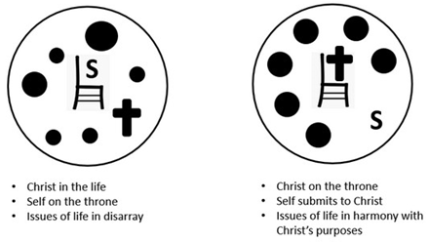

Why is no occasion of stumbling present in the person who loves his brother or sister?
- When God is ruling in our lives we do not stumble
- it is when we nudge Jesus off the throne of our lives that we mess up, stumble, sin
- the person who surrenders to Christ on the throne will be directed, guided, and empowered by God, Himself to love one another

3.3 Walk According to God’s Will

Listen for how to walk in the will of God.

1 John 2:15-17 (NIV) Do not love the world or anything in the world. If anyone loves the world, the love of the Father is not in him. 16 For everything in the world--the cravings of sinful man, the lust of his eyes and the boasting of what he has and does--comes not from the Father but from the world. 17 The world and its desires pass away, but the man who does the will of God lives forever.

What prohibition does John give to his readers?
- don’t love the world
- don’t love the stuff of the world
- speaking of the values of the world, things which motivate people

What does love for the world indicate about a person’s love for God?
- love for things of the world becomes an idol in one’s life
- whatever is more important to you than Jesus, is an idol
- our material stuff, our desire for popularity or power can become more important to us than God … they are idols

What were three means of temptation that John cautioned his readers to avoid?
- cravings of sinful man
- lust of the eyes
- boasting of what you have, what you do

How do we demonstrate that we love the world and the things in it?
- demonstrated by how we spend our money – your checkbook or credit card statement will be evidence
- how we spend our time
- who we spend time with

What can we expect if we choose the way of the world?
- the rewards or pleasures are fleeting
- all that stuff passes away
- means nothing in eternity
- we end up dissatisfied with life
- only a personal relationship with God through Jesus Christ will be lasting and fully satisfying

What do we enjoy by choosing the way of God?
- joy, peace,
- assurance of salvation – now and in the life beyond this one
- forgiveness of sins
- empowering to make good choices
- empowering to live a life free from slavery to sin
Use the last page as a handout so your learners can take home the application points of this week’s lesson.

Application
Examine your life.
- Consider the fruit of the Spirit listed in Galatians 5:22-23.
- If, after examining your life, you feel as though you have fallen short in manifesting a true Christian’s character, then repent and trust in Christ now.

Align your life.
- Perhaps through this study, you have been assured of your relationship with God.
- However, you also realize there are a few things in your life that need to be re-aligned under God’s will.
- If so, begin making those changes this week. It might be something as simple as waking up earlier so you can spend quality time with God.

Make a difference in someone else’s life.
- Be intentional this week to share about your relationship with Christ.
- Look for opportunities to serve someone, and when you see it, don’t hesitate.
- Serving others gives a great opportunity for sharing the gospel.
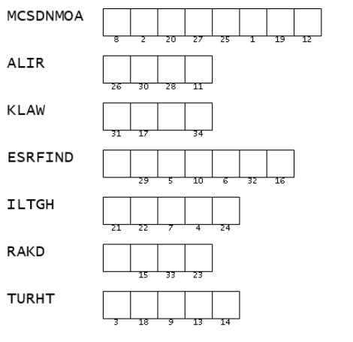
Double Puzzle
So … as you can see, I’m pretty busy here. I could use your help. Those clue words are all messed up. If you could get them sorted, they will give you the letters to match with the numbers in the quote. I think it’s an important quote to go with this lesson. If you get stuck, go to https://tinyurl.com/tjj9n7sw There’s other good stuff there too. When you get it done, make sure to forward it to your Bible Study leader.

