1. Motivate

What are things our society tends to worship?
- cars
- big TV’s
- sports stars
- their phones (along with Twitter, Facebook, Instagram, etc.)
- their gardens
- their tools
A video introduction to the lesson is available.
View it at https://watch.liberty.edu/media/1_ughxmpmh
If you have no Wi-Fi where you teach, best to download to your computer from https://tinyurl.com/y5r5aleu
- their houses
- their collectables
- famous musicians
- rock stars, hip-hop stars
- famous movie stars
- famous movies

2. Transition

Many people or places or things can be the most important element in our lives.
- By definition, that makes them idols – more important than God
- As believers, God should have first place in every aspect of life.

3. Bible Study

3.1 He Alone Is God

Listen for why to devote yourself to God.

Exodus 20:1-6 (NIV) And God spoke all these words: 2 "I am the LORD your God, who brought you out of Egypt, out of the land of slavery. 3 "You shall have no other gods before me. 4 "You shall not make for yourself an idol in the form of anything in heaven above or on the earth beneath or in the waters below. 5 You shall not bow down to them or worship them; for I, the LORD your God, am a jealous God, punishing the children for the sin of the fathers to the third and fourth generation of those who hate me, 6 but showing love to a thousand [generations] of those who love me and keep my commandments.

Why do you think God prefaced the Ten Commandments by announcing who He is?
- He wanted to establish the authority of the commandments
- to make sure people didn’t think these were just ideas that Moses thought up
- so people wouldn’t think these were rules that would be voted on
- so we know this is how God expects people to live

Because that is true, what are they commanded to avoid?
- nothing else, no one else can be more important to us than God is
- God is a Spirit, we must not have anything physical that we believe represents Him
- His power and majesty and glory are far beyond any physical image we can come up with
- nothing physical does justice to who He really is

So, with the first commandment “no other gods before me,” how do Christians violate this commandment?
- we have influences in our lives that have more control over us than God does
- we submit to other people or other things in our lives ahead of God
- some things are more important to us than God is in our lives
- we spend more time, energy, emotion, and resources on these other things than in knowing and serving God
- we often say that these are “idols” in our lives

How is this first concept (no other gods) really different from the second commandment which speaks of actual physical objects which someone might bow down to?
- a carved or cast statue is a symbol
- it is a physical image of an invisible, spiritual deity

Why would God not want any physical representations of Himself to be used in worship?
- physical images are man’s imagination of what God is like
- God is so far beyond our understanding that He could not be adequately represented by a mere physical icon
- it would be so much like just all the other deities in surrounding nations
- He is not just one of many … He is THE God Who Is … Jehovah

How does God respond to those who sin against Him?
- He is a jealous God
- He punishes sin
- sinning against God affects your children and grandchildren (and beyond)

Why do you think this exclusive loyalty is the first command, foundational to all the rest?
- if we put God first, all the rest of the commands will follow
- if God is the most important motivation in our lives, we will be doing all the rest of the things He commands

How do you guard against or fight idolatry (actual objects or influences) in your own life?
- work daily at putting God first
- spend time with Him
- read and heed His Word
- claim His promises then idols dim in contrast
- worship Him, praise Him daily
- submit to Him, “serve the Lord with gladness”

3.2 He Alone Is Good and Completely Trustworthy

Listen for a poetic expression of devotion to God.

Psalm 16:1-4a (NIV) Keep me safe, O God, for in you I take refuge. 2 I said to the LORD, "You are my Lord; apart from you I have no good thing." 3 As for the saints who are in the land, they are the glorious ones in whom is all my delight. 4 The sorrows of those will increase who run after other gods.
What brief prayer does the psalmist offer?
- prays for safety
- declares that God is his refuge

What confession does he make?
- speaks to Jehovah … you are my Lord, the one to Whom I give allegiance
- every good thing I have has come from you

What was another element of trusting in God that brought him pleasure?
- his favorite people are fellow believers
- he enjoys the company of fellow saints
- implying that unbelievers are lacking in true fellowship

When has your relationships to fellow believers brought you joy and encouragement?
- working together on a mission trip
- participating together in a musical ministry program – singing, playing an instrument
- being on a home visit and seeing someone make a profession of faith
- being in a prayer group that experiences multiple significant answers to prayer
- supporting one another in your Bible study group

What is his concern about those who pursue other gods? How might verse 4a relate to Exodus 20:5-6?
- they will be sorry
- they will regret their lack of knowing and serving Jehovah God
- their sorrows will increase !
- they invite more problems for their succeeding generations
- in contrast to faithful believers and followers of God who will experience blessings farther down their succeeding generations

When are you most tempted to put your trust in something besides the Lord?
- when you see a nice car you could never afford
- when someone comes to you with a “guaranteed” quick way to make a lot of money
- when you are tempted to pursue friendship with someone mainly to gain influence or popularity
- when you are confronted with a worldly pleasure that you know is wrong
- when a tragedy strikes and you look for earthly help – doctor, government, rich uncle

What experiences from your life reflect the truth that God is good?
- guidance in life decisions
- opening and closing doors of opportunity
- provision
- life accomplishments in things that really count … not necessarily in material or worldly ways
- God’s Truth can be depended on
- knowing that God is in control … within my life, but also on a much larger scale

3.3 He Alone Is the Way to Eternal Life

Listen for how God is for us and with us.

Psalm 16:9-11 (NIV) Therefore my heart is glad and my tongue rejoices; my body also will rest secure, 10 because you will not abandon me to the grave, nor will you let your Holy One see decay. 11 You have made known to me the path of life; you will fill me with joy in your presence, with eternal pleasures at your right hand.

What resulted from the psalmist’s contemplation on the assurance of God’s presence?
- his heart is glad
- his tongue rejoices
- his body rests secure

What did David expect of his future? (16:11)
- God’s guidance … the path of life
- continuing joy
- continuing being in God’s presence
- eternity in God’s presence – at His right hand

What words in these verses reinforce the idea that hope in the Lord has eternal benefit?
- God showed him the path of life
- filled him with joy
- privileged to be in God’s presence
- eternal pleasures at God’s right hand

How had his confidence in God affected his view of death?
- he is sure God will not abandon him to the grave
- not let your Holy One see decay

How does your faith in God affect your perspective on death?
- like Paul said, “absent from the body, present with the Lord”
- God’s presence is with us here in our physical lives
- we continue on in God’s presence when we finish this life
- Heaven is a safe and wonderful place to be … not to be feared

Who could be the "Holy One"? How might it apply to Christ?
- God raised Jesus from the dead
- didn’t stay dead after the crucifixion
- because Jesus was given new life, so are those who believe

What does it look like to place God first in your life?
- spending time with God is a priority
- someone said, “no Bible, no breakfast … no prayer, no newspaper”
- involvement in Kingdom ministries
- using your Spiritual gifts
- tithing your time as well as your finances
Use the last page as a handout so your learners can take home the application points of this week’s lesson.

Application
Acknowledge.
- The starting point for any personal change begins with honestly acknowledging what needs to change.
- If you do not put God first in any area in your life, confess that to God.
- Ask for His forgiveness and help in putting Him first in your thoughts, words, and actions.

Begin.
- Make a commitment to begin each day by putting God first.
- You can develop the habit of putting God first more consistently by reminding yourself of this truth before you start your day.
- This will look different for each person, but it could mean saying a prayer when you first wake up, reading your Bible before you do anything else, or quoting a Scripture from memory before you pick up your phone in the morning.

Track.
- Consider keeping a note-pad or journal this week where you write down every time you sought to put God’s perspective and His guidance first in your life.
- You may want to share this with a friend as a way to encourage your friend to do the same.
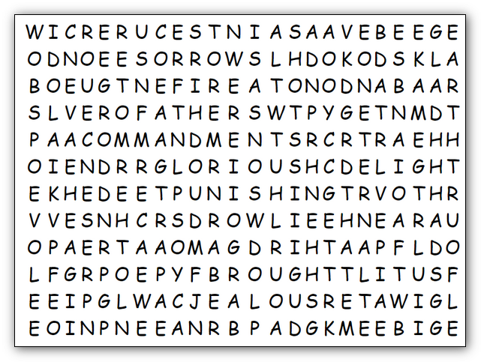
Humph! This confound pandemic has put those words in the grid every which way … up, down, right, left, and even diagonally! You must find them in order to get the full benefit of the Bible Lesson. Humph! I suppose you’ll get stuck, so help is available at https://tinyurl.com/y5r5aleu along with your precious favorite, the Crossword. And even a coloring page!
IDOL
INCREASE
JEALOUS
KEEP
LAND
LORD
LOVE
MAKE
OTHER
PATH
PLEASURES
PRESENCE
PUNISHING
REFUGE
REST
RUN
SAFE
SAINTS
SECURE
SLAVERY
SORROWS
SPOKE
TAKE
THIRD
WATERS
WORDS
WORSHIP

ABANDON
AFTER
APART
BEFORE
BODY
BOW
BROUGHT
CHILDREN
COMMANDMENTS
DECAY
DELIGHT
DOWN
EARTH
EGYPT
ETERNAL
FATHERS
FOURTH
GENERATION
GLAD
GLORIOUS
GODS
GOOD
GRAVE
HATE
HEART
HEAVEN

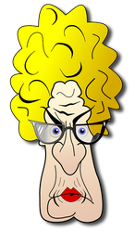
IDOL
INCREASE
JEALOUS
KEEP
LAND
LORD
LOVE
MAKE
OTHER
PATH
PLEASURES
PRESENCE
PUNISHING
REFUGE
REST
RUN
SAFE
SAINTS
SECURE
SLAVERY
SORROWS
SPOKE
TAKE
THIRD
WATERS
WORDS
WORSHIP

