1. Motivate

When have you said, “I’m glad that’s behind me”?
- colonoscopy (no pun intended)
- final exams
- finishing IRS forms
- involvement in a yearly Christmas or Easter concert
- Covid
A video introduction to the lesson is available. View at https://watch.liberty.edu/media/t/1_pmgmvg0u If you have no wi-fi where you teach, best to download to your computer from https://tinyurl.com/ytat2ynr
- clean up after a big holiday dinner
- finishing mowing and trimming the lawn
- a long drive coming home after a vacation trip
- a major car repair or home improvement job
- all the bills are paid

2. Transition

Someday all our fears will be left behind!
- Fear will be a thing of the past in God’s eternal kingdom

3. Bible Study

3.1 Humble Yourself before God

Listen for renewal.

Zephaniah 3:9-13 (NIV) "Then will I purify the lips of the peoples, that all of them may call on the name of the LORD and serve him shoulder to shoulder. 10 From beyond the rivers of Cush my worshipers, my scattered people, will bring me offerings. 11 On that day you will not be put to shame for all the wrongs you have done to me, because I will remove from this city those who rejoice in their pride. Never again will you be haughty on my holy hill. 12 But I will leave within you the meek and humble, who trust in the name of the LORD. 13 The remnant of Israel will do no wrong; they will speak no lies, nor will deceit be found in their mouths. They will eat and lie down and no one will make them afraid."

Note the words and phrases that describe the unity of God’s people.
- God will purify His people’s lips – purify their speech
- All God’s people can call on His name and serve Him together
- Believers from all nations will bring Him offerings

Verse 11 says, “On that day you will not be put to shame for all the wrongs you have done …” What will the Lord do to eliminate that shame?
- God will remove the prideful people
- no more will people be arrogant or haughty
- those present will be meek and humble
- they will be people wo trust in the Name of Jehovah God – The God Who IS
How do the faithful remnant behave?
- do no wrong, speak no lies
- no longer speak with deceit
- well provided for – food, shelter
- don’t live with fear

Why will they have no need to be afraid?
- God’s provision
- God is in control
- they are no longer preyed upon by prideful people who lie and deceive

How does embracing God’s purpose set your mind at ease about the future?
- know that God is in control
- trust in God’s power and authority
- assured that God is Love … that love is expressed toward each one of use, personally

What kinds of fears hinder believers experiencing the joy God intends for us?
- fear of what the government might do
- fear of recession
- loss of health
- fear of tragedy – accident, storm, attack …
- abuse – in the home, at work

Based on this passage, what should the believer do to conquer these kinds of fears?
- submission to, trust of God
- know that God is in charge
- focus thoughts on God’s Truth – read and apply God’s Word
- review the attributes of God … omnipotent, omniscience, omnipresence, love, holiness, righteousness/justice, etc.

Consider John 15:11-16 (NIV) I have told you this so that my joy may be in you and that your joy may be complete. According to this verse …
- God’s joy is in you
- Your joy is complete

In what ways does this happen? How is God’s joy manifested in you? How is it made complete?
- you have the assurance that He is in charge, even when life gets tough
- you experience His sufficiency to deal with all kinds of situations
- you are able to see God’s hand at work in your life in both good times and bad times
- you come to realize the difference between happiness and joy … you can have God’s joy, whether you are grieving or celebrating
- you learn more and more that loving obedience is the key to this joy
3.2 God’s Presence throughout Harm

Listen for returning to joy.

Zephaniah 3:14-17 (NIV) Sing, O Daughter of Zion; shout aloud, O Israel! Be glad and rejoice with all your heart, O Daughter of Jerusalem! 15 The LORD has taken away your punishment, he has turned back your enemy. The LORD, the King of Israel, is with you; never again will you fear any harm. 16 On that day they will say to Jerusalem, "Do not fear, O Zion; do not let your hands hang limp. 17 The LORD your God is with you, he is mighty to save. He will take great delight in you, he will quiet you with his love, he will rejoice over you with singing."

What words and phrases express what the people are encouraged to do in verses 14 and 16?
- sing, shout
- be glad, rejoice with all your heart
- do not fear
- don’t let your hands hang limp, don’t be paralyzed by fear

What are some reasons for singing and rejoicing?
- God took away your punishment
- He has turned back your enemy
- Jehovah God (The God Who IS) is with you … personally
- you will fear no harm

What does the Lord promise about Himself in relationship to His people? Why can the Lord’s people face fear with strength?
- His presence
- He is mighty to save
- God takes delight in YOU, He loves you
- He will quiet you
- He rejoices over you
- He sings about YOU – a happy song

Note: God rejoices over you with singing
- Not because of your merits
- Not because you’ve been a good person
- Not because you’ve avoided being a bad person
- But … because He loves you … God Is Love
- He rejoices that you have placed your trust in Him

How does God’s presence with you help you not be afraid?
- He has your back
- soldiers or airmen would say, “He has your 6” (ask them what that means)
- His power and authority are working in your behalf
- He will accomplish His purposes for you
- He will supply your needs abundantly
3.3 Eternally Restored in God’s Kingdom

Listen for promises of hope.

Zephaniah 3:18-20 (NIV) "The sorrows for the appointed feasts I will remove from you; they are a burden and a reproach to you. 19 At that time I will deal with all who oppressed you; I will rescue the lame and gather those who have been scattered. I will give them praise and honor in every land where they were put to shame. 20 At that time I will gather you; at that time I will bring you home. I will give you honor and praise among all the peoples of the earth when I restore your fortunes before your very eyes," says the LORD.

What additional actions of the Lord are described in these verses?
- sorrows for failures
- take away burdens, take away our feelings of guilt
- deal with your oppressors
- rescue the lame
- gather those who have been scattered
- giver you honor and praise among all peoples
- restore your fortunes “before your very eyes”

What do you think it means “before your very eyes”?
- you’ll know it was God who did it
- it will be out in the open, God will work in an obvious fashion
- you won’t be tempted to say, “it just happened” or “how lucky” or “it was a fortunate coincidence”

The people of God will be vindicated. Why does the glory truly belong to God?
- He is the one who accomplished it
- no one else could have done it
- we certainly were unable to accomplish what was needed
- our opposition was too great for us, but not for God
- we cannot take credit – we were otherwise beaten

How can knowledge of God’s eternal kingdom, God’s eternal rule and authority impact our lives now?
- realization that our concept of God is too small
- gets our focus off our current problems
- see God at work with a perspective of eternity
- if we study God’s attributes, we begin to learn and appreciate more His power and authority
- the names of God give us insight into how awesome God really is
- go back and study our previous lesson about “The Fear of God”
Use the last page as a handout so your learners can take home the application points of this week’s lesson.
Application
Anticipate.
- Reflect on Zephaniah 3 and Revelation 21–22.
- Thank God for the ways His heavenly kingdom will be unlike our current world.

Memorize.
- Keep being reminded of the joy we have in Christ.
- Memorize Psalm 16:11: “You reveal the path of life to me; in your presence is abundant joy; at your right hand are eternal pleasures.”

Witness.
- Share the gospel with someone.
- We are surrounded by those who don’t have the assurance of a joy-filled future in Christ.
- Ask God to reveal to you who that person is and pray for the opportunity to share Christ’s love and what He has done for him or her.
Word Search
AFRAID
ALOUD
BEYOND
BRING
BURDEN
CALL
DAUGHTER
DECEIT
DELIGHT
EAT
ENEMY
FEAR
FEASTS
GATHER
GLAD
HANDS
HARM
HAUGHTY
HOLY
HUMBLE
KING
LAME
LIES
LIMP
LIPS
LOVE
MEEK
MIGHTY
MOUTHS
OFFERINGS
OPPRESSED
PEOPLES
PRIDE
PUNISHMENT
PURIFY
REJOICE
REMNANT
REMOVE
REPROACH
RESCUE
RIVERS
SCATTERED
SERVE
SHAME
SHOULDER
SHOUT
SINGING
SORROWS
TRUST
TURNED
WORSHIPERS
WRONG
ZION
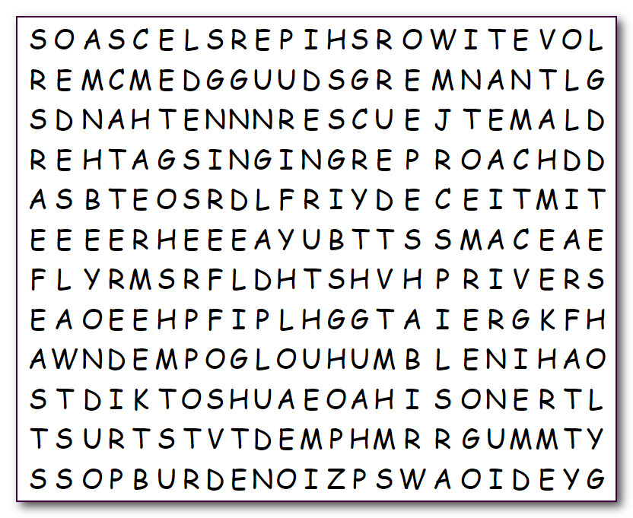
What a joy to see you people again. Humph! I began to fear you wouldn’t come to find these important words from your Bible Study. Yes, they go in all directions. Yes, some are hard to find. Just see how many you can find. Help and other Fun Family
Activities are available at https://tinyurl.com/ytat2ynr

