1. Motivate

What’s the worst car trouble you’ve experienced?
- Locked keys in a running car
A video introduction is available. View at https://watch.liberty.edu/media/t/1_7qamxpgi If you have no wi-fi where you teach, best to download to your computer from https://tinyurl.com/5393wvb3
- Fuel pump just quit on the interstate
- Blew out a tire on the highway
- Slid on the ice and went off the road
- car ruined by hailstorm while parked at airport
- ran down the battery at work trying to start the car at -20 degrees
- forgot to set emergency break and car rolled out into traffic to be hit
- stuck in the ditch in a blizzard

2. Transition

We’ve all had times when we’ve felt alone, especially with a non-working car all by ourselves.
- But even then, as followers of Christ, we’re never truly alone.
- The presence of God is with us in the person of the Holy Spirit.
- The Holy Spirit’s presence in our lives affirms our relationship with God.

3. Bible Study

3.1 The Spirit Indwells Every Believer

Romans 8:9-11 (NIV) You, however, are controlled not by the sinful nature but by the Spirit, if the Spirit of God lives in you. And if anyone does not have the Spirit of Christ, he does not belong to Christ. 10 But if Christ is in you, your body is dead because of sin, yet your spirit is alive because of righteousness. 11 And if the Spirit of him who raised Jesus from the dead is living in you, he who raised Christ from the dead will also give life to your mortal bodies through his Spirit, who lives in you.

What are some situations when we feel like our sinful nature is in control?
- cannot resist that extra doughnut
- we lash out in anger
- can’t turn off that R-rated movie
- cannot get to sleep because of worry
- can’t get out of bed an extra half hour early to have that quiet time
- just have to have that new item, even though it means not tithing this month

What does Paul say is true about every believer?
- God’s Spirit lives within you
- if the Spirit does not live within you, you are not a believer
- your body is dead because of sin
- but your spirit is alive because of righteousness … God’s righteousness, God’s Holy Spirit

Paul says, “your body is dead because of sin, but your spirit is alive because of righteousness.” How does verse 11 explain that statement?
- God’s Spirit is living within you
- God’s power is at work in your life
- it’s the same power that raised Jesus from the dead – amazing power
- even though we still have mortal (dying) bodies with sinful tendencies
- God’s Holy Spirit gives life, spiritual life

He is saying a person can be dead and have life at the same time.
- Our bodies are dead to sin (separated from a sinful lifestyle)
- Our spirits are made spiritually alive (united with Christ) by the presence of the Holy Spirit

What does the indwelling of the Holy Spirit mean for the Christian? What are some signs that tell us the Holy Spirit is at work in a Christian’s life?
- able to overcome sinful tendencies
- a desire to love others that we might not like otherwise
- receive wisdom and courage to make right choices
- a desire to know God better … reading, applying God’s Word
- God’s Spirit put’s the “want to” in our lives to do the right things

Note evidence Paul speaks of in other of his letters.
- The Spirit produces Spiritual Fruit within/through our lives … love, joy, peace, patience, kindness, goodness, gentleness, faithfulness, and self-control
- Each believer is given a Spiritual Gift … a special skill or ability that God will use to minister to others

To review, let’s contrast the two forces that control people as described in these verses.
Controlled by Sinful Nature | Controlled by the Spirit of God
- cannot please God  - not controlled by God’s Spirit  - body dead because of sin  - do not belong to Christ  - live according to the sinful nature  - spiritual death, eternal separation from God | - God’s Spirit lives within you  - your spirit alive because of God’s righteousness  - gives life to your mortal bodies  - put to death misdeeds of the body  - eternal life, eternal union with God

3.2 Led by the Spirit

Listen for how the Holy Spirit leads.

Romans 8:12-14 (NIV) Therefore, brothers, we have an obligation--but it is not to the sinful nature, to live according to it. 13 For if you live according to the sinful nature, you will die; but if by the Spirit you put to death the misdeeds of the body, you will live, 14 because those who are led by the Spirit of God are sons of God.
What two contrasting images—one showing what we are not and the other what we are—does Paul use to describe our relationship with God?
- live according to the sinful nature
- result is death – spiritual separation from God
- by the Spirit put to death misdeeds of the body
- result is life – spiritual union with God
- led by the Spirit of God

Paul says we are not obligated to the sinful nature. What obligation do we have?
- receive the Spirit’s power and enabling
- put to death the misdeeds of the body
- you don’t die, instead you live in His power

What are other results of the Spirit of Christ living within the life of the believer?
- the body is dead because of sin
- your own spirit is alive because of Christ’s righteousness
- God’s Spirit gives life to your mortal body
- the Spirit puts to death the misdeeds of the body

From what kinds of actions and attitudes can God’s Spirit set us free?
- anger
- physical or emotional abuse of those around us
- substance abuse
- improper desires about the things we see and hear
- misuse of the resources God gives us

The Holy Spirit is continually at work in our lives
- He convicts/convinces us of the righteousness available for our daily living
- He enables us to replace patterns of sin with patterns of righteousness

How can believers distinguish between being led by the Holy Spirit and the desire to live according to the flesh?
Live According to the Flesh | Led by the Holy Spirit
- respond to your physical appetites  - do not glorify God  - just do what feels good  - ignoring principles of Scripture  - rejecting the Spirit’s convicting/convincing  - love things, use people | - live according to God’s principles found in Scripture  - sensitive to convicting/convincing of the Holy Spirit  - glorify God by our attitudes and actions  - love people, use things

3.3 Affirmed as a Child of God

Listen for words about “family”.

Romans 8:15-17 (NIV) For you did not receive a spirit that makes you a slave again to fear, but you received the Spirit of sonship. And by him we cry, "Abba, Father." 16 The Spirit himself testifies with our spirit that we are God's children. 17 Now if we are children, then we are heirs--heirs of God and co-heirs with Christ, if indeed we share in his sufferings in order that we may also share in his glory.

What words did you read that had to do with family elements?
- sonship, adoption
- Father
- children (Verses 12 – 14 include “brothers” and “sons”)
- Abba
- heirs

Consider the special relationship an adopted child has with the adoptive parents.
- He/she was chosen on purpose
- The adoptive parents did not make a “mistake”
- Birth parents have to “take what they get

So, what kinds of feelings does being “chosen on purpose” by God bring to you?
- encouraged
- you feel special
- you feel wanted
- you realize that God sought you out
- your relationship with Him was not by accident, not by chance

What are some privileges and responsibilities of being God's Child?
Privileges | Responsibilities
- speak directly to God  - hear from God through His Word  - hear from God via Holy Spirit living within us  - power to live victorious life | - obedience  - submission  - share with others  - involved in God's Kingdom  - praise, worship, love God  - heed Holy Spirit’s communications to us

Use the last page as a handout so your learners can take home the application points of this week’s lesson.
Application
Think.
- Putting to death the deeds of the body is a lifelong, ongoing process in the life of a believer.
- Is there an attitude or behavior that needs to be put to death in your life?
- Determine and select one such attitude or behavior.
- Ask the Holy Spirit to strengthen you regarding this area of your life.

Decide.
- Based on what you’ve selected, create an action plan designed to address this issue.
- Good action plans answer the questions who, what, when, where, why, and how.

Act.
- Choose a date to begin and then follow the plan.
- If necessary, copy the action plan and place it where you can see it regularly.
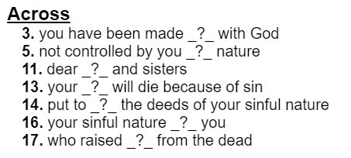
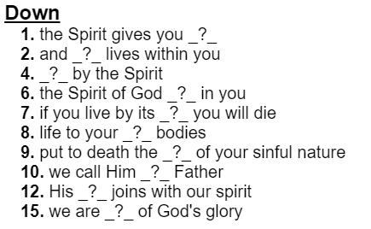
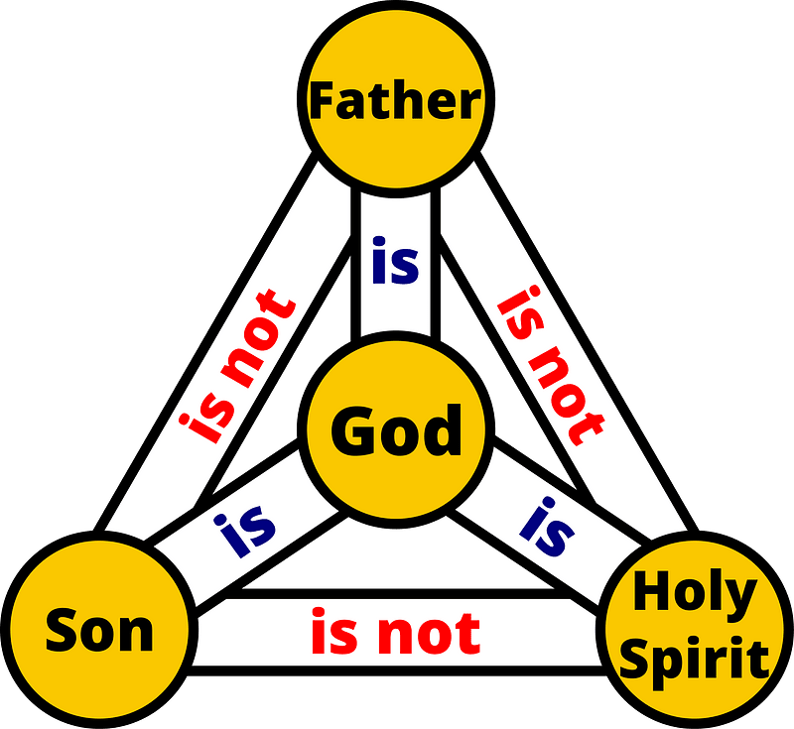
Clues and Words from Romans 8:9 – 17 (NIV) Help and other fun Family Activities available at https://tinyurl.com/5393wvb3
Crossword Puzzle

