1. Motivate

When has a word of encouragement been especially timely?
- when sick
A video introduction is available. View it at
https://watch.liberty.edu/media/t/1_pwf7egzv
If no Wi-Fi is available where you teach, best to download from https://tinyurl.com/27vsrh32
- after a difficult presentation at work
- when playing in a difficult game
- the day you didn’t feel good about yourself
- that time you did poorly on a school test
- when you weren’t sure about a decision
- after you had worked very hard on a project and weren’t sure how it had been received
- after serving a big dinner to a bunch of guests

2. Transition

Jesus speaks encouragement to the church at Philadelphia.
- They had been faithful in their ministry
- He encourages us also as we faithfully trust God and minister to others.

3. Bible Study

3.1 Door to the Kingdom Is Open

Listen for an offered opportunity.

Revelation 3:7-8 (NIV) "To the angel of the church in Philadelphia write: These are the words of him who is holy and true, who holds the key of David. What he opens no one can shut, and what he shuts no one can open. 8 I know your deeds. See, I have placed before you an open door that no one can shut. I know that you have little strength, yet you have kept my word and have not denied my name.

How does the Lord identify Himself to the church at Philadelphia?
- Him who is holy and true
- Him who holds the key of David
- what he opens, no one can shut, what he shuts, no one can open

How are these descriptive words significant to a church?
Words | Significance to a Church
- Holy  - True  - Holds key of David | - Unique, distinct, totally different from any other, honored  - Jesus is Truth … sincere, genuine, in contrast to false deities  - symbolic of absolute power and authority

What difference does it make to you that Christ is "holy and true"?
- Jesus can be trusted
- other people or deities make claims, but cannot be trusted
- what He says is TRUTH, absolute Truth – true in any situation, true for all time
- what He does, what He is able to do is unique, totally different from anyone else
What commendation do you see here?
- despite their little strength …
- they have kept God’s Word
- despite opposition …
- they have not denied God’s name

What had He given to the Christians in the city?
- an open door
- which no one can shut
- reference to the “key of David”

To what might the “open door” allude?
- opportunity for ministry
- a particular undertaking that He promises will succeed
- a specific period of time before them during which they will be able to preach, teach, reach out to those around them
- a direction of ministry that will be successful

What kinds of opportunities might God be giving us … as individuals, as a group, as a church?
- people around us who are hurting
- people need our prayers, our encouragement
- people need to hear God’s love

What might be a particular demographic in our church’s neighborhood or community who are open to help?
- new immigrants
- groups of children, nearby school kids
- teens looking for a place to gather
- kids interested in sports
- senior citizens who would appreciate a time together of fellowship
- stay at home moms with little kids … need a day out
- people who might want affordable music lessons
- a Christian Day-Care ministry

Why do you think the weak become strong when they commit themselves to the Lord in faithful service?
- the strength demonstrated is God’s strength
- when they commit themselves to the Lord, it is an act of faith
- when God calls us to something, it is He that empowers us to accomplish His purposes
- then whatever is accomplished is God’s doing, not ours

3.2 God’s Dependable Protection

Listen for the importance of endurance.
Revelation 3:9-10 (NIV) I will make those who are of the synagogue of Satan, who claim to be Jews though they are not, but are liars--I will make them come and fall down at your feet and acknowledge that I have loved you. 10 Since you have kept my command to endure patiently, I will also keep you from the hour of trial that is going to come upon the whole world to test those who live on the earth.

According to verse 9, who does it appear is guilty of persecuting the Christians in Philadelphia?
- local Jewish community
- they identify as Jews, but are not living in obedience to God
- in fact, they have departed from lives of faith in God
- they are accused of being liars

How will the Christians be vindicated?
- Jesus says they will no longer be attacking the church
- in fact, they will “fall down at your feet”
- they will be forced to acknowledge God’s love for the Christian believers

Why can we rejoice even when we are persecuted by hostile anti-God forces?
- God is still in charge
- they may believe they have the upper hand, but God is in control
- they might win battles, but God will win the “war”
- when Satan does something bad, God will take that effort and turn it around for good
- we know how the story ends … God wins!

What promise was given to the Christians for obeying the challenge to exercise patient endurance?
- they will be kept from, protected from the hour of trial
- a time of trial will come upon the whole world, all peoples
- it will be a time of testing for everyone

What are some things we can do to obey Jesus’ command to endure?
- make it a habit to read God’s words to us
- study and think about what we read
- learn to trust God in being obedient to Him
- study both as an individual and with others
- be on the look out daily for seeing God at work … through nature, through answered prayer, for God’s daily provision and protection
- trust for God’s direction in your life – the “doors” he opens and shuts

How do you remain faithful to God during difficult times?
- claim His promises
- give the problem to God … declare your trust in His sufficiency, thank Him in advance for His provision, praise Him when He does answer
- claim the spiritual armor of God
- know by faith God’s armor protects our minds and emotions, the spiritual weapons enable us to accomplish His purposes

3.3 Hold On

Listen for a promise.

Revelation 3:11-13 (NIV) I am coming soon. Hold on to what you have, so that no one will take your crown. 12 Him who overcomes I will make a pillar in the temple of my God. Never again will he leave it. I will write on him the name of my God and the name of the city of my God, the new Jerusalem, which is coming down out of heaven from my God; and I will also write on him my new name. 13 He who has an ear, let him hear what the Spirit says to the churches.

What promise was given to the Christians for obeying the challenge to exercise patient endurance?
- Jesus is coming soon
- those who “hold on” , those who continue to trust and obey will receive a “crown” … an eternal reward
- overcomers will be made a “pillar” in God’s temple
- God’s name is written on our lives
- we are identified as belonging to the City of God, the New Jerusalem

How can we help each other hold on to all that we have in Christ?
- prayer support (more than just praying for physical needs)
- encouragement to one another
- practical help when we are need
- study God’s Truth together
- worship and praise God together

What are some tools that God gives us to help us remain faithful?
- the armor of God – shield of faith, shoes of the Gospel, helmet of salvation, breastplate of righteousness, belt of Truth, sword of the Spirit (God’s Word)
- God’s presence in our lives producing, demonstrating the Fruit of the Spirit … love, joy, peace, patience, kindness, goodness, gentleness, faithfulness, self-control

How are you continuing to hold on to and nurture a persevering faith in God’s Word in your life?
- daily communication with God -- reading God’s Word, talking to God in prayer
- fill your mind with “good stuff”
- rejecting worldly values
- active involvement in Kingdom ministries – the variety of service opportunities in your church
- obeying God’s Truth
- daily putting Jesus on the throne of your life … surrendering to His direction

Use the last page as a handout so your learners can take home the application points of this week’s lesson.

Application
Endure.
- Identify times or areas of your life when enduring in your faith have been hardest.
- Pray for Christ’s power to stand strong. Let the reminder that He is coming soon to set you free from your difficulties serve as a motivation to stand with Him.

Encourage.
- As you see others standing and enduring in their faith, commend them for their faithfulness.
- Encourage them to continue being a faithful witness.

Invite.
- Invite others to walk through “the open door” of salvation and enter into eternity with Christ.
- Be faithful in your witness of Christ’s salvation.
KEY
LIARS
LOVED
NAME
OPEN
OVERCOMES
PATIENTLY
PHILADELPHIA
PILLAR
SATAN
SHUT
SOON
SPIRIT
STRENGTH
SYNAGOGUE
TEMPLE
TEST
TRIAL
TRUE
WHOLE
WORDS
WORLD

ACKNOWLEDGE
ANGEL
CHURCHES
CITY
CLAIM
COMING
COMMAND
CROWN
DEEDS
DENIED
DOOR
EAR
EARTH
ENDURE
FALL
FEET
HEAR
HEAVEN
HOLD
HOLY
HOUR
JERUSALEM
KEPT

Word Search Puzzle
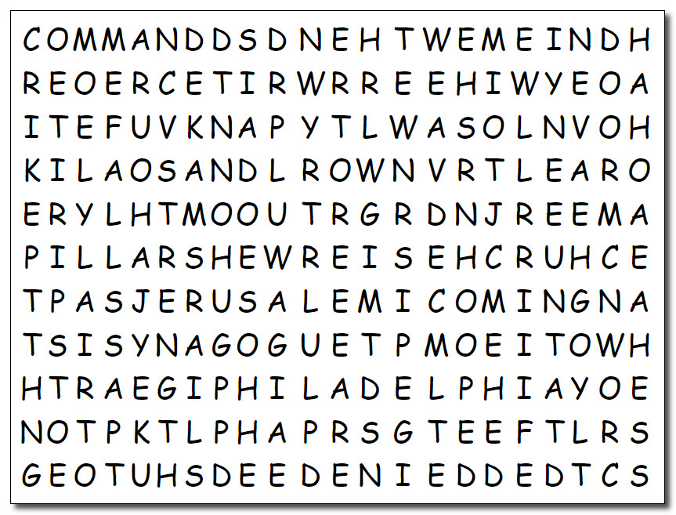
Well, it’s about time! Seems like I’ve been in quarantine well beyond what’s necessary. After all, I did get my shots. Humph! Anyway, it’s time for you people to find these words. You know the drill, they go left, right, up, down, and even diagonally. I suppose you’ll need help. Humph! Go to https://tinyurl.com/27vsrh32 There are other Family pursuits there as well. And don’t forget your summer reading program. Book reports will be due the day after Labor Day!

