1. Motivate

How do the people you love (whether close friends, spouse, or family members) know that you love them?
- what you say to them
A video introduction to the lesson is available. View at https://watch.liberty.edu/media/t/1_24qmfz5u If you have no wi-fi where you teach, best to download to your computer from https://tinyurl.com/2p995b7r
- how you say it to them
- if your actions then match your words
- you make them feel important
- you do what is best for them
- timing … say the right thing at the right time
- do nice things for them without being asked or without expectation of kindness in return
- always be careful when your spouse asks, “do I look OK in this outfit” !!!
- considerate treatment, fairness, kindness, understanding

2. Transition

Jesus spoke to the issue of how to love.
- He said we should base every relationship on the unconditional love He has for us
- Remaining in Christ means our relationships are marked by love.

3. Bible Study

3.1 Remain in Jesus’ Love

What kind of skill have you learned by watching someone else repeatedly perform the skill?
- cooking
- woodworking
- auto mechanic
- woodcarving
- artistic painting
- teaching

How was this method of learning more effective than just reading a book about the skill?
- you see the moves
- you take note of little details that cannot be communicated only in print

Listen for How Christ teaches us by His example.

John 15:9-11 (NIV) "As the Father has loved me, so have I loved you. Now remain in my love. 10 If you obey my commands, you will remain in my love, just as I have obeyed my Father's commands and remain in his love. 11 I have told you this so that my joy may be in you and that your joy may be complete.

So, how does Christ teach us by example?
- He obeyed His Father’s commands
- He remained in His Father’s love

What appeal did Jesus make in these verses?
- remain in my love
- obey my commands
- follow my example

What will be the evidence that a person is abiding in Christ’s love?
- obedience of Christ’s commands
- follow Christ’s example of obedience
- Christ’s joy is in us
- joy made complete

Is obedience the requirement or the result of abiding/remaining in Jesus’ love?
Requirement | Result
- Jesus does not love it when we disobey  - it pleases God when we obey  - some people would say that if you want Jesus to love you, then you should be obedient | - God loves me no matter what I do  - my actions do not cause Jesus to love me more or love me less  - I respond to God’s love for me by obeying His commands  - I demonstrate my love for the Lord by obeying His commands

We should understand that obedience is the result of abiding or remaining in Jesus’ love.
Obedience demonstrates our love for Jesus.

How do we sometimes miss the connection between love and obedience?
- we focus on one without paying attention to the other
- we are so focused on doing what we think to be the right thing (obedience), we do so to the hurt of someone else
- we are so focused on “love” (say, romantically), we disobey what we know to be God’s commands
- or we want to be nice and show kindness/love but act foolishly and don’t act responsibly

What does this passage tell us about God’s design for our class, our church?
- God wants joy for us
- even when times are tough we can know assurance of God’s love
- the church, the Body of Christ will support one another with love
- when we are walking in God’s love, it will be contagious, it will be passed along

3.2 Personal Sacrifice

Listen for a reminder to love.

John 15:12-14 (NIV) My command is this: Love each other as I have loved you. 13 Greater love has no one than this, that he lay down his life for his friends. 14 You are my friends if you do what I command.

According to Jesus, the greatest expression of love is to lay down one’s life for others. What does it mean for a person to “lay down his life”?
- can mean literally dying for someone else, in their place
- give up your own life to save someone else
- can also mean giving of your resources to help, sustain, bless others

Of course, Jesus’ statement in verse 13 alludes to his coming death on the cross.
- Jesus would die on the cross in our place
- He would take the death punishment each of us deserves upon Himself
- Jesus would receive the judgment for sin that should have been ours

What are some additional ways you have experienced the power of sacrificial love?
- parents who provided
- someone went out of their way to do for you
- spouse bought that special gift (story of the “Gift of the Magi”)
- parent who gave up sleep to help you do big homework project
- spouse who worked to put you through school
- parents who saved up to take you on a special vacation or send you to camp

What opportunities do you have to “lay down your life” for others? What does it look like to love others the way Jesus loves us?
- we might not end up dying for someone else, but we can give up things to help others
- I might forego a purchase I wanted to make it possible that a child or grandchild was able to do something special
- give of your valuable time to help someone with a need they had
- dedicate a time in my schedule each day to join others in prayer for a special ministry of our church or our mission
- willing to drive across town, out of my way to enable some kids to come to a special program
- donate skills to do help a family in need
- share the Gospel
- give to send the Gospel around the world
- pray faithfully for children, grandchildren

3.3 Producing Spiritual Fruit

Listen for a change of status.

John 15:15-17 (NIV) I no longer call you servants, because a servant does not know his master's business. Instead, I have called you friends, for everything that I learned from my Father I have made known to you. 16 You did not choose me, but I chose you and appointed you to go and bear fruit--fruit that will last. Then the Father will give you whatever you ask in my name. 17 This is my command: Love each other.

Note the contrasts Jesus makes between servants and friends (He calls us friends).
Servants | Friends
- does not know his master’s business  - Jesus no longer calls us servants | - great love demonstrated by laying down one’s life for a friend  - God’s friends do what He commands  - Jesus calls us friends  - Jesus made known all He learned from the Father to His friends

Do you remember as a child when they would choose up sides for a game … were you ever the last one chosen? That meant, you weren’t even chosen, the person with last choice had to take you. How did you feel?
PICKING TEAMS
Allan Ahlberg

When we pick teams in the playground,
Whatever the game might be,
There’s always somebody left till last
And usually, it’s me.

I stand there looking hopeful
And tapping myself on the chest,
But the captains pick the others first,
Starting, of course, with the best.

Maybe if teams were sometimes picked
Starting with the worst,
Once in his life a boy / girl like me
Could end up being first!
- rejected
- not much self esteem

It says here that God chose us (and not last) … to be His friends! For what other purpose did God choose us?
- appointed you to go
- to bear fruit … lasting fruit
- Fruit of the Spirit (love, joy, peace, patience, kindness, goodness, faithfulness, gentleness, self-control)
- fruit of spiritual harvest – new believers

Why is producing spiritual fruit an important part of our Christian life?
- it is the result of our relationship with God
- it is a demonstration of God’s Holy Spirit working within you
- as you surrender to God’s authority in your life, He produces the Fruit of the Spirit: love, joy, peace, patience, kindness, goodness, faithfulness, gentleness, and self-control

How should we respond to being called a friend of Jesus?
- surprise, awe
Use the last page as a handout so your learners can take home the application points of this week’s lesson.
- respect, submission
- trust, faith
Application
Remember.
- Set aside time each day this week to remember Jesus’s love for you.
- Replay the gospel to yourself and abide in Jesus’s love.

Love.
- Think of a fellow Christian you can love sacrificially this week.
- Maybe someone who has a physical need that you can love in a tangible way.
- What about someone who has an emotional need that you can listen to and pray for?

Serve.
- What actions can you take this week to show love to someone in your life who does not know Jesus?
- How can you serve them in a way that helps them to see Jesus?
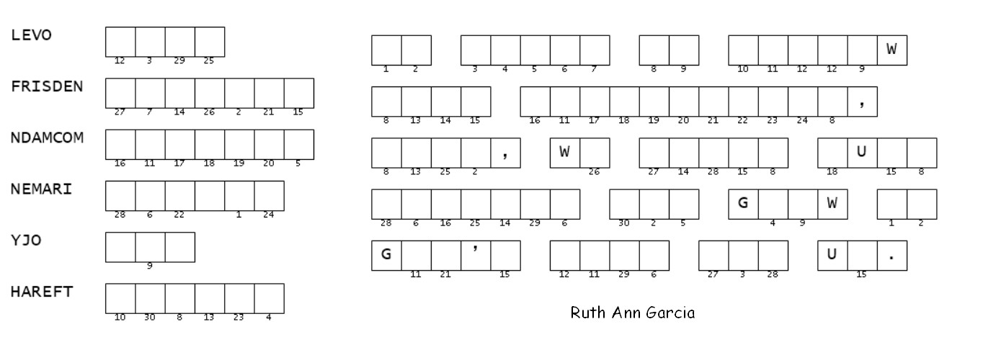
Double Puzzle
It is I, the Word Ninja. Put your Wordle puzzle aside for the moment. Give this message your full attention. The words on the left are from your Bible passage, in John 15. They have been jumbled and you must un-jumble them. This is better than Wordle …. you have all the letters! Use the numbers, then, to decode the quote about loving as Jesus loved. If you’d rather do the crossword puzzle or the color page, or if you need help, go to https://tinyurl.com/2p995b7r, but don’t let the Word Search Lady find out.

