1. Motivate

What would make you want to stand up for someone?
- see them with a problem
- they are helpless
A video introduction to the Bible study is available. View it at http://tinyurl.com/9fk2ahf6 If you have no wi-fi where you teach, best to download to your computer from http://tinyurl.com/mr3zfdyc
- they are being unjustly wronged
- they have no one else to help them
- this is a close friend in need
- the person once helped me
- you owe this person a favor
- best man, maid of honor for a wedding

2. Transition

God calls us to defend, to stand up those who cannot defend themselves.
- Join God in seeking justice, including justice for unborn children.

3. Bible Study

3.1 No Fear of God

Listen for a cry of injustice.

Psalm 10:1-4 (NIV) Why, O LORD, do you stand far off? Why do you hide yourself in times of trouble? 2 In his arrogance the wicked man hunts down the weak, who are caught in the schemes he devises. 3 He boasts of the cravings of his heart; he blesses the greedy and reviles the LORD. 4 In his pride the wicked does not seek him; in all his thoughts there is no room for God.

What is the attitude of the wicked toward the Lord? How does the Psalmist describe the arrogance and pride of the wicked?
- hunts down the weak
- catches them with wicked plans
- boasts of his evil
- blesses greedy
- but reviles the Lord
- does not seek God
- no room for God

Why does that seem unjust?
- the weak are trapped
- they have no chance
- the evil are “in your face” with God
- why doesn’t God strike them down?

Where do you see examples of injustice in our culture?
- current laxity on crime in some cities
- shoplifters are “shopping without money” – no longer prosecuted
- unwanted babies are murdered
- the rich and powerful are not held to account with the law
- the law is disregarded so often
- politicians promise so much but rarely live up to their promises
- some government agencies are acting or being used to attack people or organizations that disagree with a current administration

When has it seemed God was far away in the face of injustice? Identify moments in your life when you've experienced the sentiments expressed in this Psalm?
- stiffed by an insurance company
- a teacher does not treat some students fairly
- athletes get special treatment
- finance companies are happy to let you get so deep in debt, you will never get out
- a manufacturer does not stand by their product, refuses to fix or replace
- a developer destroys a beautiful forest in order to get rich on selling houses
- those who govern seem to have concern only for keeping themselves in power
- elements of our society declare an unborn baby is “just tissue” to be removed
- women’s sports are invaded by men who “identify” as females – and the feminist movement refuses to object
- truth is seen as false, and falsehoods are declared to be truth

Bottom line:
- What was true for the psalmist is still true today.
- Even though we are trying to live faithfully for the Lord, we see ourselves being victimized by the wicked who refuse to think about God at all.

3.2 Look to God for Justice

Listen for a request for God to work.

Psalm 10:12-15 (NIV) Arise, LORD! Lift up your hand, O God. Do not forget the helpless. 13 Why does the wicked man revile God? Why does he say to himself, "He won't call me to account"? 14 But you, O God, do see trouble and grief; you consider it to take it in hand. The victim commits himself to you; you are the helper of the fatherless. 15 Break the arm of the wicked and evil man; call him to account for his wickedness that would not be found out.

In verse 12, what appeal does the psalmist make to the Lord?
- get up, arise
- lift up your hand (to strike the evil and arrogant)
- don’t forget the helpless

We see the flawed thinking of the wicked person.
- He reviles God.
- He believes he will get away with it, will not be called to account.

What emotions and desperation are evident in the Psalmist's plea?
- anger
- desperation
- desire for vengeance, justice
- trust that God is righteous and just
- belief that God has the power and authority to make things right

What confidence does the psalmist have that the Lord will act justly toward the humble of heart and toward the wicked and evil ones?
- you DO see trouble and grief
- you do consider it
- you do take care of it
- the victim can commit himself to you
- you are the helper of the fatherless

What does the psalmist appeal for the Lord to do against the wicked?
- break his arm
- call him to account for his wickedness
- let him know that YOU know

Why is it wise to look to God for justice?
- God’s omniscience – He knows the truth, the reality
- God’s omnipotence – He has the power to make things right
- God’s righteousness/justice – He always DOES make things right
- God’s authority, sovereignty – He is the One in charge, along with the power, He has the authority to act

Our faith should impact our response to injustice.
- Personal anger and desire for vengeance don’t do any good.
- Neither are they the response of faith.
- You have to give up the anger and revenge desire and put it in god’s hands.
- You have to remember that God sees and knows your problem.
- He is at work and will remedy the problem in His time and in His way.
- Remember that He is also working to redeem those who are acting unjustly.

3.3 God Overthrows Injustice

Listen for hope expressed.

Psalm 10:16-18 (NIV) The LORD is King for ever and ever; the nations will perish from his land. 17 You hear, O LORD, the desire of the afflicted; you encourage them, and you listen to their cry, 18 defending the fatherless and the oppressed, in order that man, who is of the earth, may terrify no more.

What claim does the psalmist make concerning the Lord?
- The Lord is KING
- He is in charge … always and forever
- He will render justice to nations and to people
- God hears and listens to the prayers of the afflicted

What does the Lord do on behalf of the humble or those who suffer?
- God listens to their prayers
- He encourages the suffering
- He defends the fatherless and oppressed
- His defense results in the removal of terror

Therefore, with what attitude can we face whatever befalls us?
- assurance of God’s presence and attention to our problems
- full knowledge of His capability to deal with injustice
- God is righteous and just … He does the right thing

How should we handle our frustration with unfairness or wrongdoing that goes unpunished?
- in all things give thanks (not for the bad things) but for God’s power, authority, and love
- fill your mind with what God says
- Psalms are great reading in this context
- David voices his fears and frustrations to God
- then proceeds to praise Him and worship Him
- we can echo both the venting and the declarations of faith and worship

What role can the church play in seeking justice?
- unite in prayer for justice – especially for the unborn in the context of this lesson
- communicate your concerns to those in government
- support those organizations that minister to individuals facing an unexpected (unwanted) pregnancy
- know and vote for those who hold life to be precious and holy

This Psalm inspires individuals or communities to address social issues today.
- Know that God is in charge
- He has BOTH the power and authority to work for the right
- He hears our prayers
- He defends the fatherless and oppressed
- He will do away with the terror against injustice
Use the last page as a handout so your learners can take home the application points of this week’s lesson.
Application
Pray.
- Seek God’s protection for those who cannot fight for themselves.
- Pray for them and for those who care for them and minister to them.

Learn more.
- Seek out a local Christian pregnancy center that is helping moms make choices that honor God and protect their babies.
- Sign up for their mailing list and participate in opportunities they provide.

Change some diapers.
- Do you know a mom who is struggling? Ask for ways you can help.
- Care for her little ones so she can run errands.
- Enlist your Bible study group to provide for their needs.
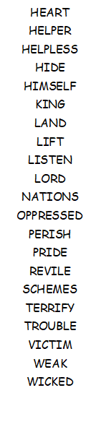
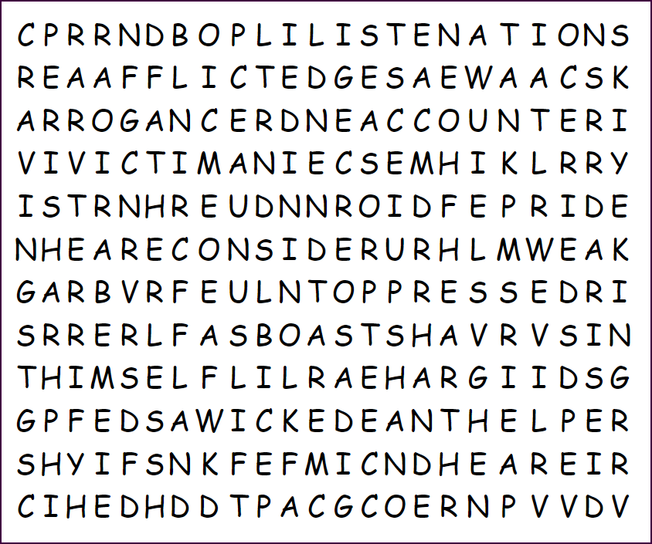
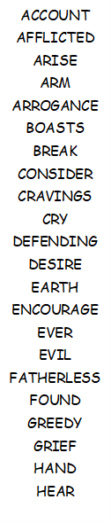
Well, humph! You’re back for a new semester. We’re going easy on you this time around. No backwards or words reading bottom-up. You’ll need to find as many words as possible to beat that other class. Help and the color page is available at http://tinyurl.com/mr3zfdyc . Report your findings to your church treasurer.

Word Search

